LOWCOUNTRY WATERFRONT LIVING AT ITS BEST!!!
54 Scipio Road
Beaufort, SC
MLS# 161938
Only $579,000
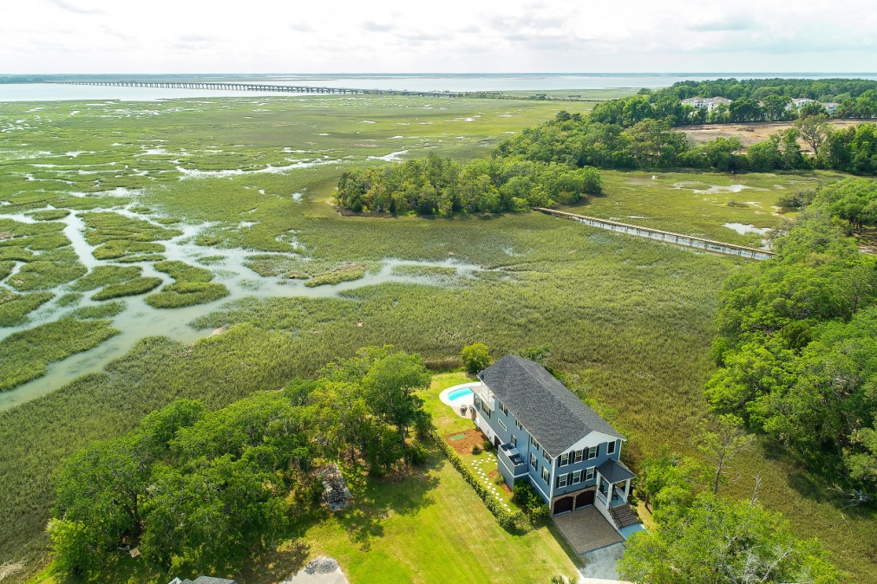
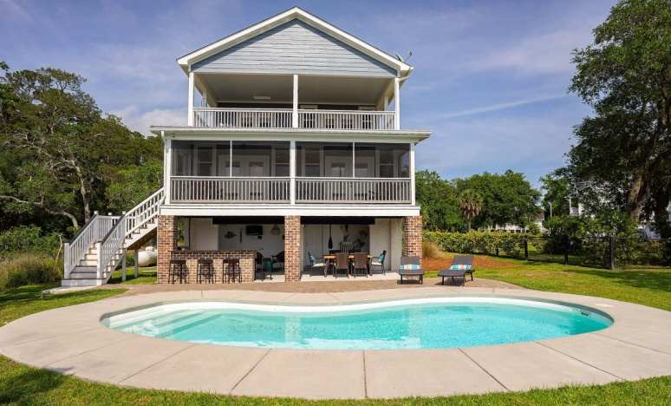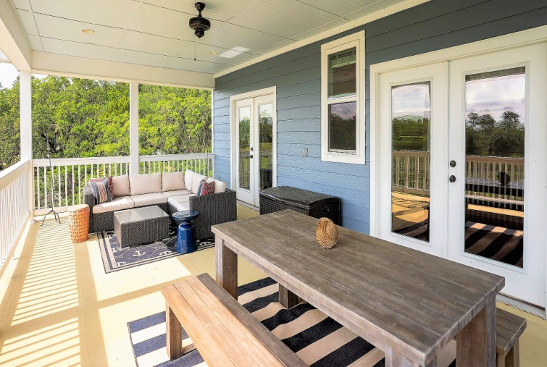
- Beautiful waterfront Charleston-Style 4BR/2.5BA home with private and peaceful settings
- Two huge porches allow for outdoor dining and relaxing
- Stunning and expansive long views of the marsh, creek and the Broad River
- Nice summer breeze on the porches
- Memorable sunsets every evening!!
- Private pool, outdoor bar, BBQ, fire pit…. Lowcountry living at its best!!
- Only 10 min. easy drive to Beaufort historic district,

Call Corinne Woodman at (843) 812-5424 or email at
corinnewoodman@embarqmail.com for additional information

