





~
Welcome Home to The Heart of Daniel Island

WELCOME HOME TO THE ISLAND LIFESTYLE! JUST STEPS TO SHOPS, RESTAURANTS, TENNIS ~ ESCAPE IN THE RESORT STYLE POOL SURROUNDED BY GORGEOUS LANDSCAPING, PICNIC AREA, WALKING TRAILS.

GREAT LAYOUT ! SPLIT 2 BEDROOM PLAN ~ PERFECT FOR GUESTS OR A ROOMMATE. SUNROOM NOT ONLY ADDS SQUARE FOOTAGE BUT OFFERS A GREAT PLACE TO RELAX.

OWNER UPGRADES INCLUDE: NEW HVAC 2016, NEW WATER HEATER, NEW PAINT, NEW CARPET, NEW BLINDS, NEW CEILING FANS, NEW FLOORING … THIS OPEN CONCEPT CORNER UNIT CONDO IS READY FOR ITS NEW OWNER!

600 Bucksley Lane Unit 201
MLS # 16013129
Offered at $214,000

- 2Bdr / 2 Ba SPLIT PLAN
- BRIGHT CORNER UNIT
- REGIME Fee: $275 / MONTH

- SUNROOM
- WOODED NATURAL SETTING
- GREAT AMENITIES ~ POOL ~ FITNESS CENTER ~ PICNIC AREA

AGENTS PLEASE DO NOT MISS THIS CONDO SO WORTH YOUR CLIENTS TIME AND PRICED TO SELL!

FACTS & FEATURES

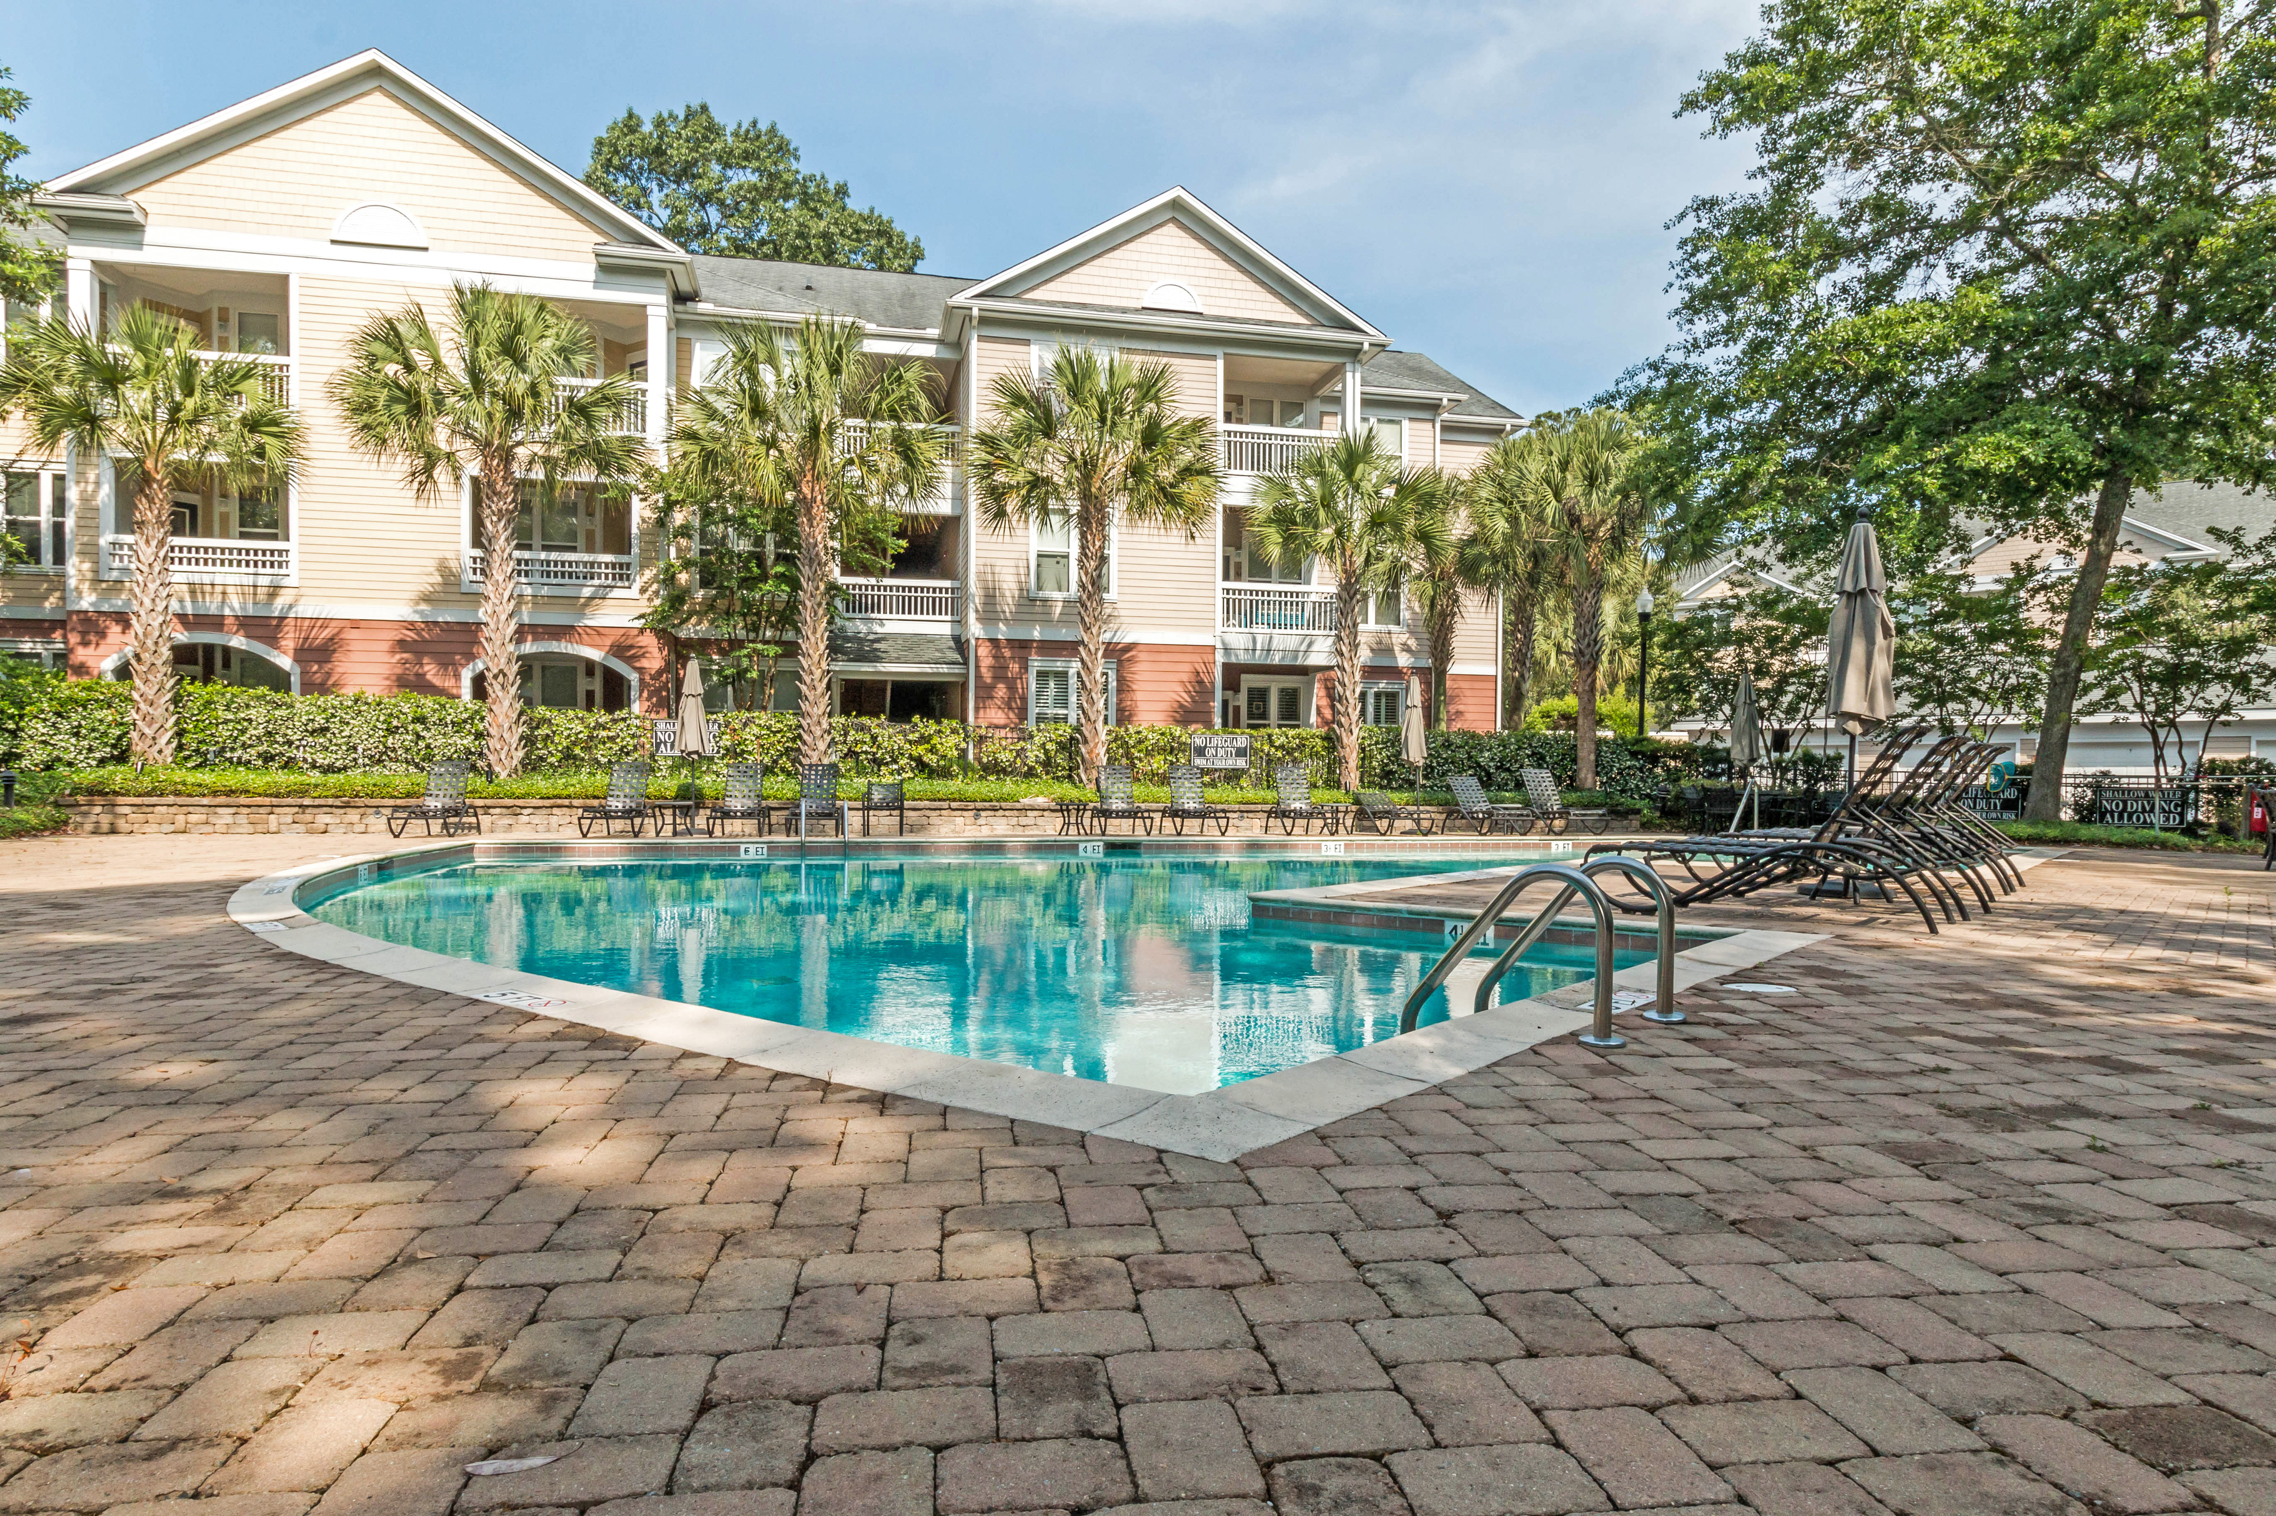
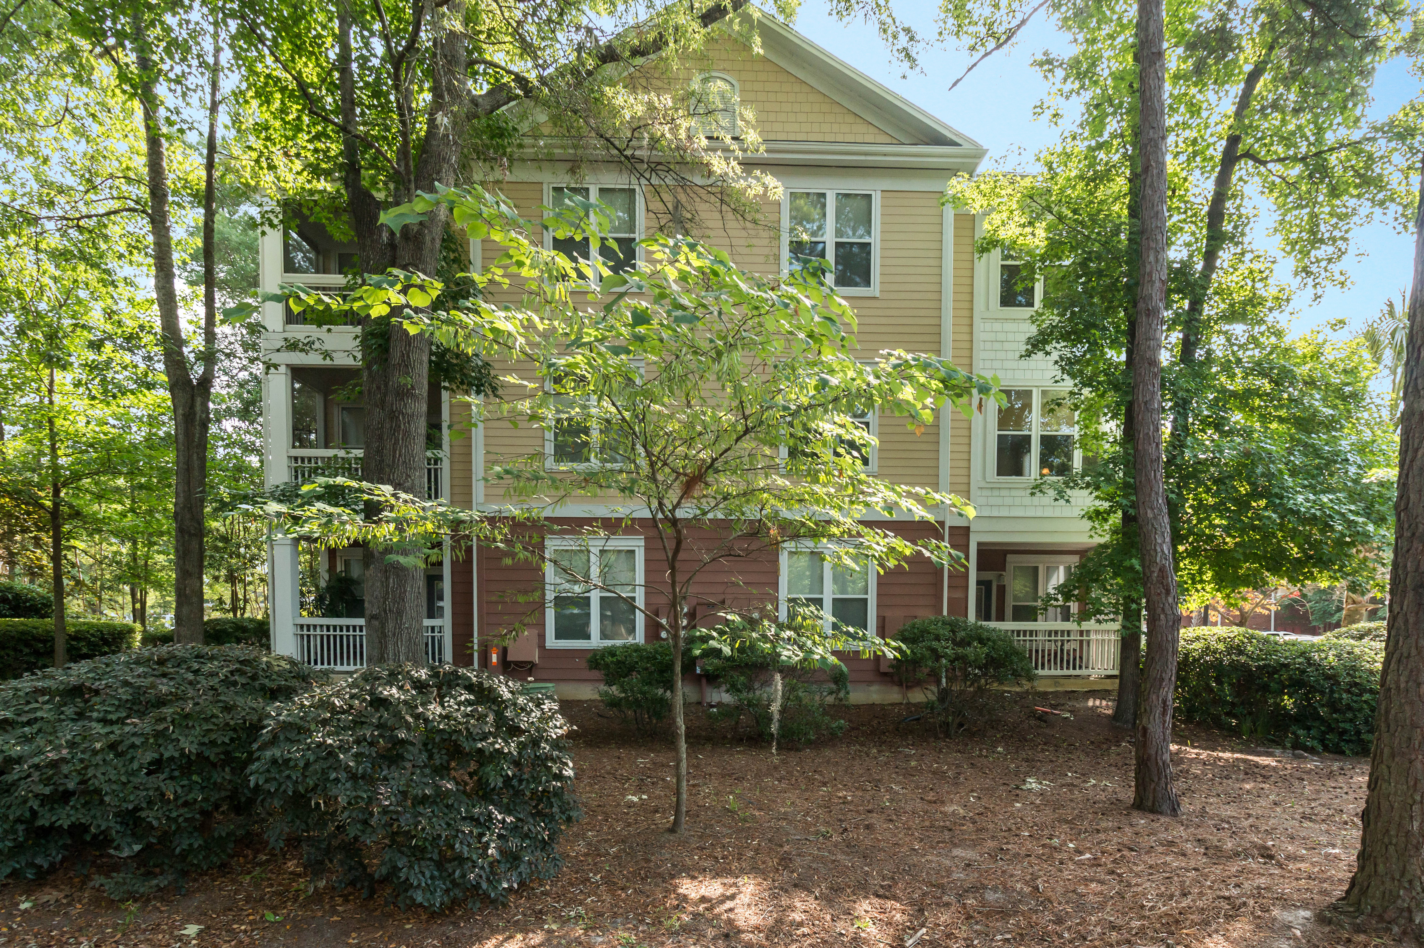
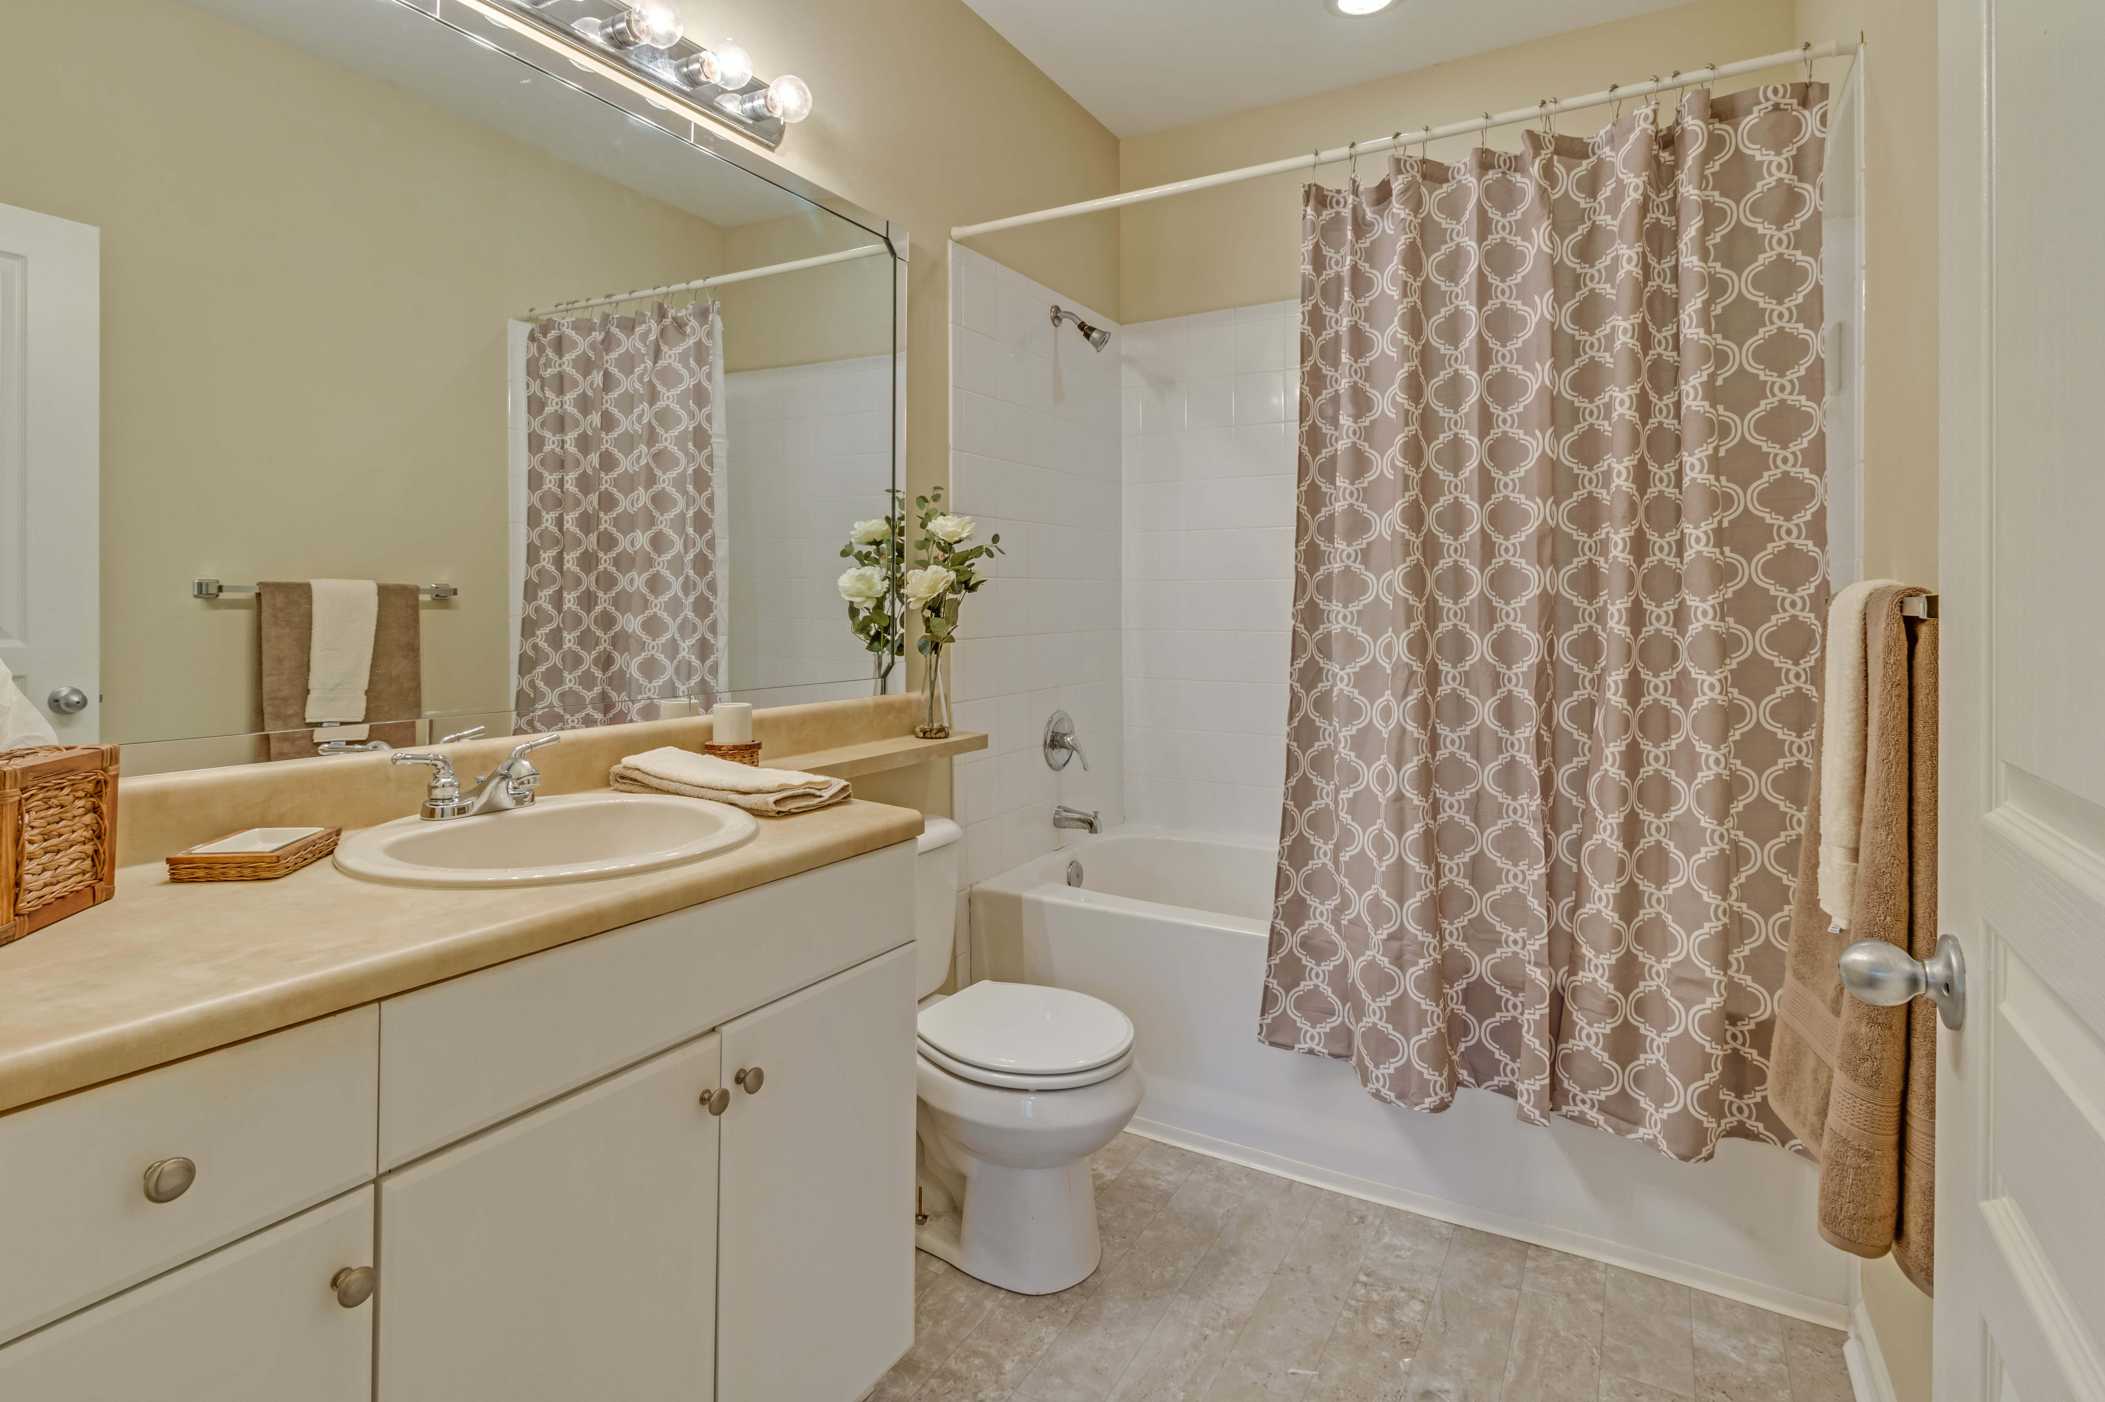
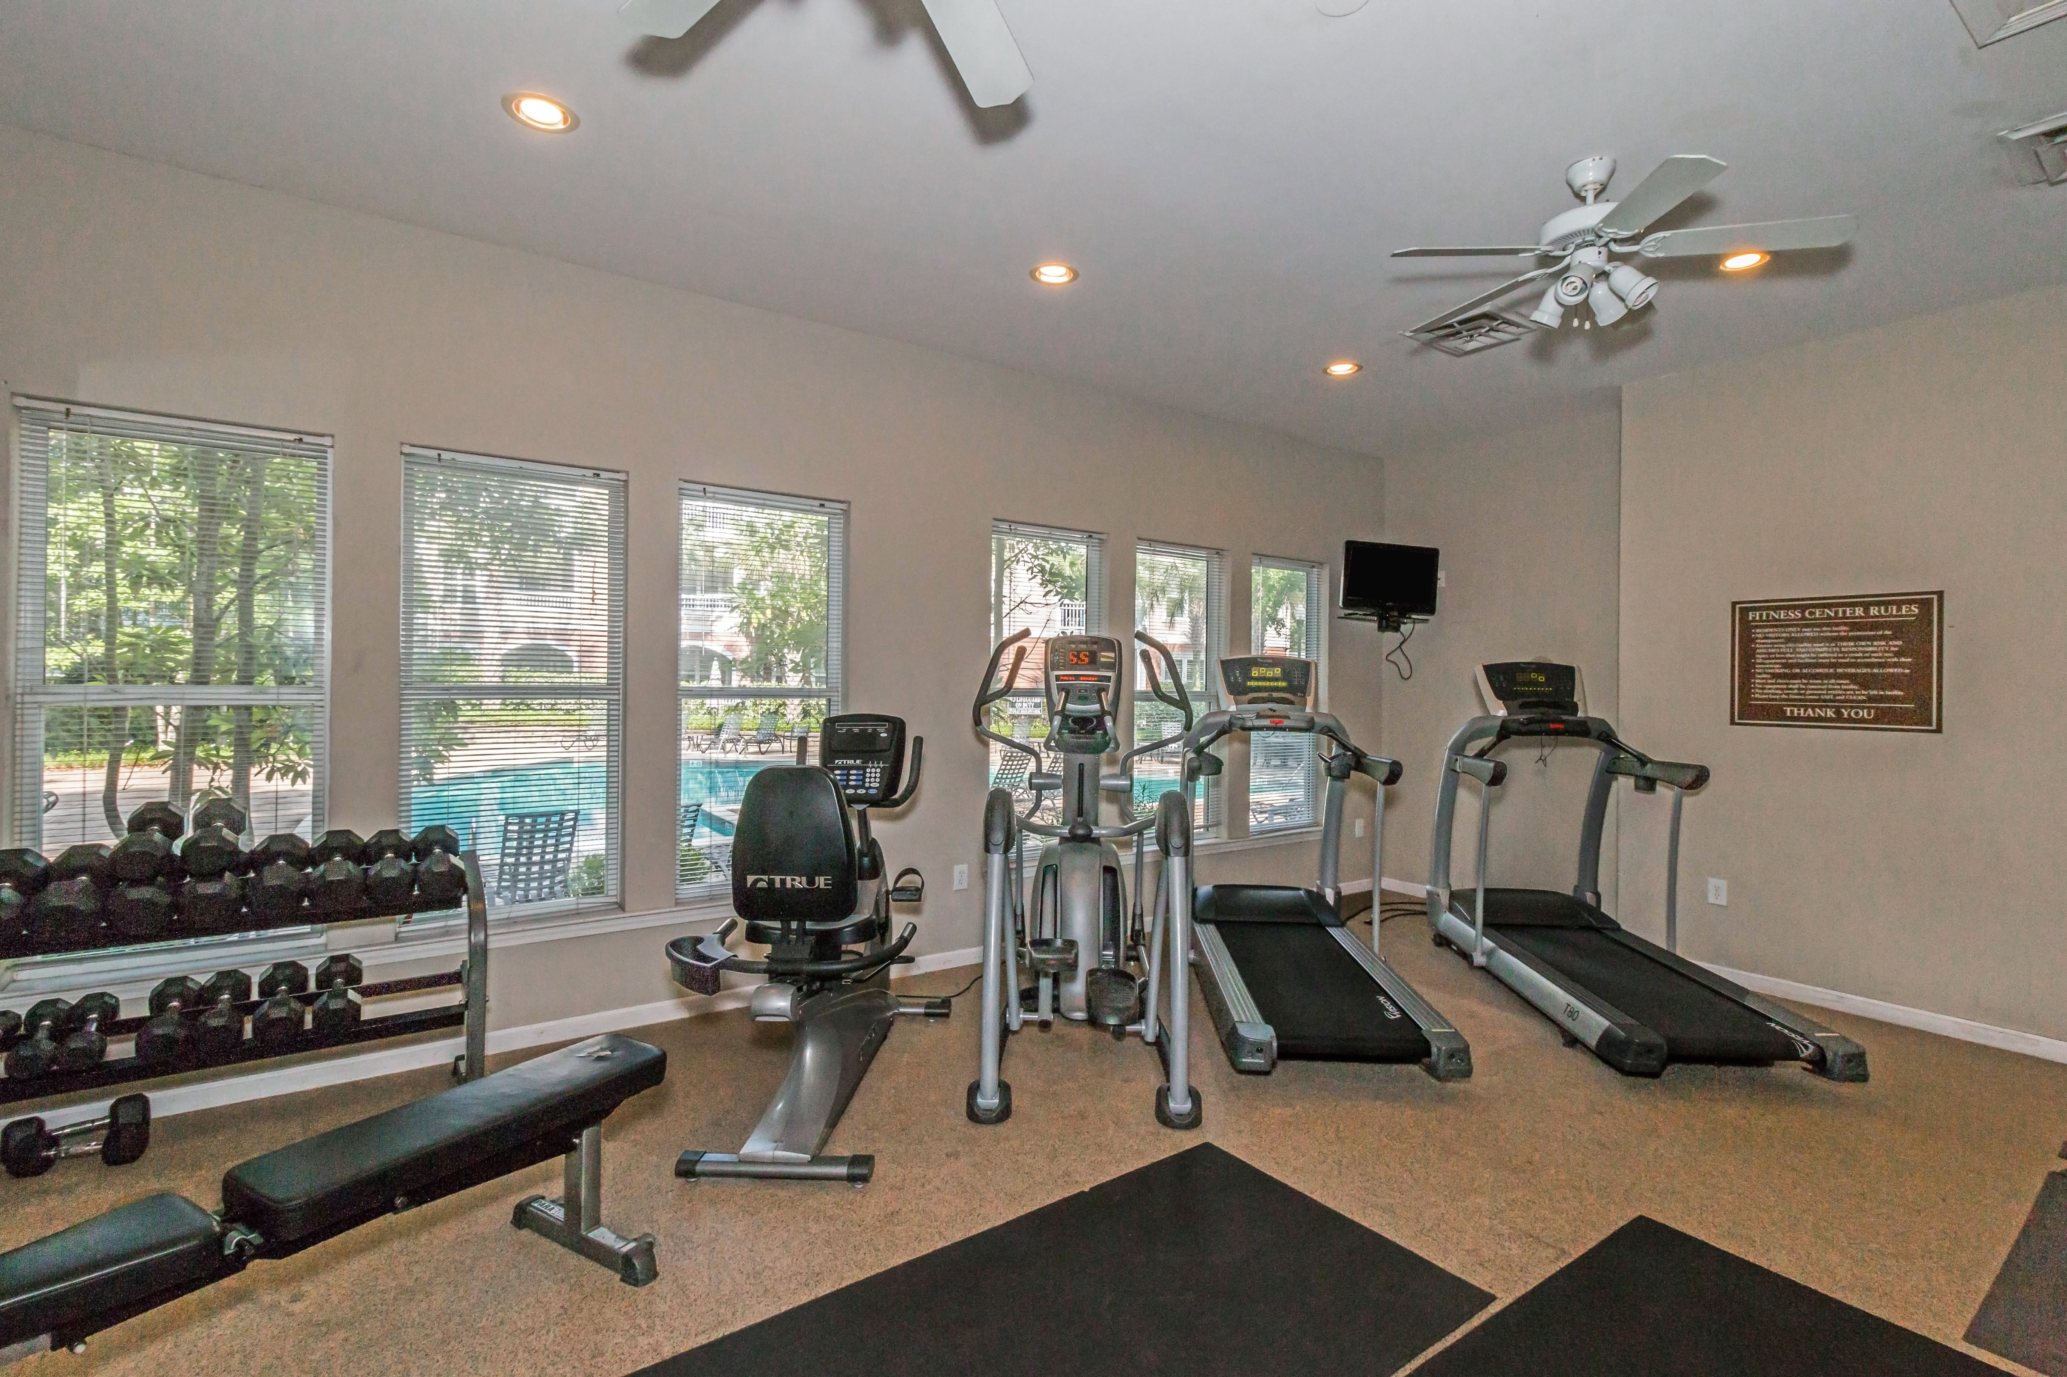
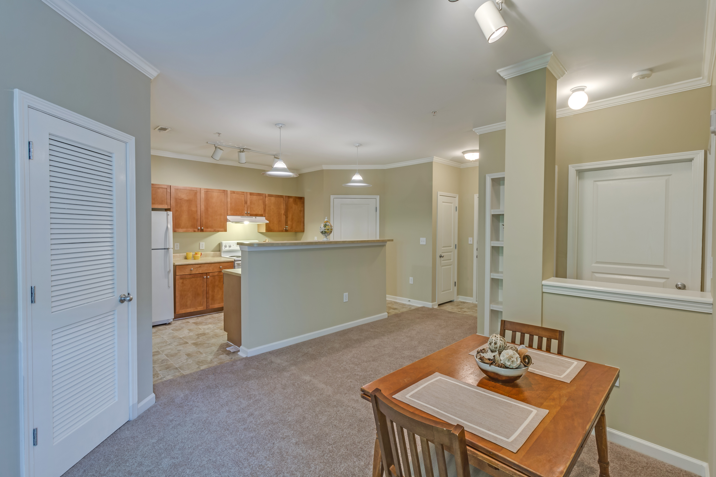
“Charleston is your forever love. It is a perfect blend of character and class. There is always something, but not too much. It is playful and it romances you.”
– Rebekah Phillips
Heather Lord
Broker Associate GRI, e-PRO, RSPS
Keller Williams Realty Charleston
www.heatherlord.com
heather@heatherlord.com
Phone: 843.810.9414

