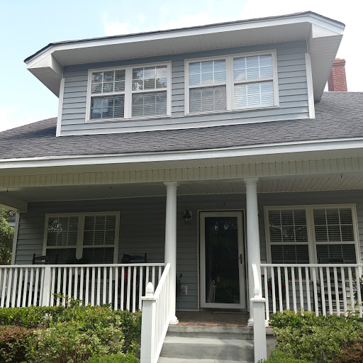  OPEN HOUSE  August 25, 2018 1:00 p.m. – 4:00 p.m.  Welcome to this beautiful home located in a great neighborhood. Enjoy your evenings while sitting on the front porch facing 244 Saint Margaret Street. This home has 2 bedrooms and two bathrooms. There is an additional home located on 6th Avenue(64 – 6th Avenue, Charleston, SC 29403) The attached home has 2 bedroom and 1 bathroom.  Listed for $790,000. MLS# 18017840 – Multi Family Unit  MLS# 18017921 - Residential | 64 – 6th Avenue  Charleston, SC 29403  Bedrooms - 4  Bathrooms – 3  Sq. Footage - 2724  ────  Great Location  Duplex – Extra Income  Full Front Porch  Across from Lowndes Grove Plantation  Close to Ashley River  Close to Hampton Park  Parking in the rear  Den/Office located off kitchen  This duplex can be easily converted to a single family home!  The Goodwin Group  P.O. Box 40926  Charleston, SC 29423  843-437-0351 - Cell  Tiffanie M. Jowers, Realtor  Opening the Door To Your Real Estate Needs

