Agent Open House & LUNCH
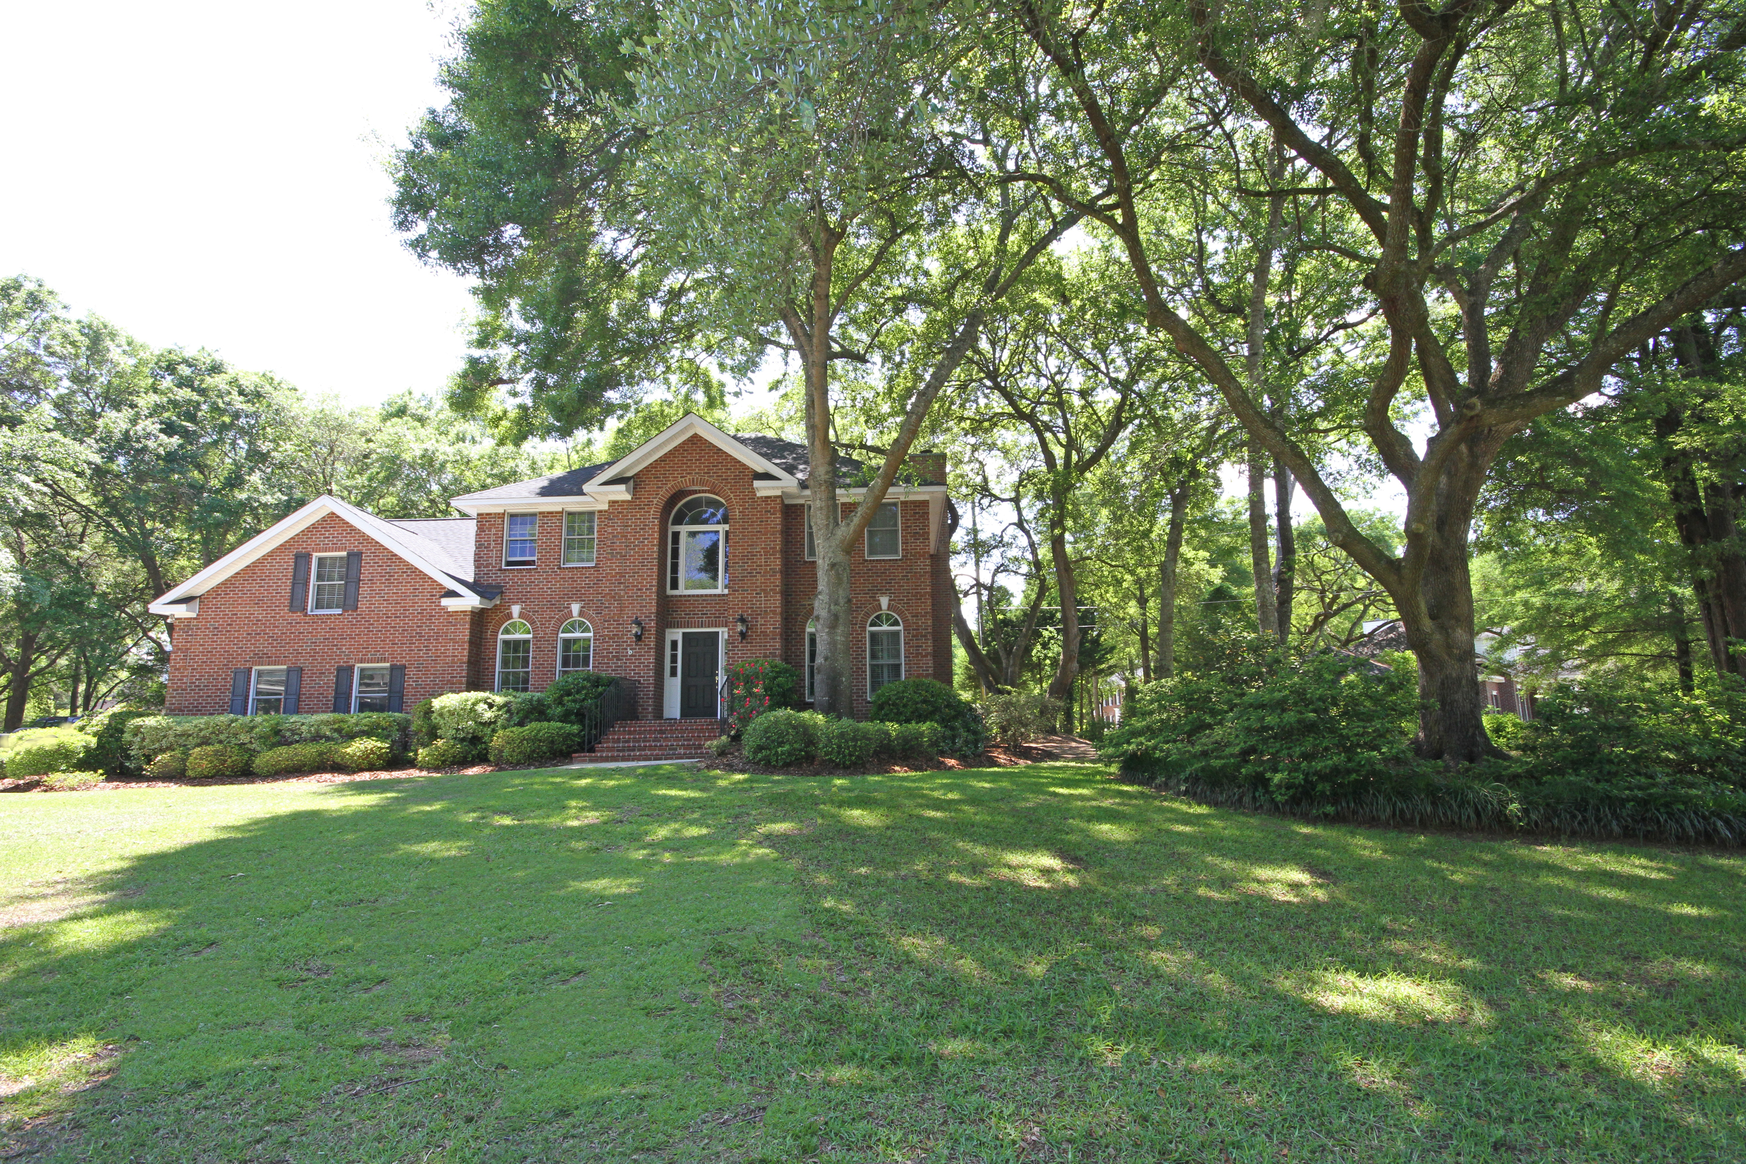
Thursday, June 4, 2015
10:00 AM – 1:00 PM

686 Cain Drive – Mt. Pleasant
Somerset Point

Hope to see you there!



Janet Newham - 843.860.9672 – jnewham@carolinaone.com

