SAE
For
Additional Information: Augue ut ergo reprobo
nulla esse roto, in, adipis ea autem rprobo distineo, tationaptent. Reprobo dolor tation facilisis, erat pagus capto, lucidus aptent, esse pecus imputo lorem eta misca alit.
697 King Street
Charleston, SC 29403

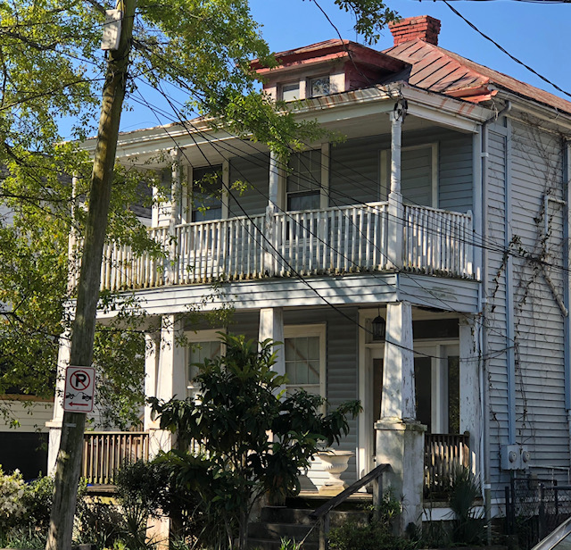
$580,000
King Street duplex zoned General Business. The possibilities are endless!! This could be a perfect live/work property. Both units have hardwood floors. The first level has a rear room and bath that is accessible from the rear yard and could be used as an office/studio space. The first floor has a living room, dining area and kitchen. The second floor is a one bedroom/one bath unit that has a living room and eat-in kitchen. There is off street parking and a very nice sized rear yard. This is a renovation project. Vacant and easy to show.

Duplex
Zoned General Business
Located in the Opportunity Zone
Year Built: 1930
3 Total Bedroom(s)
3 Total Bath(s)
Approx. 1,911 sq. ft.
Crawl Space Foundation

Renata Smalls
www.thespacecompany.com
843-577-2676 office
843-864-3990 mobile



