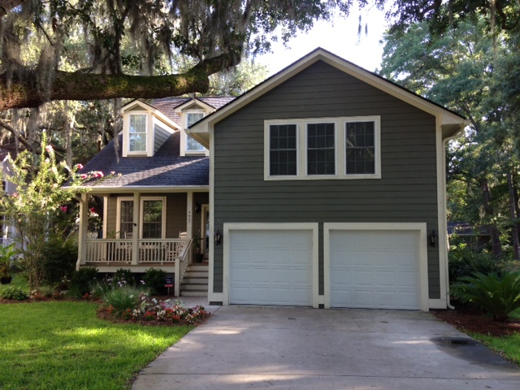
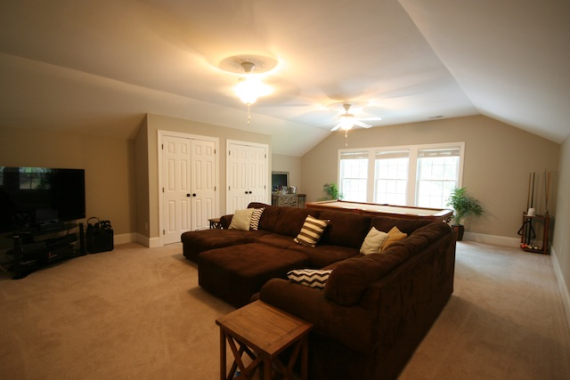
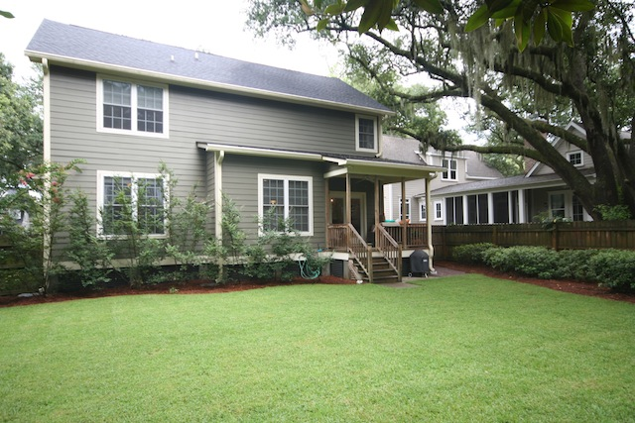
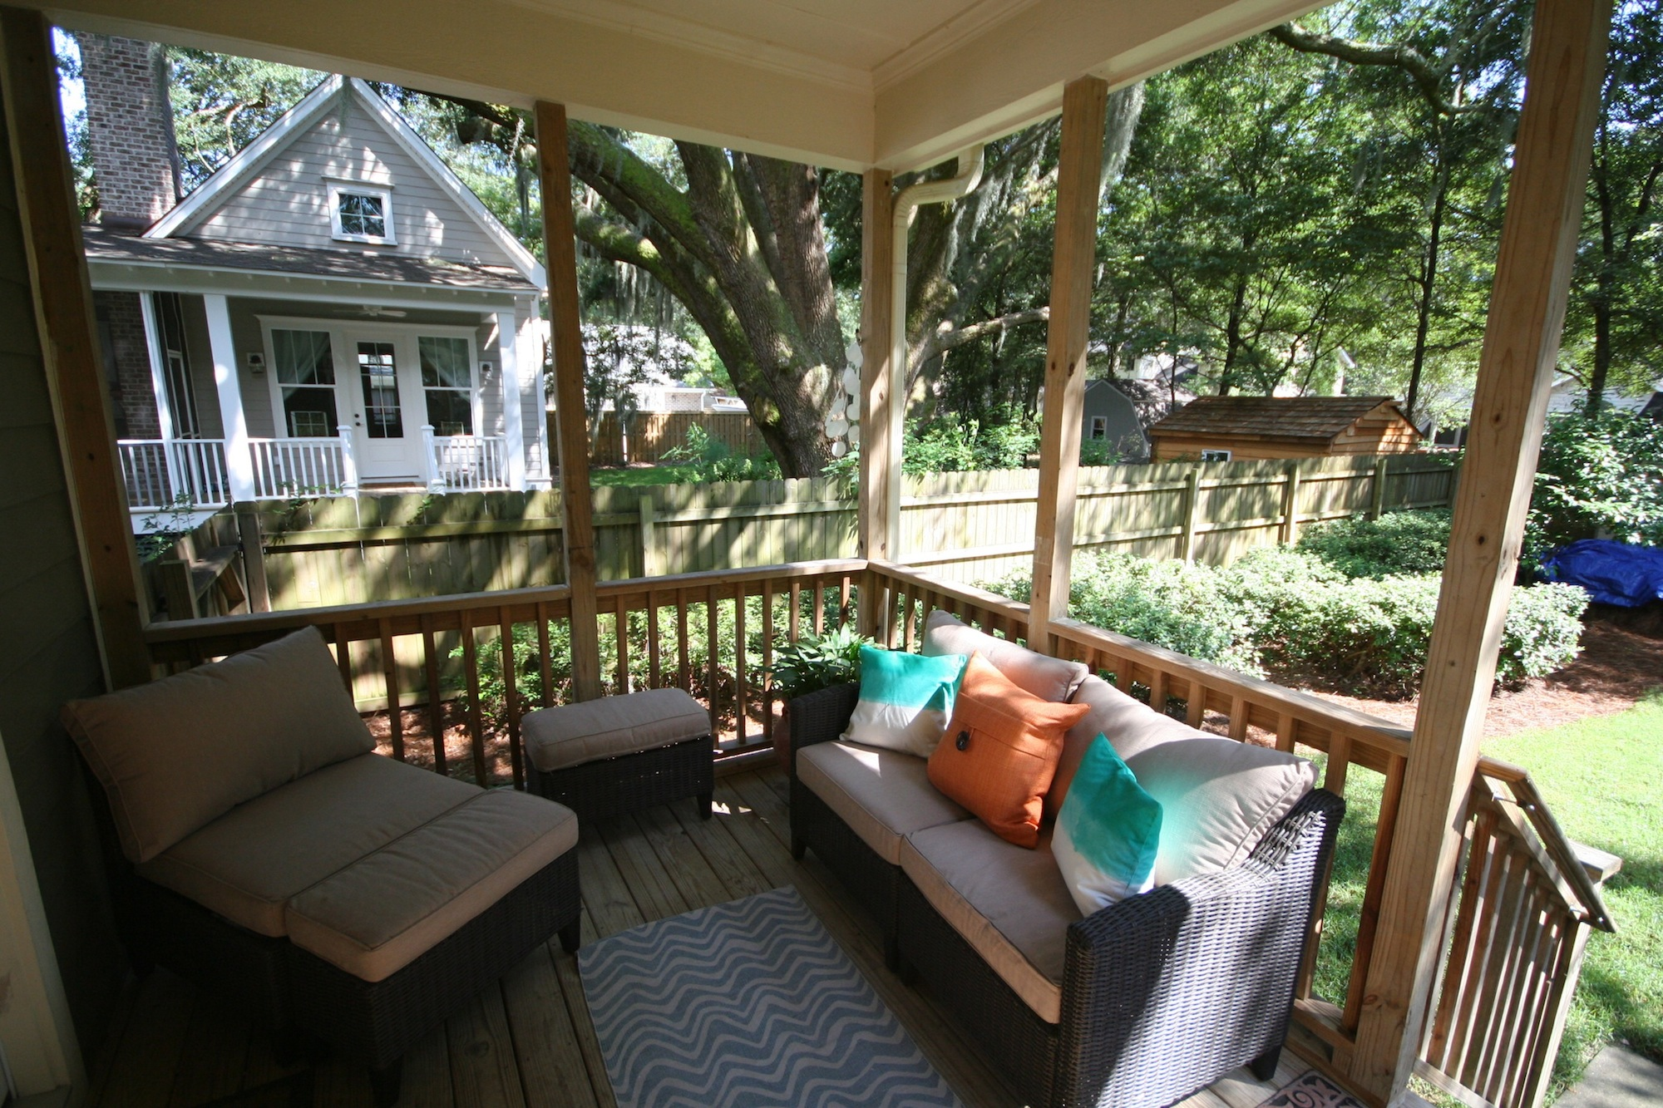
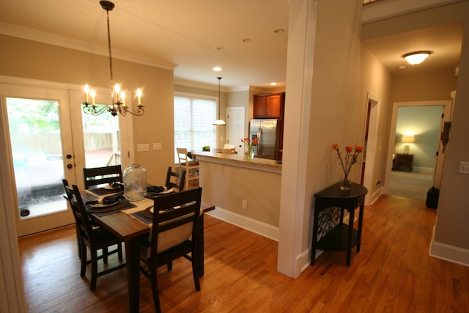
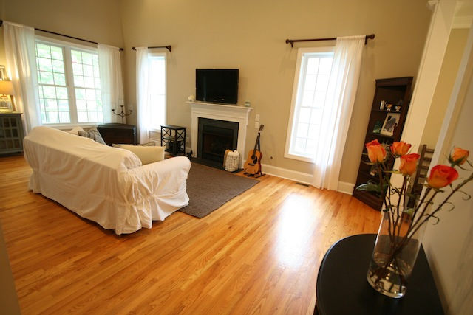
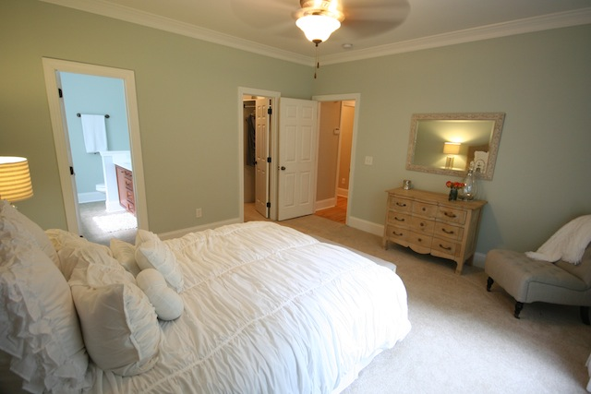
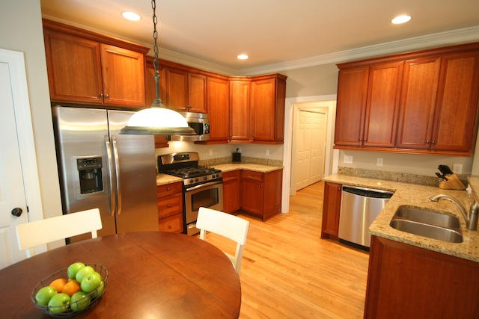

James Island 777 Canopy cove- $464,000
JUST LISTED! 4br+Bonus Rm, 2.5Ba home is a rare opportunity for ownership in one of James Islands newest and most sought after neighborhoods. Carolina Oaks is a small enclave of custom built homes located on a culdesac with a streetscape of gorgeous old Oak trees. Features include large bonus room with multiple closets to meet all your storage needs (perfect for media rm, gym, or 5th br), generously sized bedrooms with large closets, gas FP, site finished hardwood floors throughout the first floor except in the master, wood tread stairs, ceramic tile floors in all bathrooms and laundry, 42” maple kitchen cabinets with crown molding and light rail, granite kitchen countertops, GE profile stainless appliances including gas double oven/range w/ convection oven, refrigerator and microwave, upgraded oil rubbed bronze lighting and door hardware, 9 foot smooth ceilings, beautiful crown moldings, cement plank siding, gutters, tankless gas hwh, covered back porch, security system, finished garage w/ openers and exterior coded entry pad. The owners suite boasts brand new custom closet, deluxe bath with jetted tub & glass shower w/ frameless shower door, and raised double vanity. The oversized backyard is perfect for entertaining your guests, is enclosed with a wood privacy fence, and features a wood storage building for increased organization. The beautiful grand oak in the front and magnolia tree in the backyard welcome you with southern charm to this beautifully landscaped property which is sodded and has irrigation in the front and back. Faux wood blinds to be included on most windows. Flood zone X (no flood insurance required), conveniently located less than 10 minutes to historic downtown Charleston and Folly Beach, and is zoned for the best public schools on James Island!
$2,000 Agent Bonus!!
*See listing for details

Call today to request a tour of this home
*By appointment only. Minimum 24hr advance notice.

843-557-7337
Brandi Metcalfe

Owner is agent. Buyers agents welcome!

E

D

F

C

B

A

