OPEN HOUSE July 1 & 2 11am to 3pm

7 Simonton Mews
Morris Square ~ Charleston, SC 29403 ~ MLS# 17003777 ~ $799,000

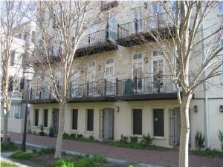

Impressive 3 BR, 2.5 BA townhouse in Morris Square with ELEVATOR and 2-car GARAGE PARKING on first level (rare in downtown Charleston). There are also 2 residential street parking decals available for the unit. In addition to world-class dining, you can step outside your front door and enjoy everything downtown Charleston has to offer including the vibrant Upper King and Cannon Street neighborhoods, Saturday Farmer's Market, Second Sundays, the experience of Spoleto, the feel of history, the taste of Charleston Food and Wine Festival, and the sounds of worldwide artists at the newly rebuilt Gaillard Center! College of Charleston, MUSC, Ashley Hall and the Citadel are all world class schools within your vicinity and all in walking distance. Renewed City owned park in front of unit meticulously groomed by the city parks commission. There is a large living room/dining area that flows into the kitchen. Hardwood floors throughout. Great counter space and storage, granite countertops, top of the line stainless steel appliances. The second floor has 2 bedrooms, laundry (washer/dryer conveys), & a full bath. Master suite is the entire top floor- separate dressing area flows into the bath with water closet, huge walk-in closet, garden tub and separate shower. 2 terraces to enjoy the park views and much more!

Randy Bazemore, REALTOR
Office - (843) 277-6677 | Mobile - (843) 524-6900
randybazemore99@gmail.com

Century 21 Properties Plus | 2000 Sam Rittenberg Blvd #118 | Charleston, SC 29407
http://rbazemore.century21properties.com

