80 ALEXANDER STREET
Home of the Liberty Tree and the birthplace of American Independence
$2,645,000

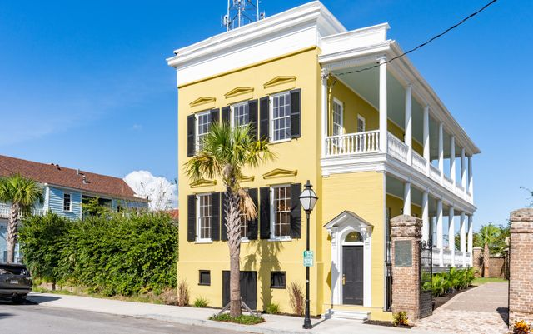
Built in 1805, 80 Alexander Street is the site of the Liberty Tree, where American independence
was first proposed and where the Declaration of Independence was first read to Charlestonians.

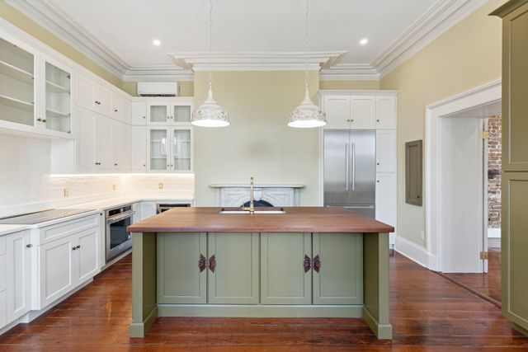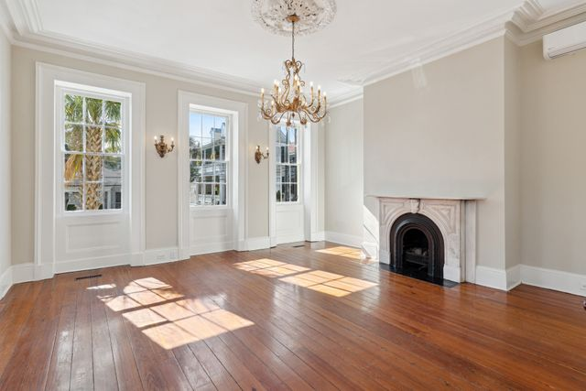
Located in the heart of historic Charleston. Close to everything the city has to offer.

All new plumbing, all new HVAC, updated electrical, new rear roof, new sinks & vanities,
new faucets, new soaking tub, new toilets, new tankless gas water heater, new recessed lighting,
new kitchen with brand new cabinets and appliances, new bathrooms with custom tile.

Original heart pine floors, original crown molding, original ceiling medallion, 11 ft. + ceilings,
double piazzas, oversized windows, antique lighting fixtures, marble fireplace mantles,
generously proportioned rooms, both original and reproduction door hardware.

CONTACT: John Johansen 843-801-7463

