898 1/2 Ashley Avenue
Wagener Terrace ~ Charleston, SC 29403
SAE
For
Additional Information: Augue ut ergo reprobo
nulla esse roto, in, adipis ea autem rprobo distineo, tationaptent. Reprobo dolor tation facilisis, erat pagus capto, lucidus aptent, esse pecus imputo lorem eta misca alit.


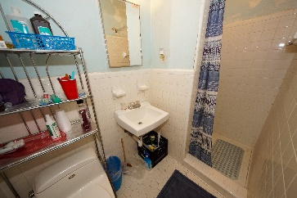
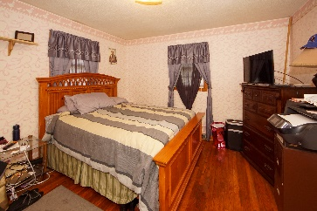
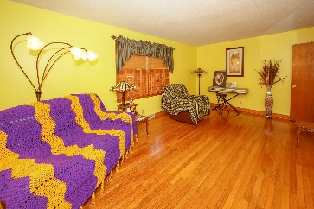
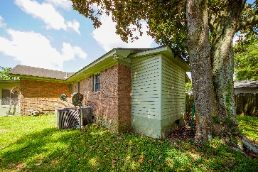
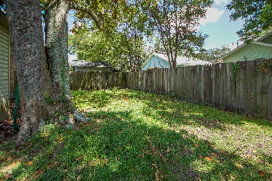
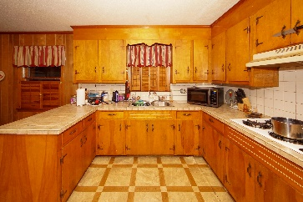
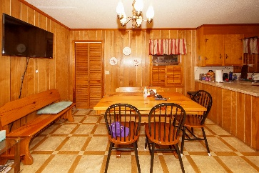
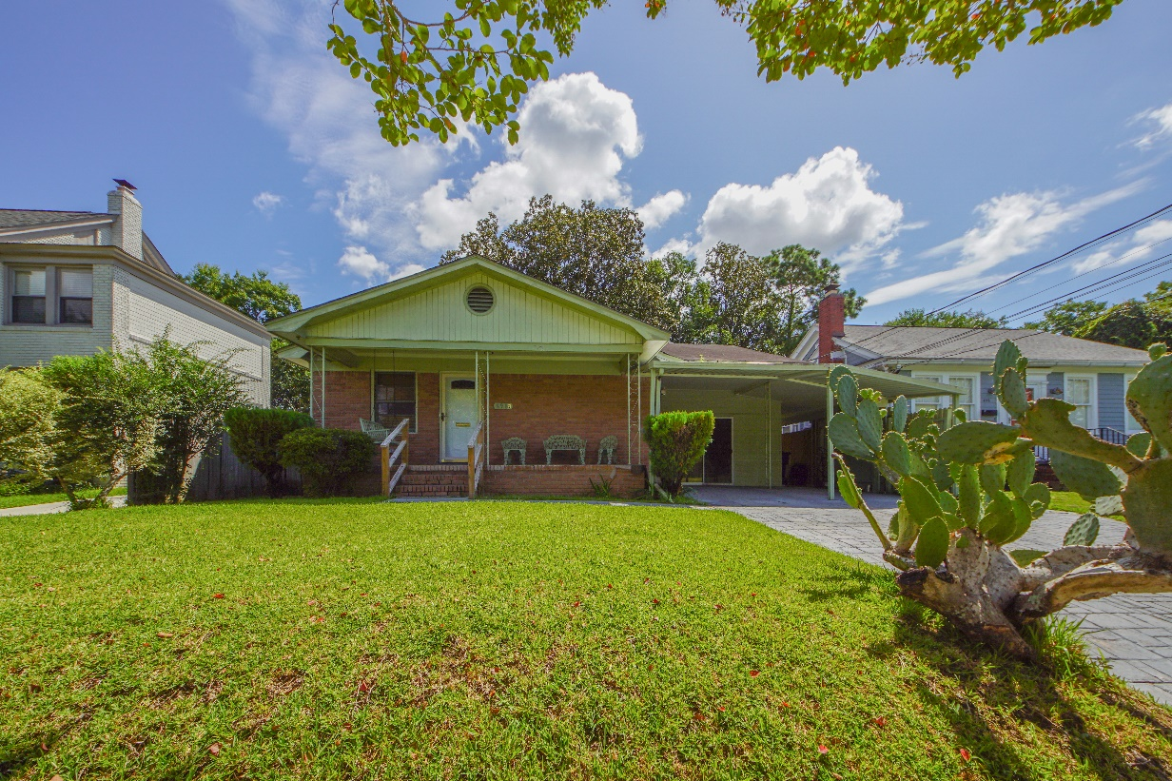
Improved Price!
$445,000
Traditional Charleston home in an excellent area close to downtown, Hampton Park, The Citadel and I26. Three bedrooms, two full baths large eat-in kitchen and laundry room. There is a nice back yard, front porch and carport. Low maintenance exterior.
Make this your dream home.
Debbie Abraham
delaine52@aol.com
www.thespacecompany.com
843-607-2055
- MLS# 19023819
- Single Family Detached
- Charleston Peninsula
- Bedrooms: 3
- Baths: 2
- 1 Story
- Year Built: 1968
- Apx. SqFt: 1,524

