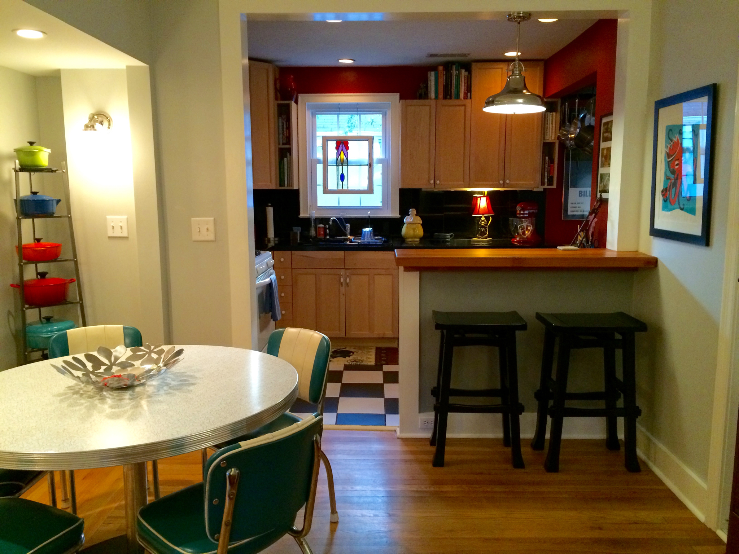
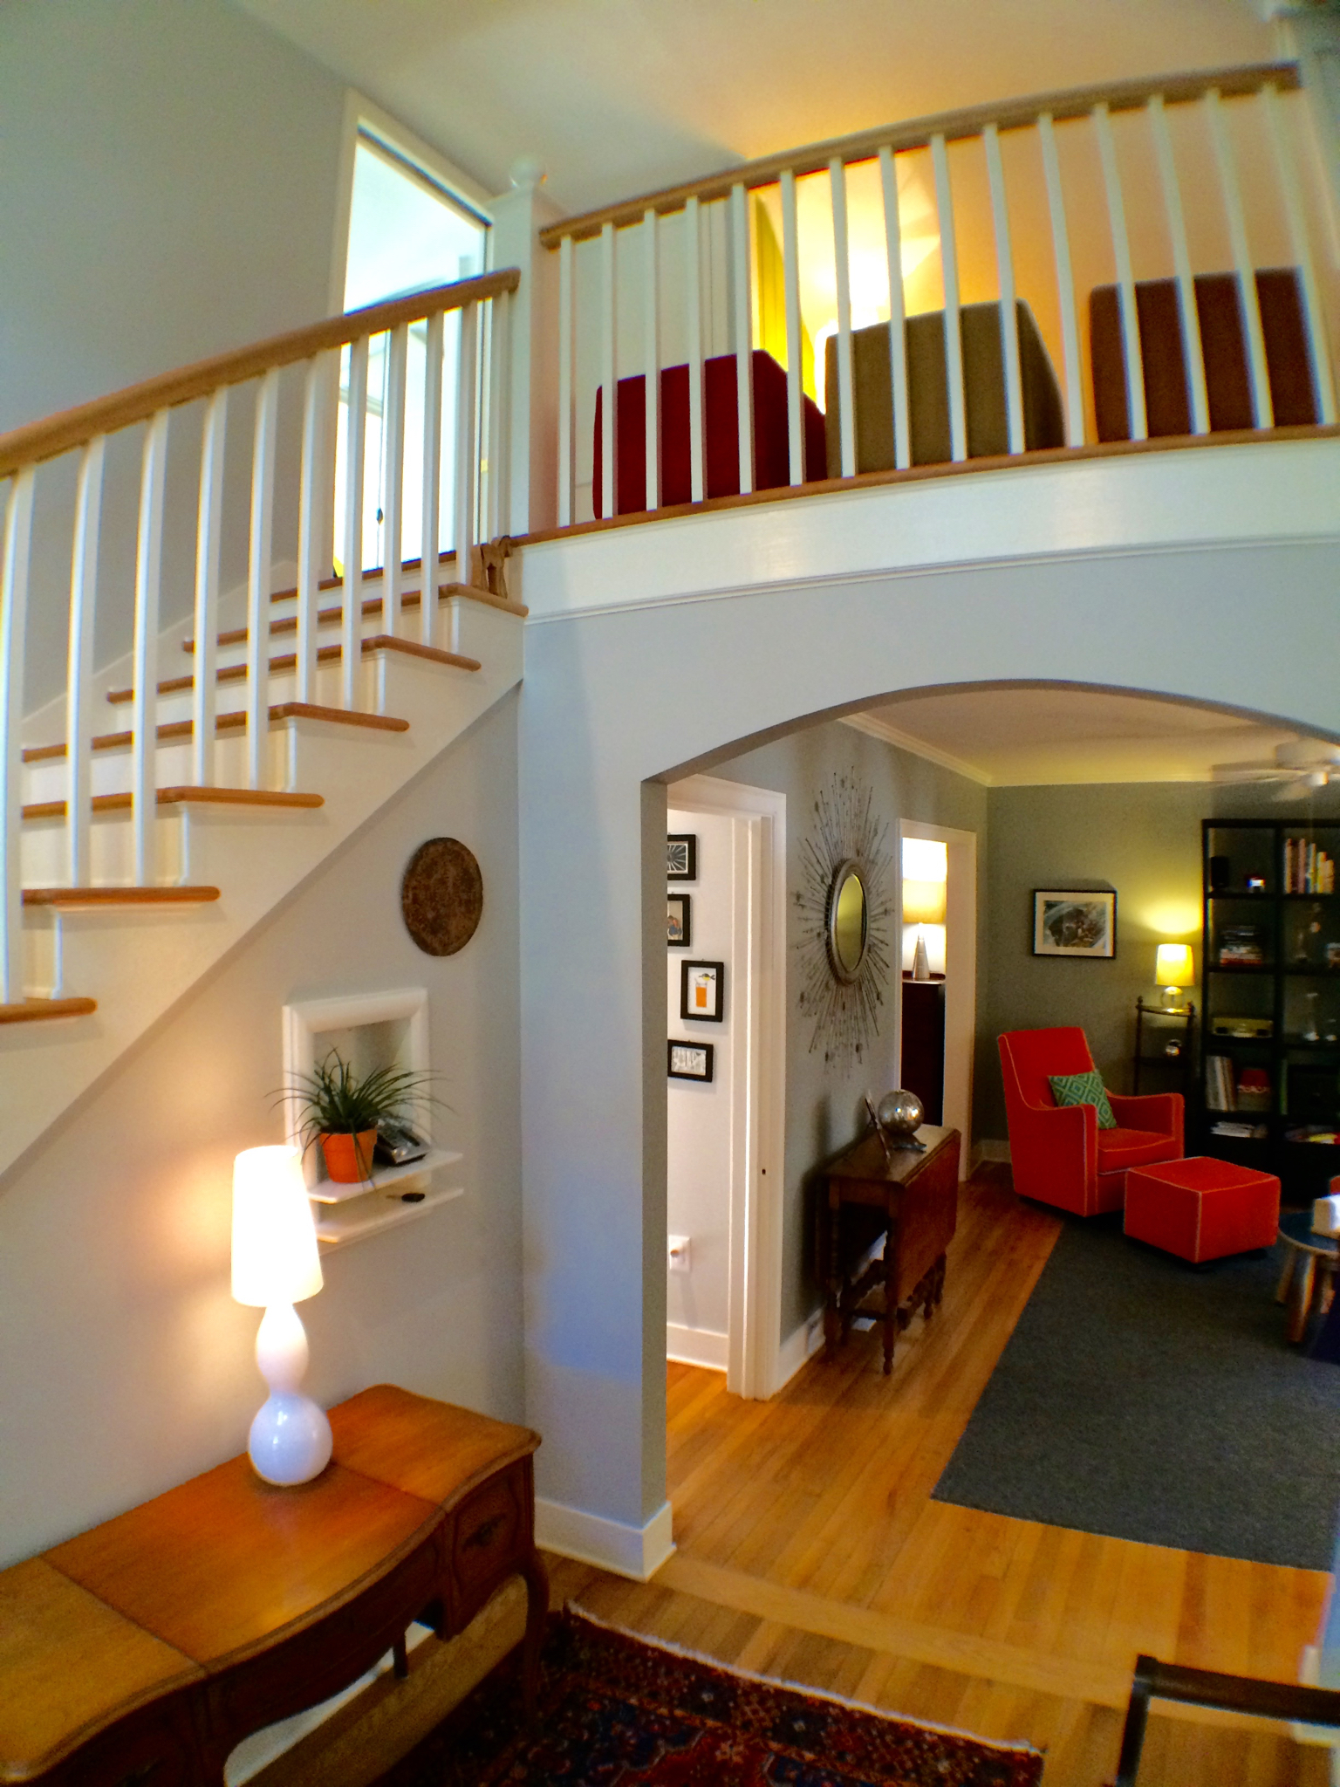
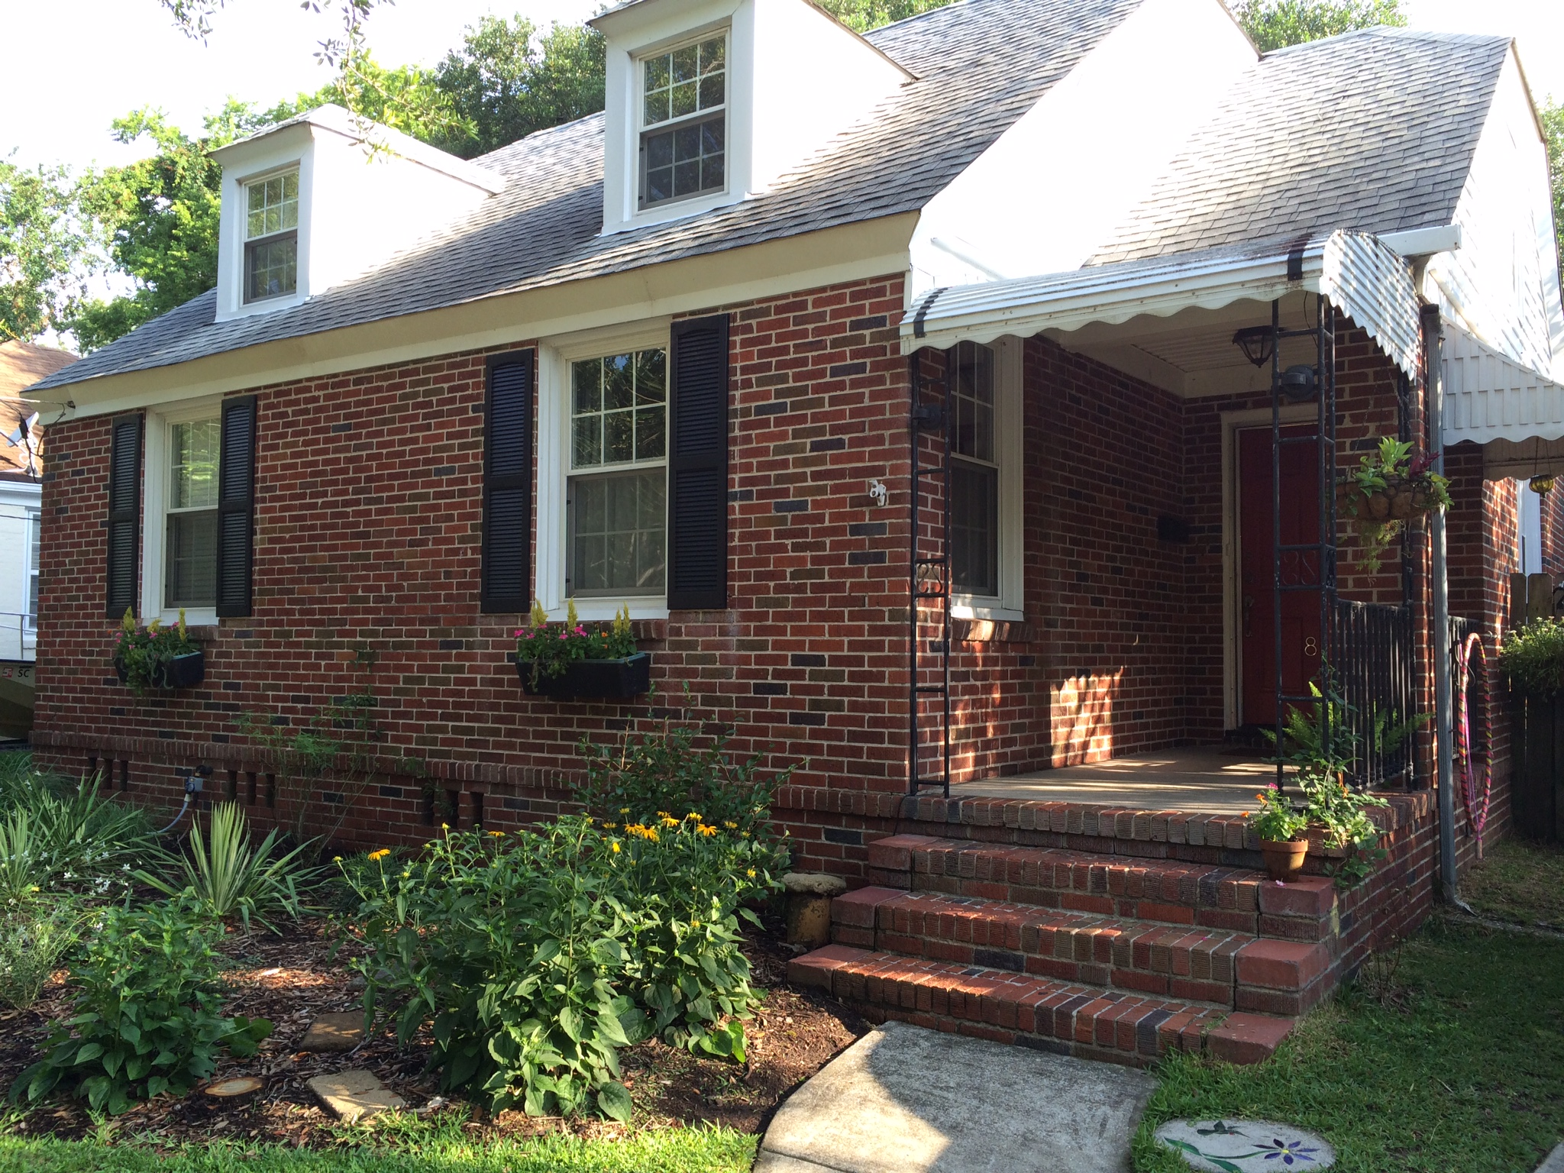
This stylish and well-maintained historic bungalow, located in Byrnes Downs, is just steps away from the vibrant dining and shopping areas of Avondale Point and South Windermere. The West Ashley Greenway is just a few doors down and provides a beautiful 10-mile pathway for walking and biking. This is the perfect place to keep your car parked all weekend long.

8 lyttleton
ANDREA
WOODFIELD

843.442.7442
ANDREA@
ANDREAWOODFIELD.COM


$400,000 - 1572 sf

3 Bedroom / 2 Full Bath
- Huge, detached 2-car garage
- Off-street parking
- Spacious decking
- Huge grand oak in backyard
- Remodeled, open kitchen with heart pine bar, granite countertops, and designer lighting
- Stunning 16’ ceiling in stairwell at entry of home
- Abundant natural light
- Original vintage bathroom fixtures
- Thermal, double-hung windows throughout
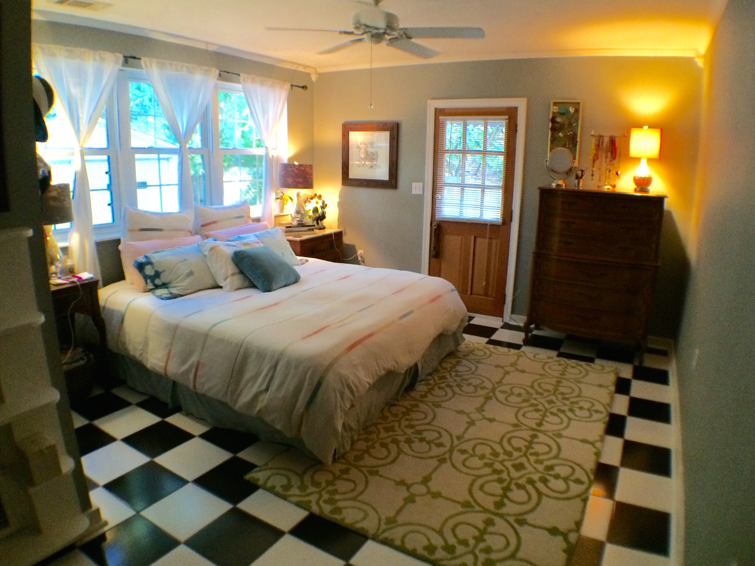
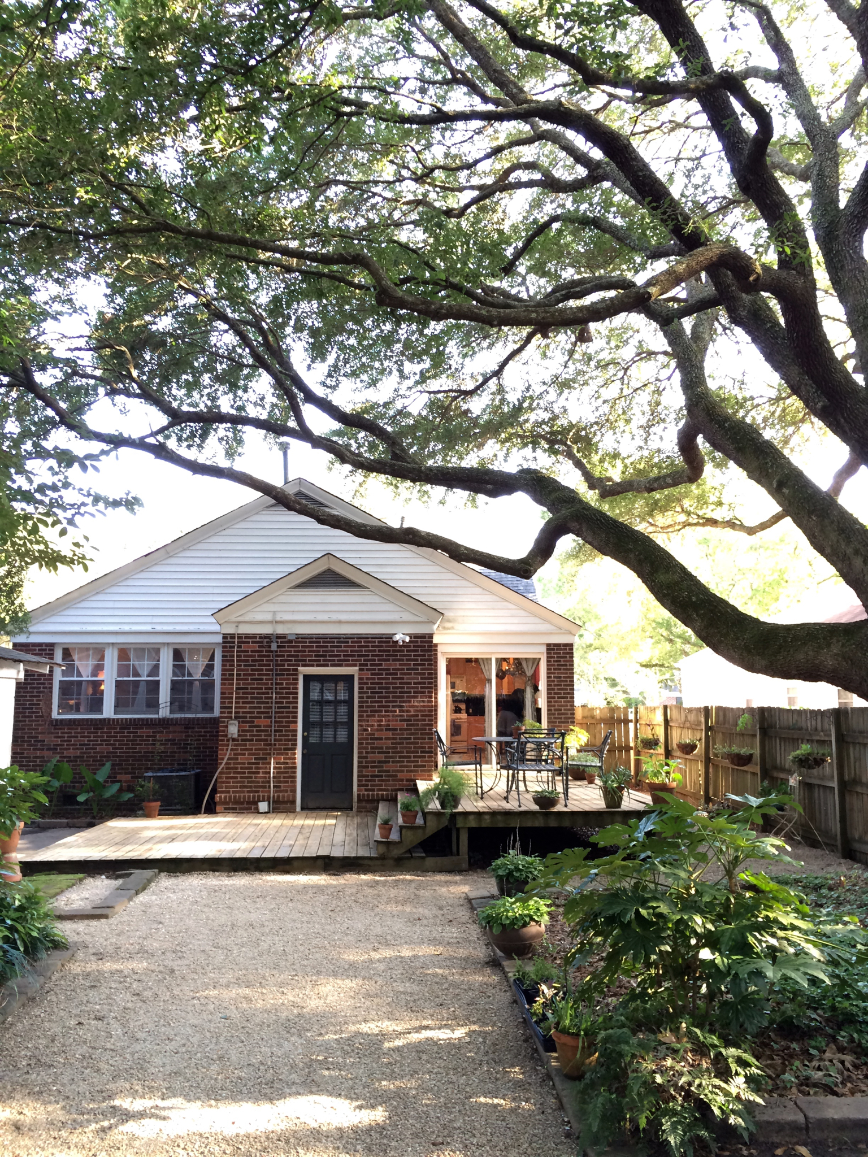
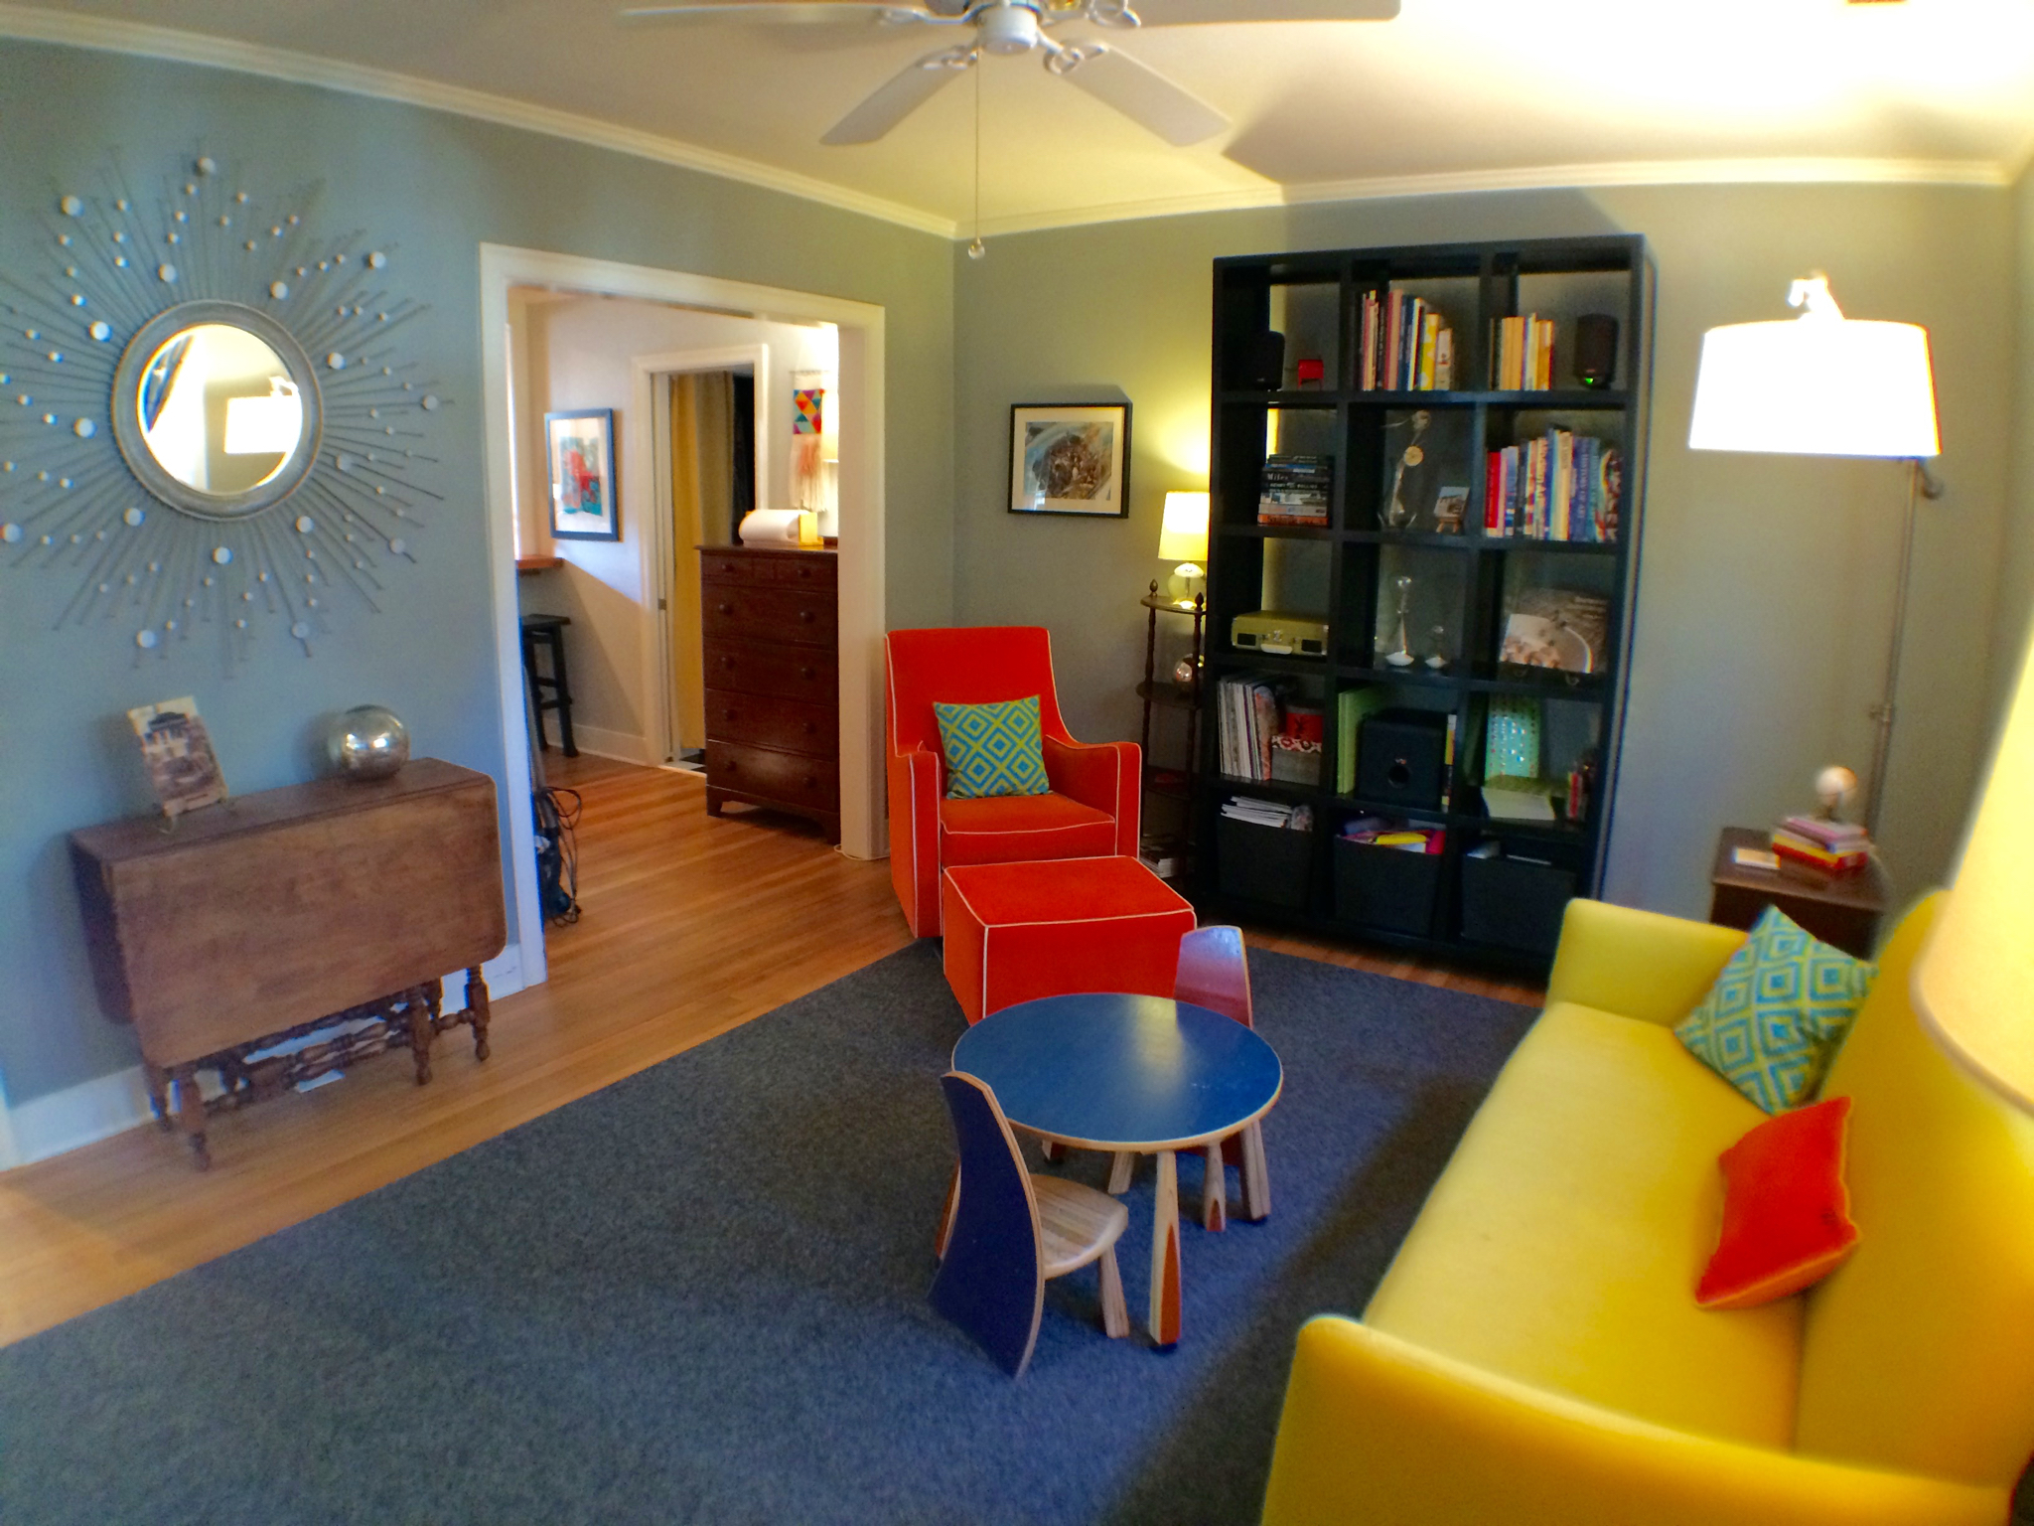
- Hardwood, ceramic tile, and cork flooring
ANDREA
WOODFIELD

843.442.7442

ANDREA@
ANDREAWOODFIELD.COM
- Large master bedroom with ensuite bath and laundry
- Media loft
- Cedar closets with built-in shelves
- New, fully grounded electrical wiring, dimmer light switches throughout
- Brand new HVAC unit
- Professional, irrigated landscaping
- Fully fenced
- Encapsulated crawl space with dehumidifier
- Transferrable termite bond
- Assumable flood insurance policy
- Active neighborhood civic club ($10/year)

