




T

- 3BDR/2BA MIDDLETON PLAN
- 2 CAR GARAGE
- CUL DE SAC LOT
- GLEAMING NEW HARDWOODS
- NEW WINDOW BLINDS
- UPDATED KITCHEN
- INCLUDED LAWN MAINTENANCE
- CLUBHOUSE ~ POOL~ TENNIS COURTS ~ PLANNED EVENTS

AGENTS PLEASE DO NOT MISS THIS HOME WORTH YOUR CLIENTS TIME AND PRICED TO SELL!

WELCOME HOME TO THIS UPDATED – 1 STORY GEM ! THE ELMS OF CHARLESTON OFFERS: NATURAL SETTING WITH GRAND OAKS GALORE, CLUBHOUSE WITH POOL, TENNIS COURT, FULL TIME ACTIVITIES DIRECTOR!

UPGRADES INCLUDE: GLEAMING NEW HARDWOODS, 2013 ARCHITECTURAL SHINGLED ROOF, 2014 GARAGE DOOR & REMOTE, GRANITE COUNTER TOPS, DECORATIVE BACK SPLASH, NEW WINDOW BLINDS, & MORE ….. MOVE IN READY!

THE ELMS IS CONVENIENTLY LOCATED LESS THAN 2 MILES TO I-26 – EVEN CLOSER TO MEDICAL FACILITIES, RESTAURANTS, AND TRIDENT MEDICAL CENTER.

Welcome Home to The ELMS OF CHARLESTON~ Gorgeous, Gated, 55+ Active Adult Community

9122 Lafayette Ct
MLS # 15027436
Offered at $199,900
FACTS & FEATURES

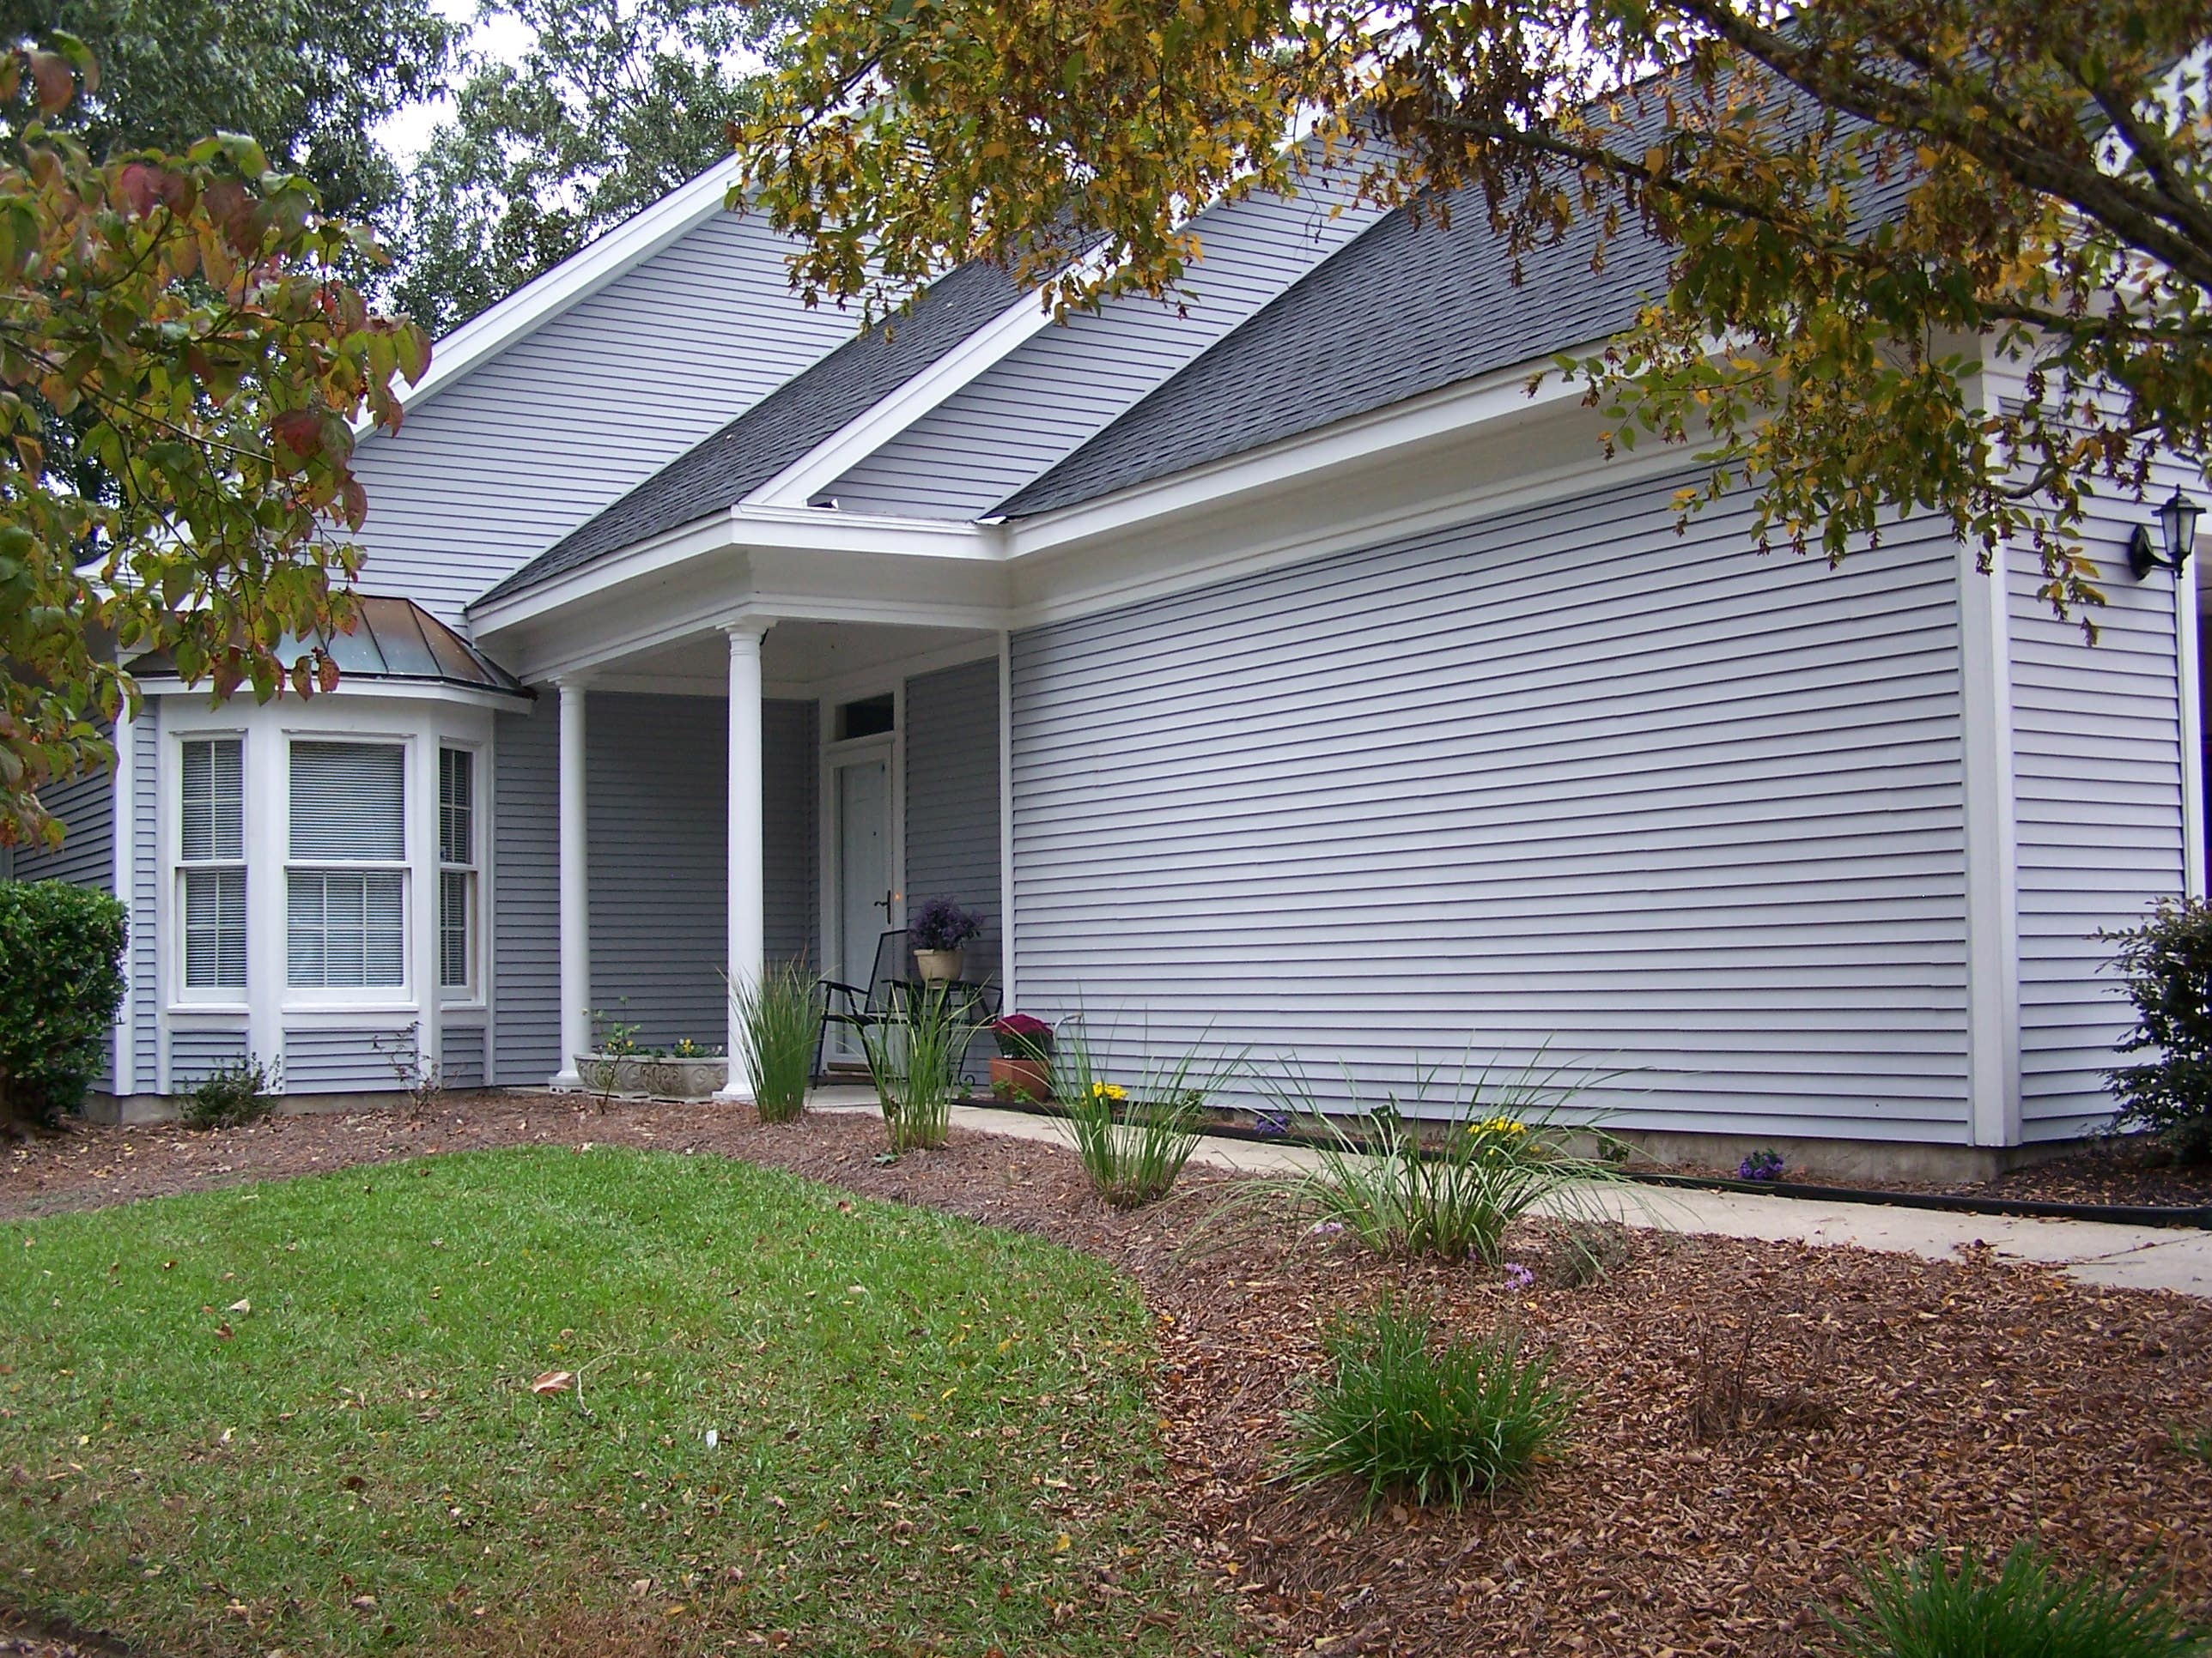
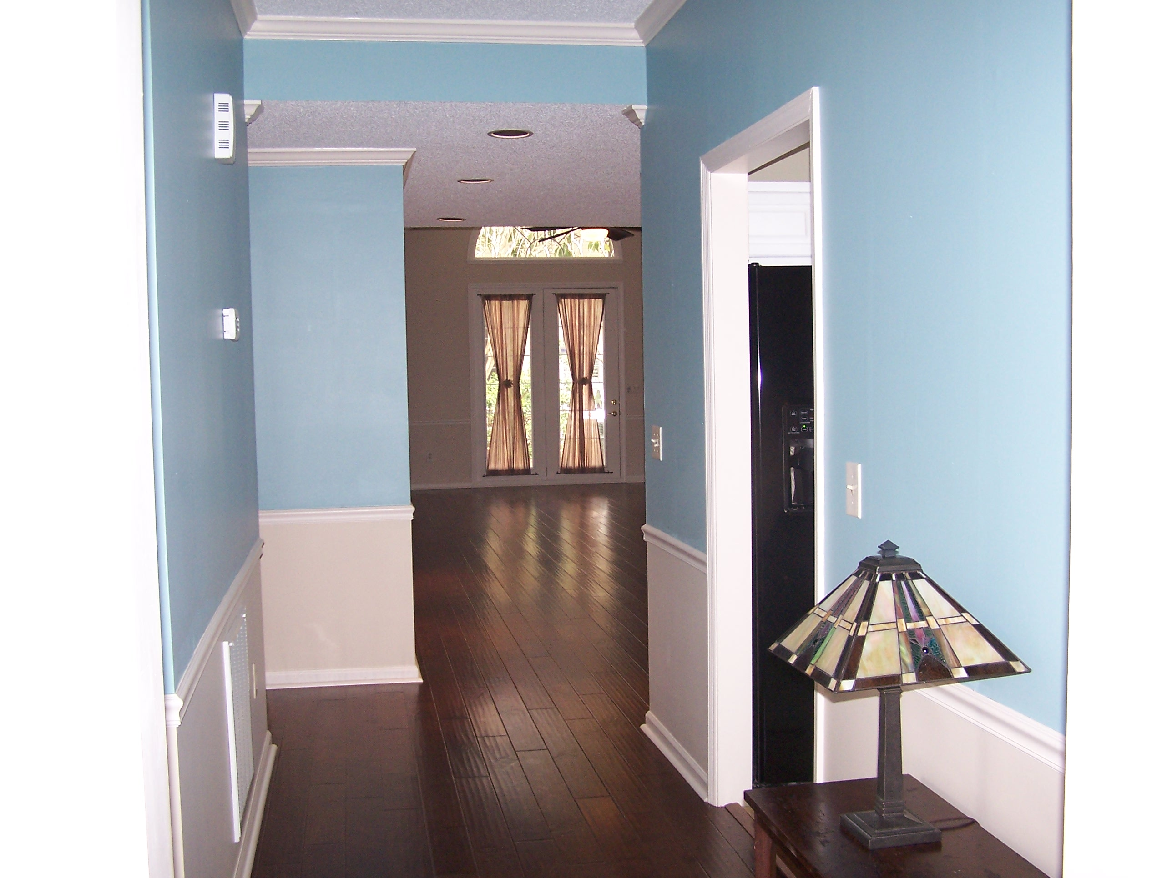
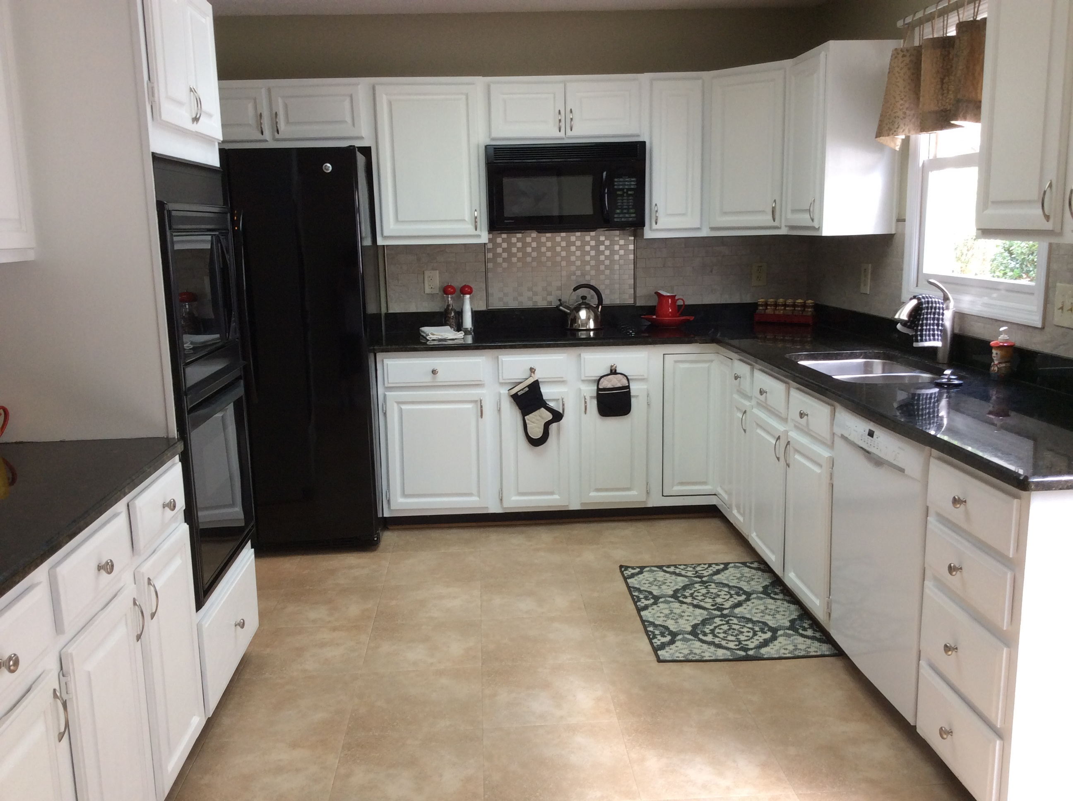
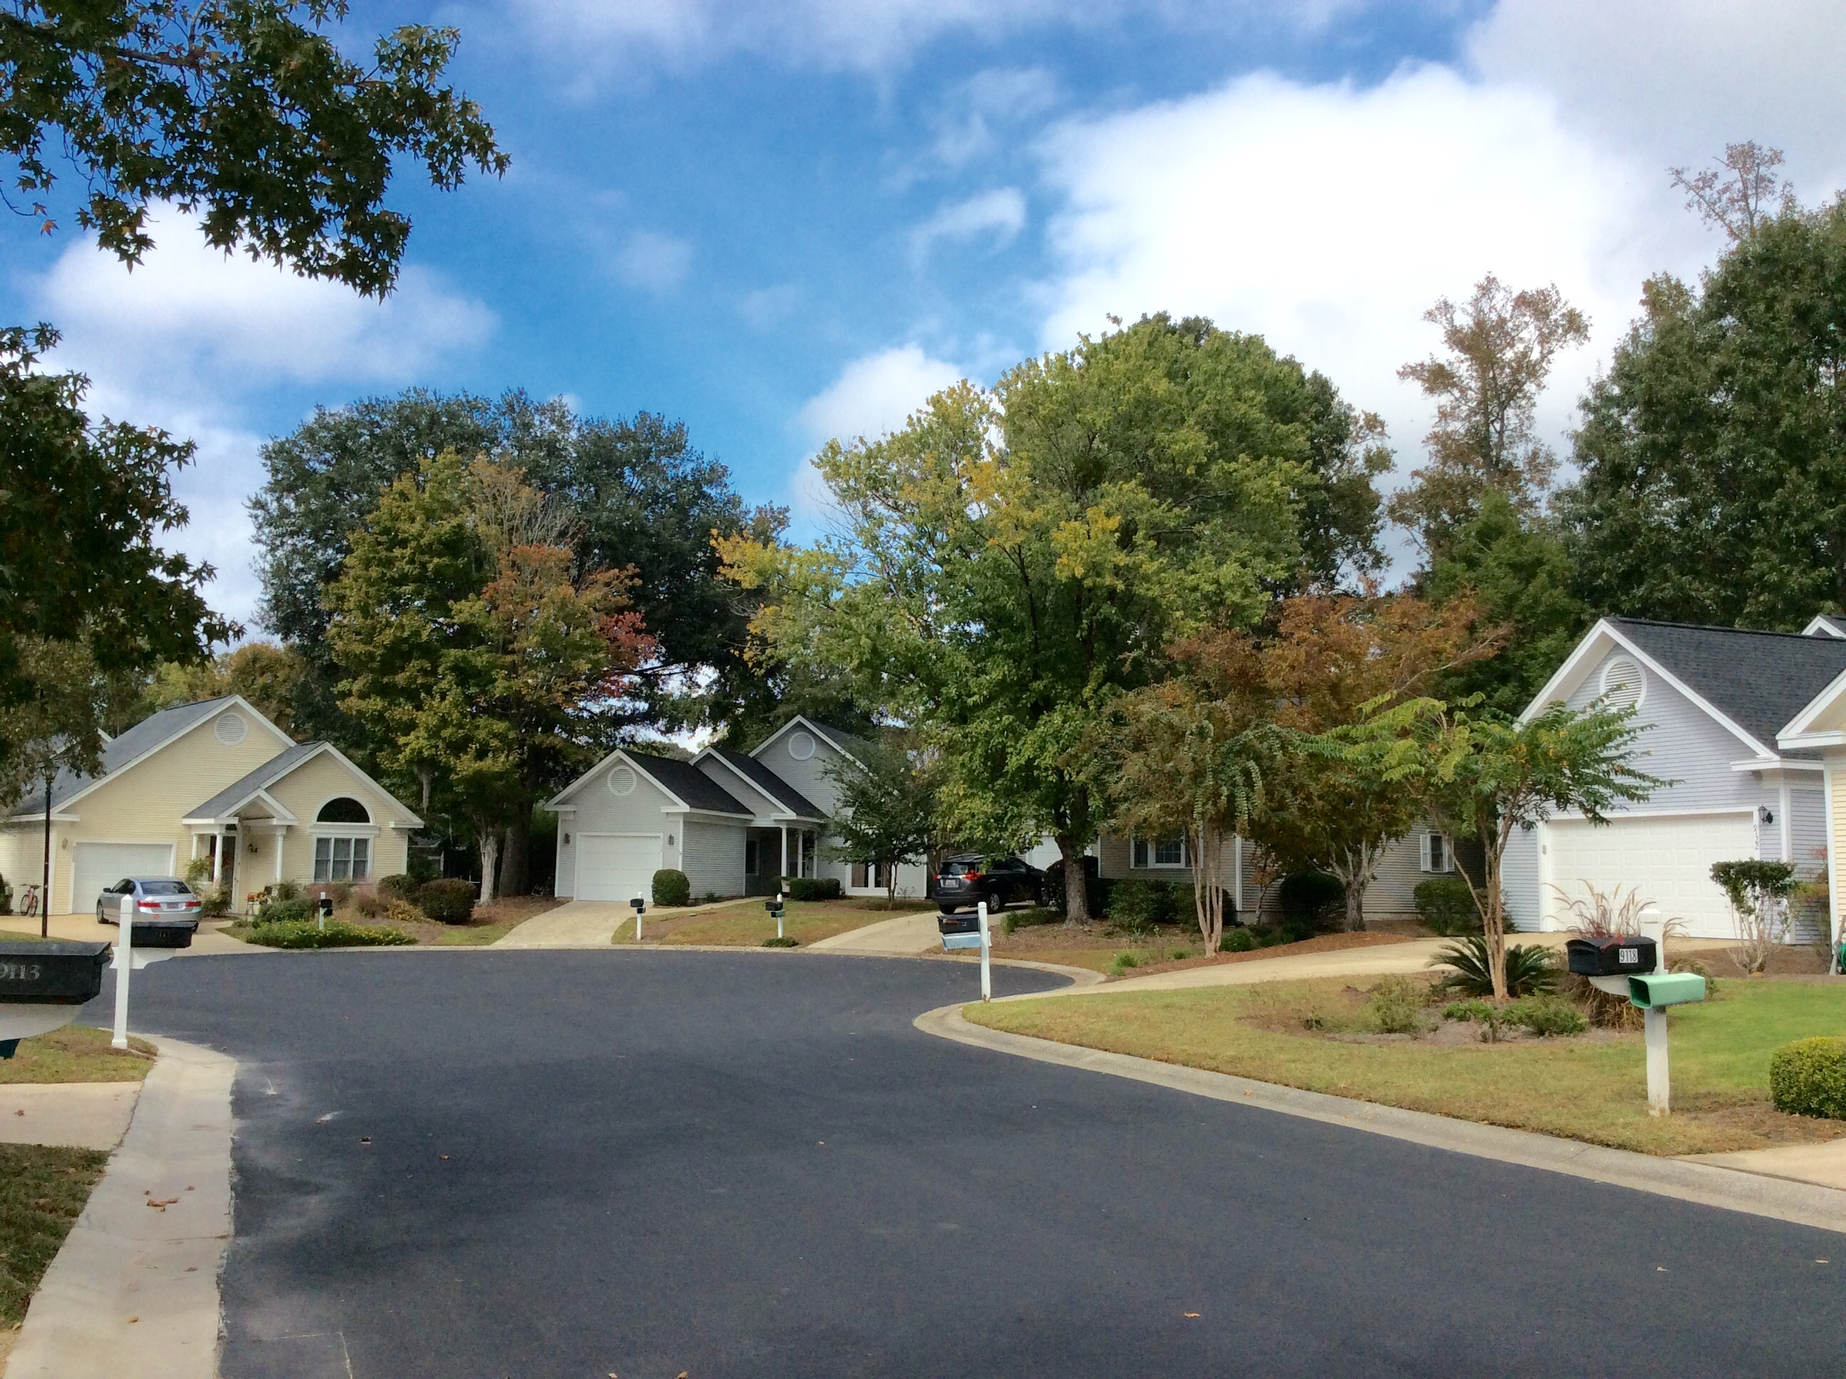
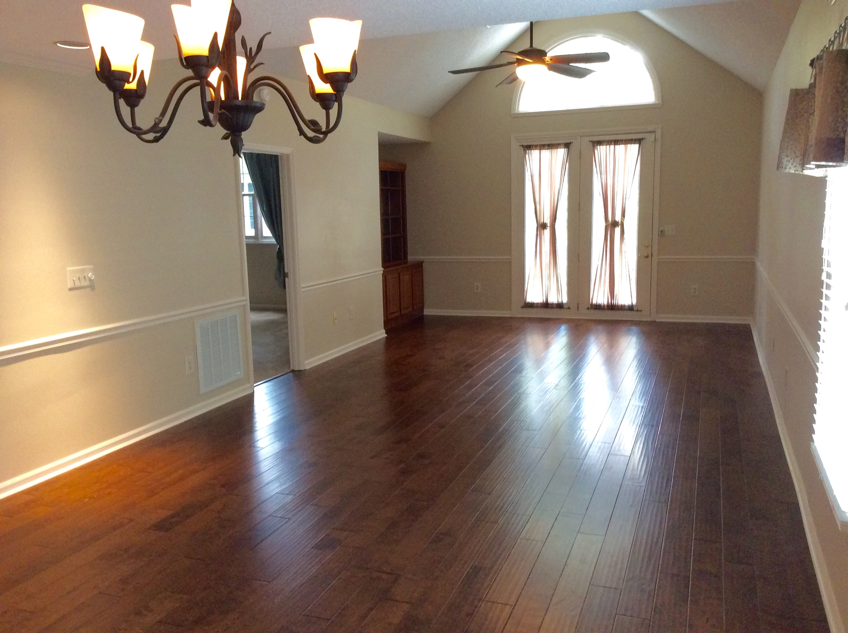
“Charleston is your forever love. It is a perfect blend of character and class. There is always something, but not too much. It is playful and it romances you.”
– Rebekah Phillips
Heather Lord
Broker Associate GRI, e-PRO, RSPS
Keller Williams Realty Charleston
www.heatherlord.com
heather@heatherlord.com
Phone: 843.810.9414

