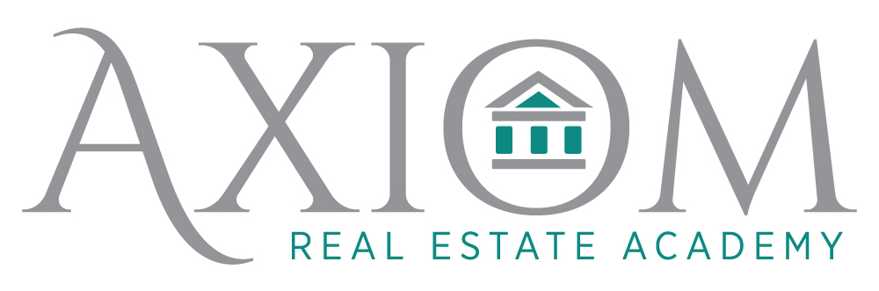
~Learn what makes your soul shine

Upcoming classes:

Unit III- Broker A- April 25-29 M-F 10-4 $300

Property Management- June 7-9, & 14-16 TWTh 9am-2pm $275

Pre-Licensing April 23-June 18 Sat/Sun 10-4pm $675

To register: call 843.518-2213 or go online to www.axiomrealestateacademy.com/book-online

Want to earn FREE CE?
Email us for more information on how to get credit for FREE CE- no purchase necessary!

