Last chance to get in on the fun! Prices will go up on December 10th for rooms!
Agents, it’s time to mix business with pleasure! Join us for a one-of-a-kind event where you’ll gain valuable CE credits, network with top professionals, and enjoy a luxury vacation at sea.
✨ Benefits of Attending:
- Earn Continuing Education credits while traveling
- Learn from industry experts in engaging, hands-on classes
- Build connections with agents, brokers, and vendors from across the state
- Enjoy a fun, professional environment — we work hard and play harder!

- Access to exclusive events, games, and networking opportunities on board
This Photo by Unknown Author is licensed under CC BY-SA

 Event Dates: February 21-26, 2026
 Location: Departing from Fort Lauderdale, FL  cruising to the Bahamas!
Www.AxiomRealEstateAcademy.com/CECruise2026 or
 Register HERE – Only 10 cabins left!

Special Thanks to our SPONSORS!

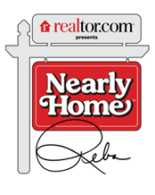

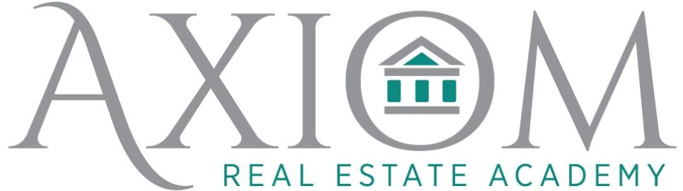
Contact us at info@axiomrealestateacademy.com or at 843.518.2213 for more information.

