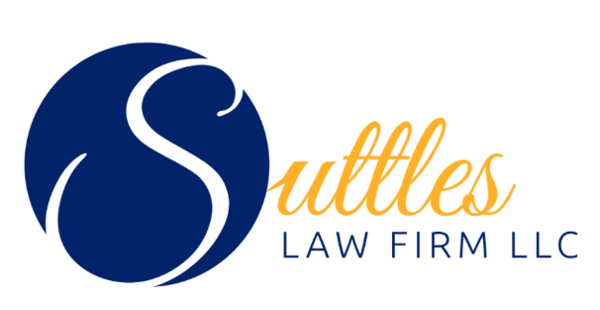
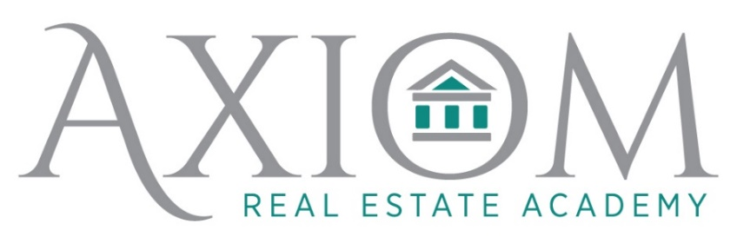
~Learn what makes your soul shine

Axiom Real Estate Academy will be hosting contract training coming up on the NEW contracts with The Suttles Law Firm!

Join Brent Suttles and Austin Kendrick for training. These sessions will give you:
• Breakfast at the morning session /lunch at the afternoon session.
• Forms for markup and draft
• Q & A for everyone to get their burning questions answered.

Seating is limited so register today for incredible insight on our new contracts.

Reserve your seat today!
June 2nd 9-11am https://www.eventbrite.com/e/342346145537
June 9th 3-5pm https://www.eventbrite.com/e/342334380347

