Open House-Palooza!!!

Saturday, July 8, 2017

12:00-3:00

Branch Creek
of
Summerville

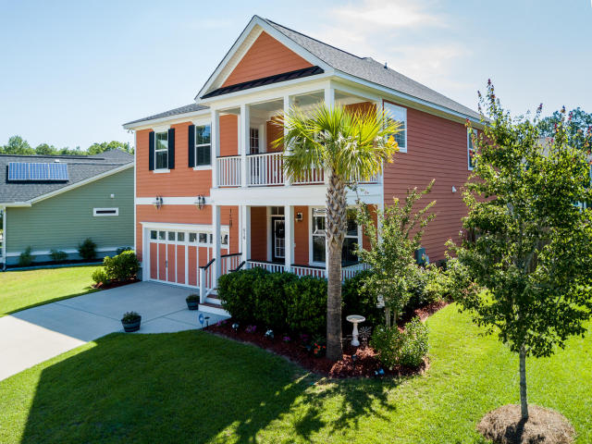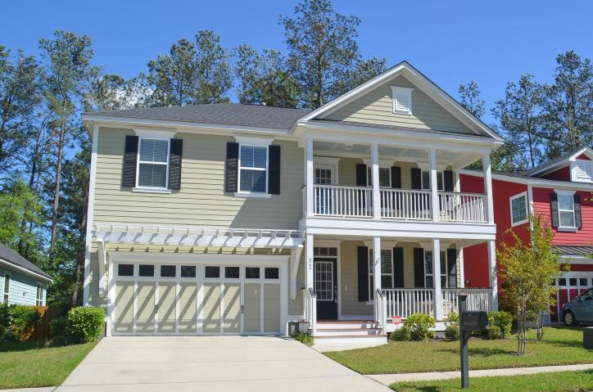

414 Branch Creek Dr. 422 Brick Kiln Dr.
$278,977 $314,000

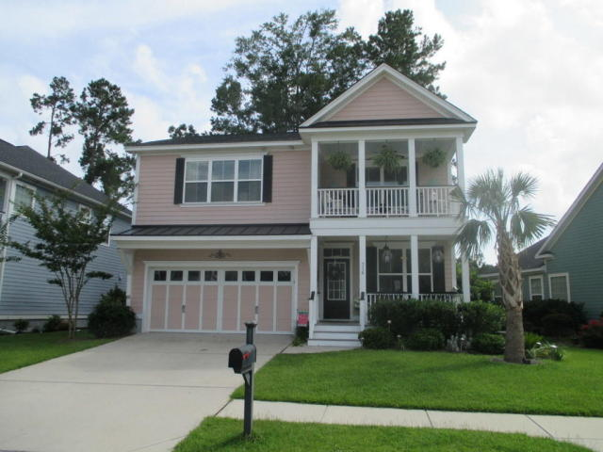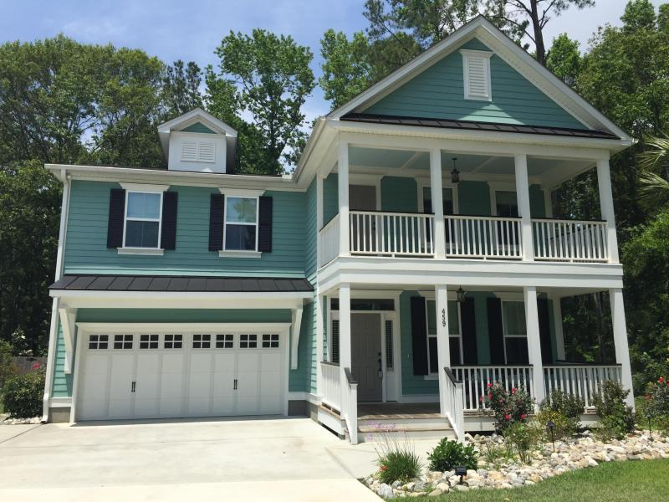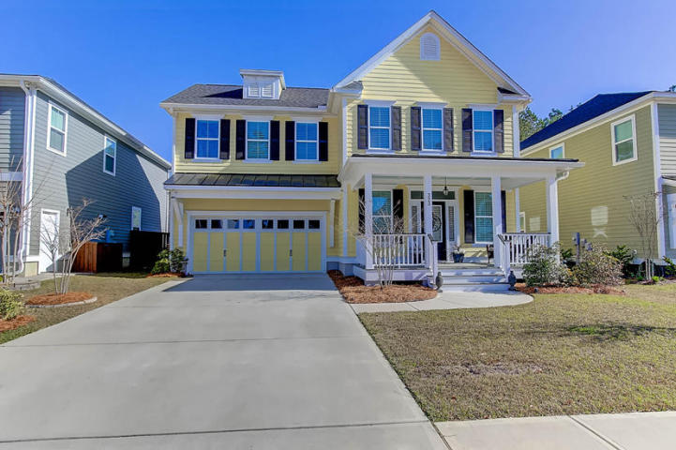

316 Brick Kiln Dr. 459 Brick Kiln Dr. 323 Brick Kiln Dr.
$289,000 $400,000 $369,500

Prizes for all!!!

Drawing for $50.00 Gift Certificate for AGENTS visiting all homes…

