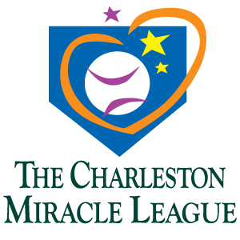
4th Annual Mulligans for Miracles Golf

Tournament Presented by

October 5, 2017 – 1:30 shotgun start
Shadowmoss Plantation Golf Course

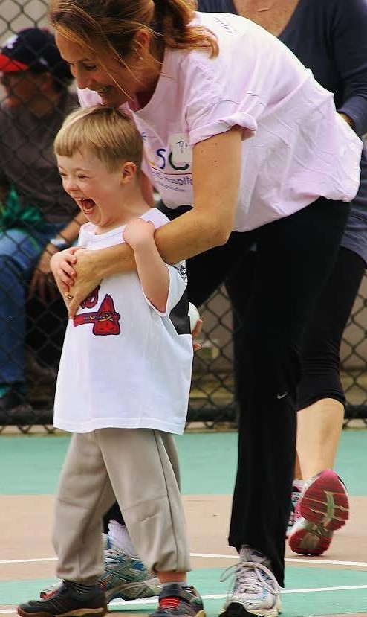

Lots of food, fun, drinks, and great prizes!

Mulligans for Miracles is CML’s Fall fundraiser that helps pay for trophies, uniforms, equipment, and opportunities to create lasting memories for our players.
CML is a baseball league for children and adults who have special needs.
For more information on CML check us out at www.charlestonmiracleleague.org

To sponsor or play in the tournament, please contact Golf Committee Chair, Evelyn Turner at eturner@dsncc.com

