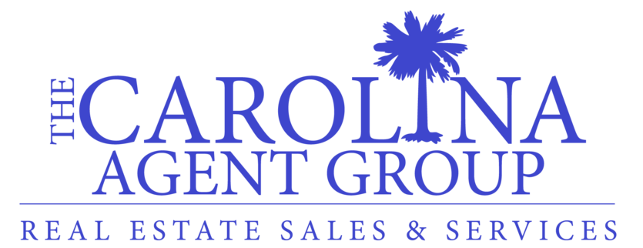

Best 100% Program & Lead Generation Service Available in Charleston, SC

100% Commission Program

Pay just $250 a month for a 100% Commission Split (No other required company fees)

3 Main Points of 100% Plan
1. Broker-in-Charge will answer contract questions quickly. He has supervised over a billion in transactions.
2. Commission checks will be processed quickly. No longer than 48 hours if all paperwork is turned in (excluding weekends and bank holidays)
3. Agent Website with your own domain and marketing tools. Truly Brand Your Own Name with these products. These products would cost $94.90 a month on your own.
Built on the same platform as www.TheCarolinaAgentGroup.com & www.ReMax.com both provided by homes.com.
- Website
- CMAzing & Neighborhood Envoy
- Design Center
- Manage Contacts
- Quick Email Drip Campaigns

Other Points of 100% Plan
- Free E&O, color printing, business cards and sign inserts.

Lead Generation Service
1. Leads will be sold in $500 increments.
2. Your cost of leads will go down tremendously.
3. Your quality of leads will go up tremendously.
4. We will be paired with a lender to bring down cost further.
5. This is a turn key system. You pay for the leads and we will provide them.
6. No more 50/50 splits. We only ask for 10% of your gross commissions and we will handle everything.
7. You concentrate on sales and not marketing or technology. The way it is supposed to be.
8. The value of this lead program combined with our 100% commission program is amazing!

Minimum Qualifications
We are looking for agents who have sold 2 million dollars or more over the last 12 months who are honest and ethical.

Contact Us
We are currently located in West Ashley close to Best Buy at 706 Orleans Road Charleston, SC 29407. We are considering moving to Mount Pleasant April 1, 2017.

CALL/TEXT
Chris Brand at 843.276.6640 to set up a phone or in person meeting.

