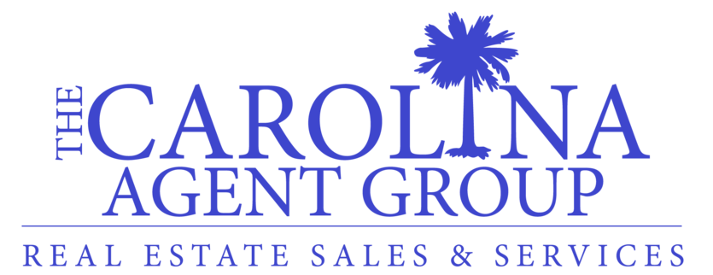

Best 100% Commission Club in Charleston, Columbia, Greenville and Myrtle Beach Areas

Our Virtual Program Saves Money
Pay just $250 a month for a 100% Commission Split (No other required company fees)

3 Main Points of 100% Plan
1. Broker-in-Charge will answer contract questions quickly. He has supervised over a billion in transactions.
2. Commission checks will be processed quickly. No longer than 48 hours if all paperwork is turned in (excluding weekends and bank holidays)
3. Agent Website with your own domain and marketing tools. Truly Brand Your Own Name with these products. These products would cost $94.90 a month on your own.
Built on the same platform as www.TheCarolinaAgentGroup.com & www.ReMax.com both provided by homes.com.
- Website
- CMAzing & Neighborhood Envoy
- Design Center
- Manage Contacts
- Quick Email Drip Campaigns
You will be kept up to date with regards to webinars and you will be given access to recorded training videos upon joining.

Other Points of 100% Plan
- Free E&O, business cards and sign inserts.

Minimum Qualifications
We are looking for agents who have sold 2 million dollars or more over the last 12 months who are honest and ethical.

Multiple Listing Services
1. Charleston Trident (Charleston Area)
2. Consolidated (Columbia Area)
3. Coastal Carolina (Myrtle Beach Area)
4. Greater Greenville (Upstate Area)
5. Western Upstate (Upstate Area)
6. Spartanburg (Upstate Area)

Contact Us
All commission checks and paperwork can be sent to corporate office in located at 706 Orleans Road Charleston, SC 29407 Your commissions will be direct deposited.
CALL/TEXT Chris Brand at 843.276.6640 to set up a phone meeting.

