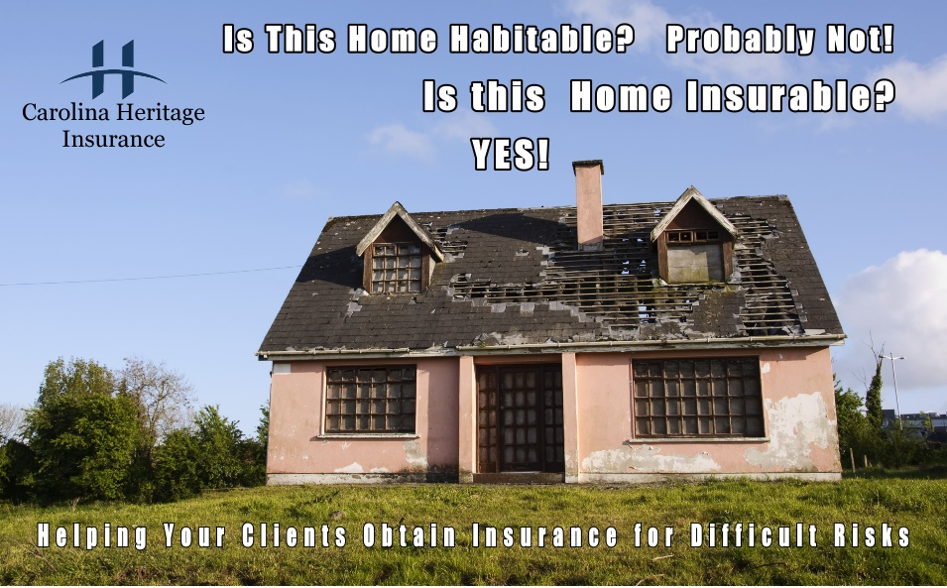
Just because a home is inhabitable, does not mean the home is uninsurable. We represent insurance carriers that can help your Buyers or Sellers with insurance solutions for homes that need repairs. In this situation, we can write a Vacant Under Construction Policy that would insure the dwelling and the renovations that are underway. Similar to a Builders Risk policy, this policy will protect the owner of the property for perils that can occur while a home is under repair. Upon completion of the repairs, we simply transfer the policy to a typical Homeowners policy.
Is there home that your clients have insurance questions? Have them call us, we can help with insurance questions and answers! 843-689-3030
A bit about us. Carolina Heritage Insurance is a regional Independent Insurance Agency. We specializes in Home, Auto, Flood and Commercial risks. Having offices in Mt. Pleasant / Charleston, Bluffton and Hilton Head markets, we have the resources and highly experienced agents that can help you and your Buyers and Sellers .
Also please note – we are happy to have an Agent stop in your office and speak about insurance topics. To schedule an agent to speak at your meeting, simply email us at Market@CarolinaHeritage.net

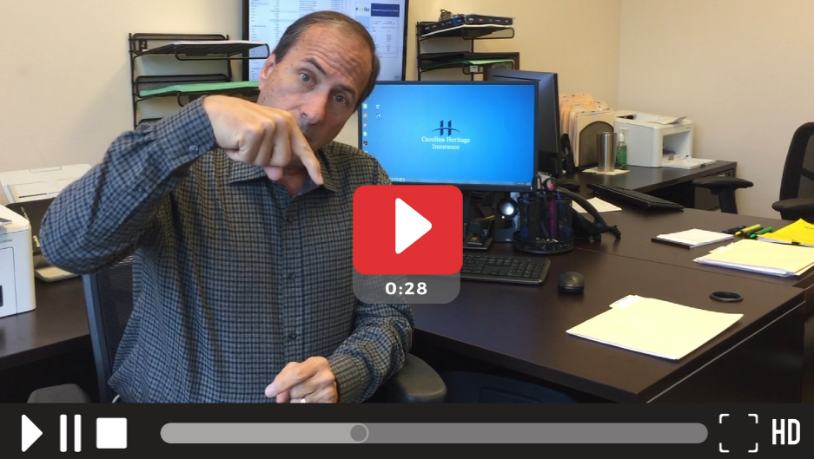
Click above image or here…

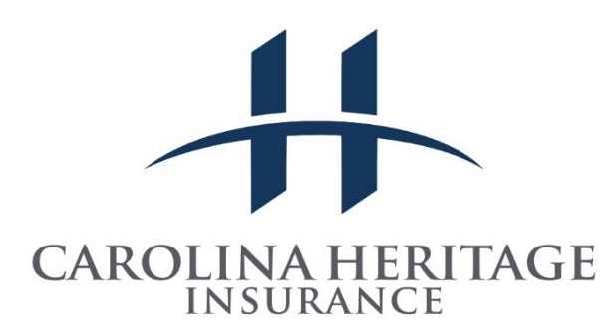
John Alagna Broker / Agent / Sr. Partner
Carolina Heritage Insurance 1154 Bowman Dr. Ste 202, Mt. Pleasant, South Carolina 29464
Phone 1-843-689-3030 | Fax 1-866-286-6264 |www.CarolinaHeritage.net

