COMING SOON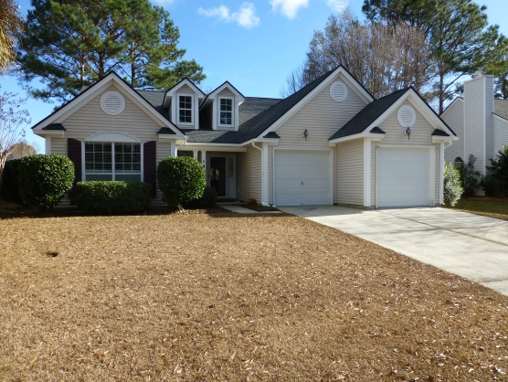 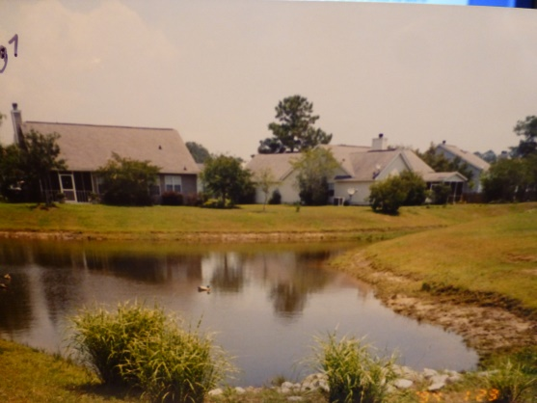

This wonderful, well-maintained ranch style home in Palmetto Hall at Dunes West is just about to hit the market! The one-story home has an open floor plan – was the Builders Model, so lots of extras like columns and arches, and has lots of windows that allow for beautiful views of the backyard and pond. A new roof was added in 2016!
This home has 3 bedrooms/2 full baths, and 1757 square feet of living space. It has a Gourmet Kitchen with white cabinets, corian counters, stainless steel appliances, and new wood flooring in kitchen, breakfast nook and laundry. There is a nice Master Suite with Bay Window tucked away in the rear of the home. The marble fireplace hearth surrounds a real working fireplace, and that wall has built-in bookshelves
The oversized lot (.24 acres) is beautifully landscaped and overlooks the Pond. There is an enclosed screened porch with sliding windows. All Dunes West Amenities are available – Tennis, pool, Clubhouse, golf, boat storage and boat ramp.
If you have Buyers looking in the Mount Pleasant area, and you want to learn more, or even set up a time to do an early preview – contact Randy Espeseth at 843-743-1025 or Randy@RandyEHomes.com.
Randy Espeseth, Broker Associate, Realtor, SRS, ABR, CPA, MST
Carolina Elite Real Estate
Cell: 843-743-1025
FAX: 1-866-604-8702
Randy@RandyEHomes.com
www.RandyEHomes.com

