
492
SPRING INTO YOUR NEW FLEX HOME!
120 Wando Reach Rd | MLS#17029562 | Hamilton II | 5 Bed/3.5 Bath | 3,815 St Ft | $580,000
132 Wando Reach Rd | MLS#18017844 | Drake II | 5 Bed/4.5 Bath | 3,418 Sq Ft | $560,000
221 Ashmont Rd | MLS#18032729 | Cassidy B | 4 Bed/2.5 Bath | 2,649 Sq Ft | $487,000
225 Ashmont Rd | MLS#18018157 | Hamilton II | 5 Bed/3.5 Bath | 3,821 Sq Ft | $570,000
5445 Clearview Dr | MLS#18025496 | Wentworth B | 5 Bed/4 Bath | 3,227 Sq Ft | $529,000
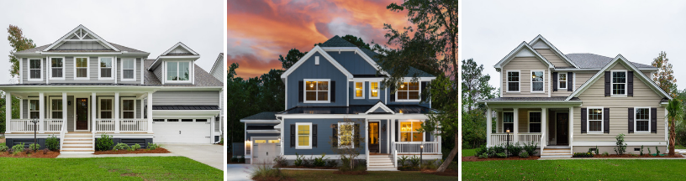

Seller pays most Closing Costs AND up to $2,500 in pre-paids! *
$1,500 Home Town Hero For Qualified Buyers

GRADUATED COMMISION OR RELOCATION REIMBURSMENT UP TO 35%!

Don’t miss our unbeatable inventory homes!
Please see agent for details and stipulations regarding available Closing Costs/Pre-Paids promotion with the use of the preferred lender and closing attorney/title company. All Financing Incentives and any other Incentives/promotions are subject to the use of Seller’s preferred lender and closing attorney. Pricing and Incentives are subject to change at any time without notice. Incentives vary per community and a minimum amount of options may be required in order to qualify for certain promotions. Restrictions may apply

CALL OR VISIT ONE OF OUR HOMES TODAY!
Becca Jett | 843.466.5000 | Becca.Jett@crescenthomes.net

