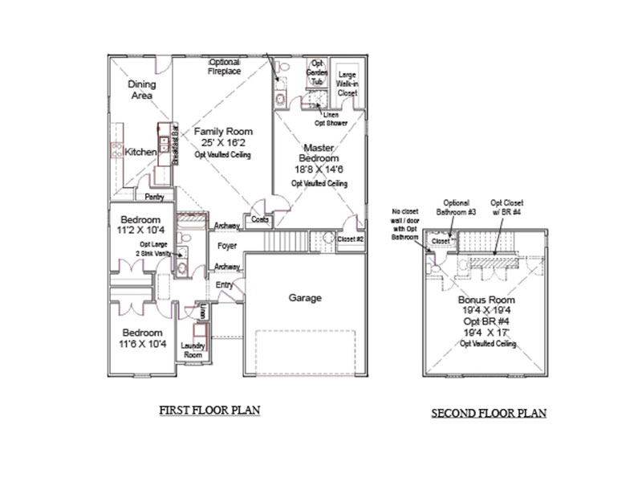
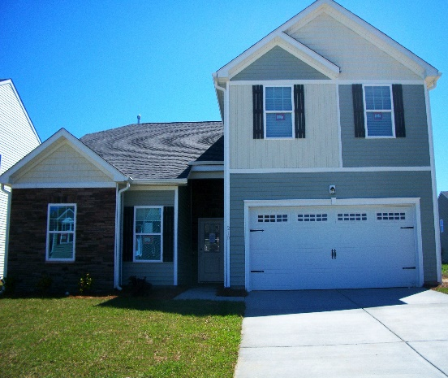


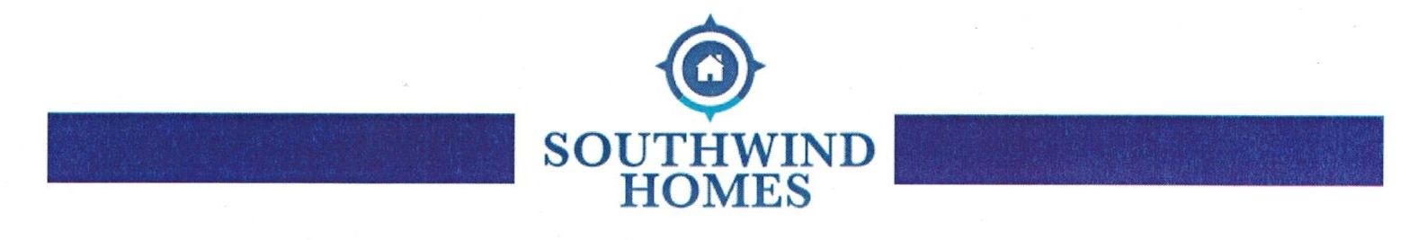
1 home available for quick move-in. The Halstead Plan is a 1 story 3 bedrooms 2 bath with GIANT bonus room that could be a 4th bedroom. Hardwood floors through Family room, Dining and Kitchen. 2191 SqFt. Priced to move at $204,900. Call me today!
Vicki Kramer (843) 270-4828
Vicki@mysouthwindhome.com

Due to our overwhelming sales, and pending builds we will be unable to host our previous advertised Cinco De Mayo Celebration at Cypress Grove

