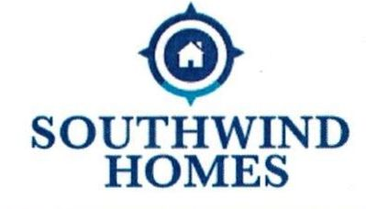
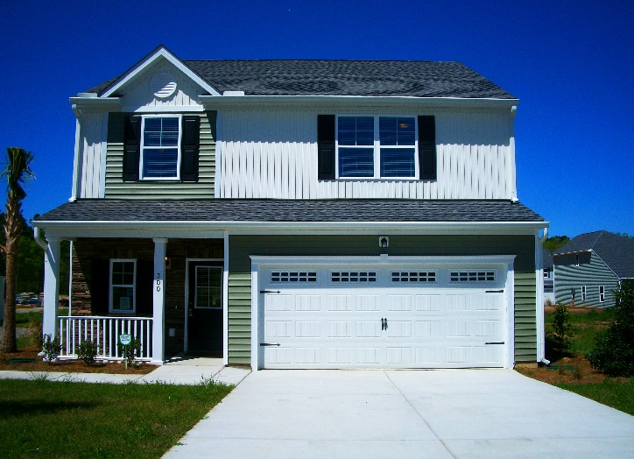
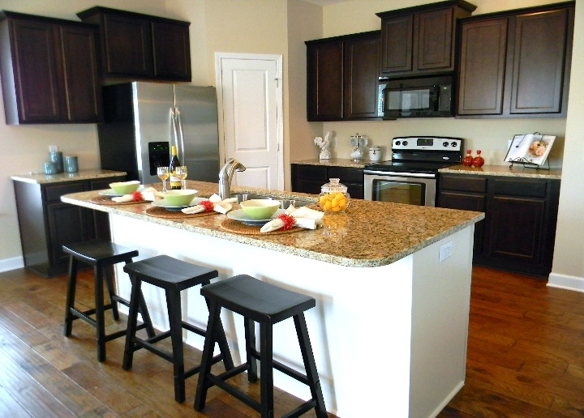
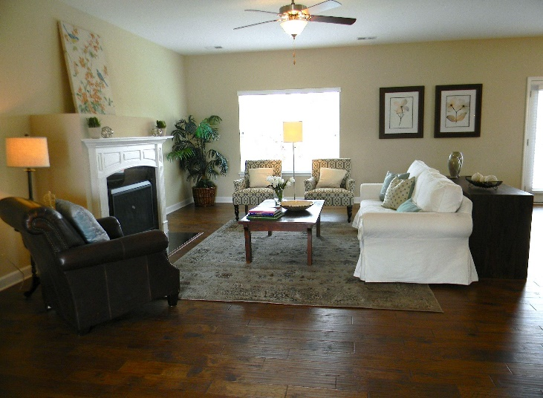
Now Pre-Selling!
Single Family Homes
from the $180’s

- 6 Plans to Choose From
- 1-2 Story 1871Sqft -2431 Sqft
- 3-5 Bedrooms * 2 – 3 Baths

May Incentives:

- 2” Blinds Throughout
- Stainless Steel Appliance Pkg.
- Community Partners Program up to $7500 grant
- 100% USDA Financing avail.
- $3000 closing cost with use of preferred Lender and Attorney

Pool Opening Memorial

