


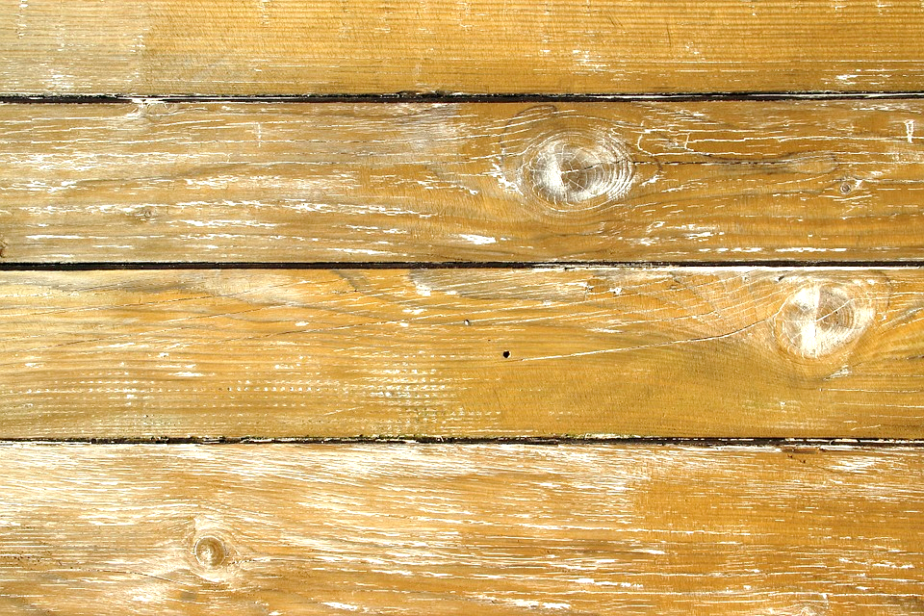
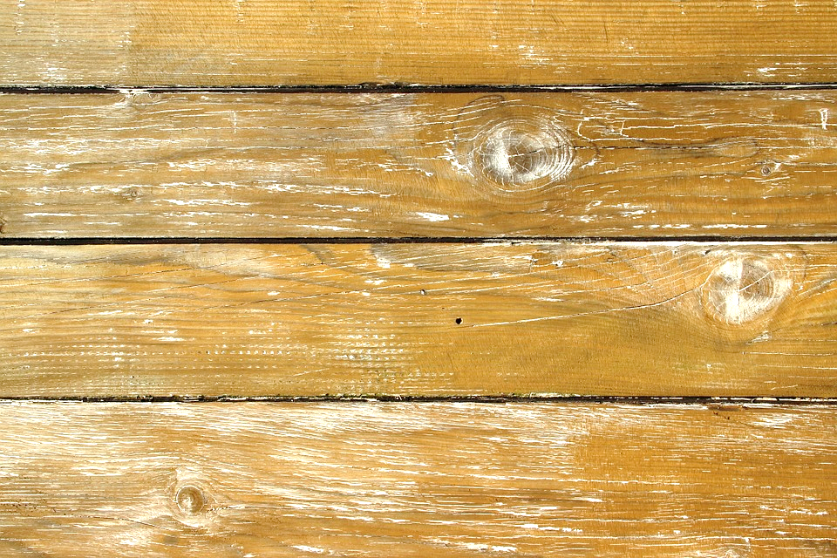
Up to $7500
in Buyer incentives
EVERY SATURDAY
Filbin Creek * Food * Fun * Chance to win a 70” Flat Screen TV*
Join us at 1177 Sumner Ave, North Charleston from 11:00 – 6:00
Vicki A Kramer (843)270-4828 or Lisa M Corona (843) 714-1407
Prices Starting in the $200’s

