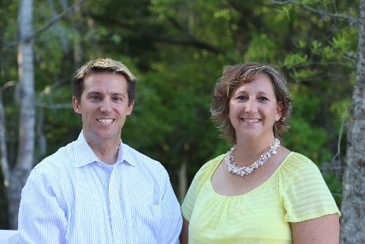
Adam Kernen & Tamara Vandiver of


Cordially invite you to their
FREE DECEMBER events!

1 – Realtor Success Series Lunch & Learn

w/ a Photographer Guest Speaker
10Dec & 12Dec from 1215 to 130pm @ Eggs Up Grill (2664, U.S 17N, Mt Pleasant, SC 29466)
Choose the one that works best for you!
We’re going to shake it up a bit this month and will be doing a drawing for a GIFT CARD at our Lunch & Learn! Earn tickets for the drawing by: Wearing tacky holiday sweaters or socks Wearing crazy holiday hats or headbands, and….. for EACH Realtor friend you bring!!!

2 - “Street-Wise” Situational Awareness & Self-Defense Class
16Dec from 930am to 1230 @ Capital Karate (3365 S Morgan’s Point Rd #103, Mt Pleasant, SC 29466)
Superbly Taught by Aaron Hawk
Peering around a corner Looking for an entrance Squatter hiding behind couch Squatter hiding under bed
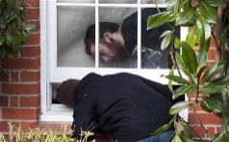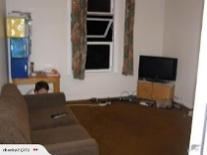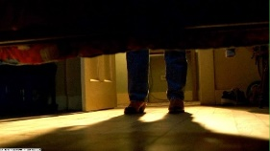
These things are occurring EVERY day, even in “Mount Perfect”. We have been hearing of squatters and other instances that are making Realtors uncomfortable. PLEASE come to see how to protect yourself and avoid confrontations all while making your buyers feel safe.
RSVP to Tamara >> tamara.vandiver@guaranteedrate.com // 843-412-2577

