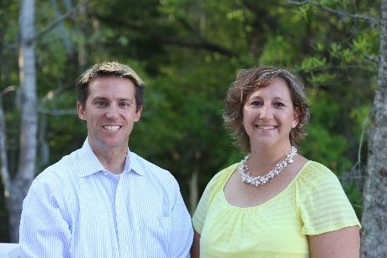
Adam Kernen & Tamara Vandiver of


Cordially invite you to their THREE
FREE November events!

1 - Meet the Experts Happy Hour Social w/ discounted Head Shots!!
07Nov14 from 5 to 7pm @ Liberty Tap Room (1028 Johnnie Dodds Blvd, Mt Pleasant, SC 29464)

2 – Realtor Success Series Lunch & Learn w/ Closing Attorney Guest
12Nov & 14Nov from 1215 to 130pm @ Eggs Up Grill (2664, U.S 17N, Mt Pleasant, SC 29466)
Choose the one that works best for you!

3 - “Street-Wise” Situational Awareness & Self-Defense Class
18Nov from 930am to 1230 @ Capital Karate (3365 S Morgan’s Point Rd #103, Mt Pleasant, SC 29466)
Superbly Taught by Aaron Hawk
Peering around a corner Looking for an entrance Squatter hiding behind couch Squatter hiding under bed
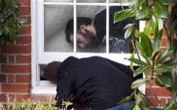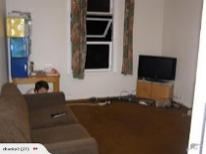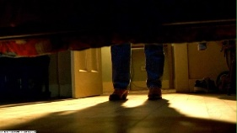
These things are occurring EVERY day, even in “Mount Perfect”. We have been hearing of squatters and other instances that are making Realtors uncomfortable. PLEASE come to see how to protect yourself and avoid confrontations all while making your buyers feel safe.
RSVP to Tamara >> tamara.vandiver@guaranteedrate.com // 843-412-2577

