So you don’t have to do it!

BEFORE

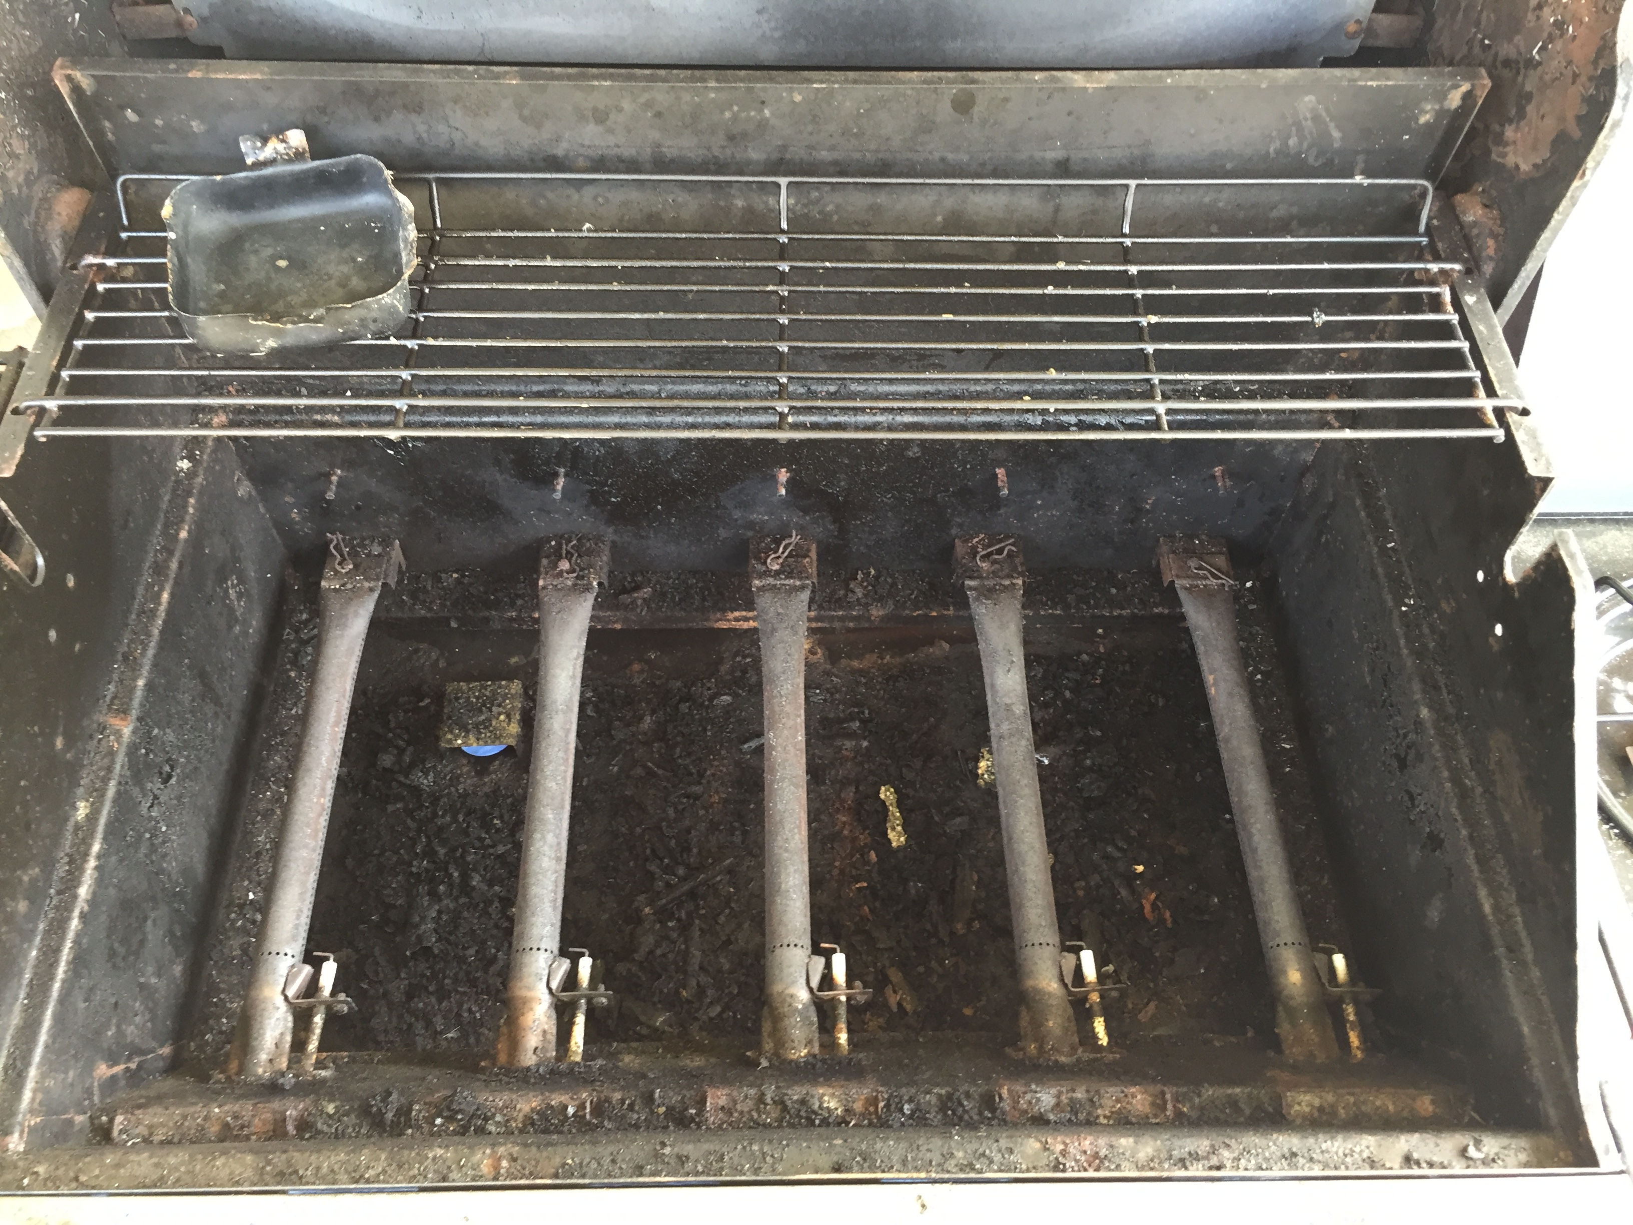

AFTER

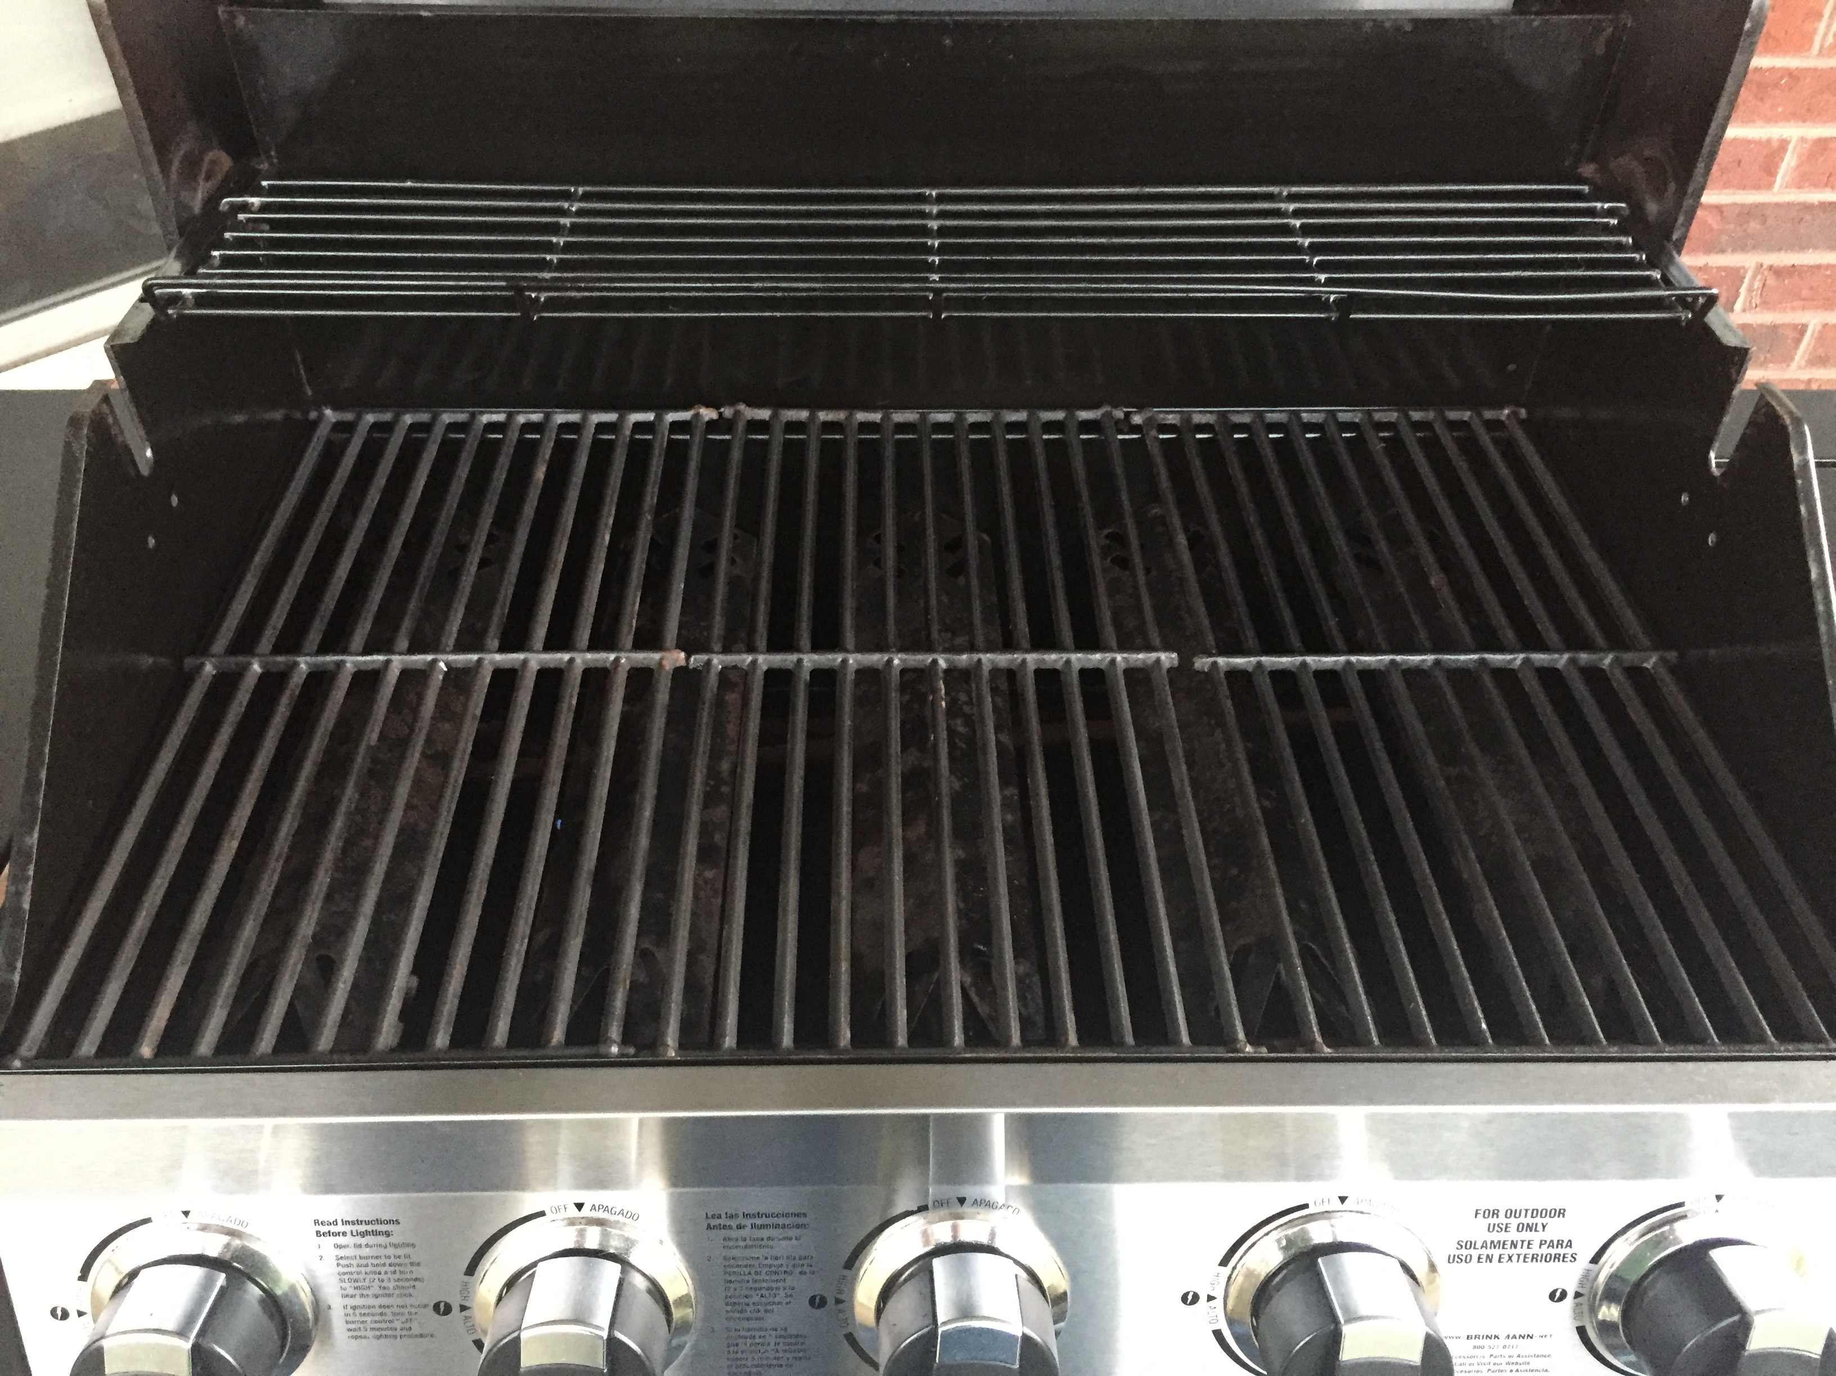

Ask about volume discounts for property management services with multiple grills.

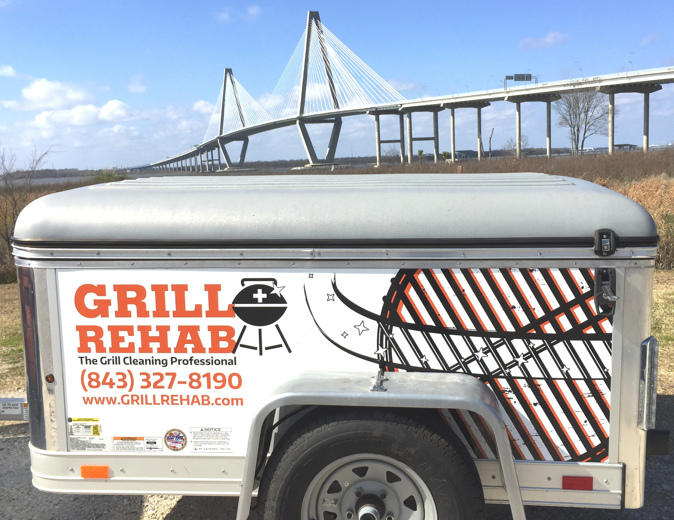


271 Alexandra Dr. #9
Mt Pleasant, SC 29464
Phone# 843.327.8190
www.GRILLREHAB.com
gril.rehab@gmail.com

The National Fire Protection Association reports that “From 2009-2013, fire departments responded to an average 8900 home fires involving grills”. “The leading causes of grill fires were a failure to clean"! Grill Rehab’s unique grill cleaning process provides many benefits for grill owners including:
- Removing harmful carcinogens and charred particles that can be passed on to food.
- Professionally cleaning burners and interior parts to improve performance, prevent future corrosion, and prolong the life of your investment.
- Removing stubborn grease deposits, drastically reducing the risk of a dangerous grease fire.

