Broker Open Houses Today on James Island!
Stop by today (1/31) between 1-3 p.m.

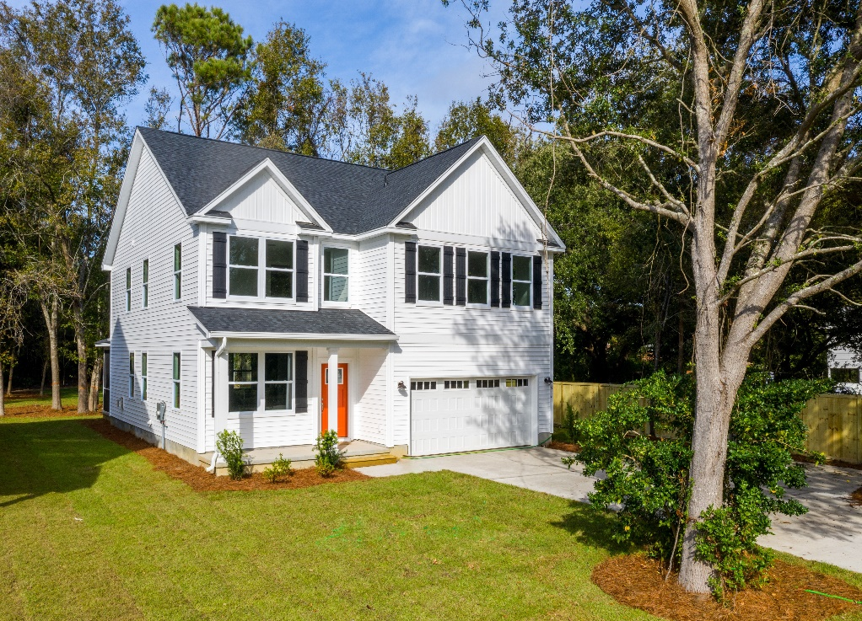
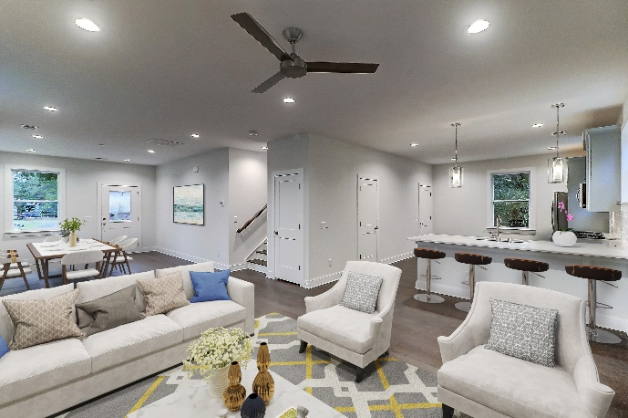

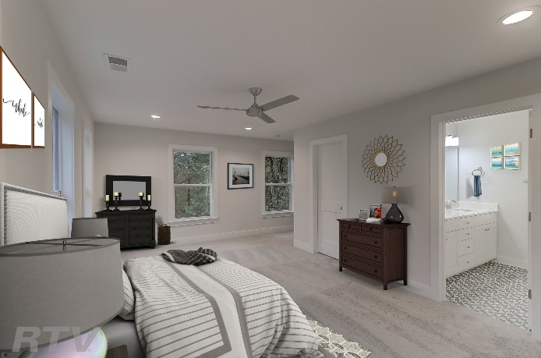

5 New Homes Available – Developer Says Sell!
1526 Grimball Rd Extension, James Island
4 bed – 2.5 bath – 2,118 SF – 2 car garage - $362,950
Donnielanehomes.com

1514 Grimball Rd Extension, James Island
1516 Grimball Rd Extension, James Island
1518 Grimball Rd Extension, James Island
1635 Cooper Judge Lane, James Island
4 bed – 2.5 bath – 2,710 SF – 2 car garage – starting at $424,900
Grimballhomes.com

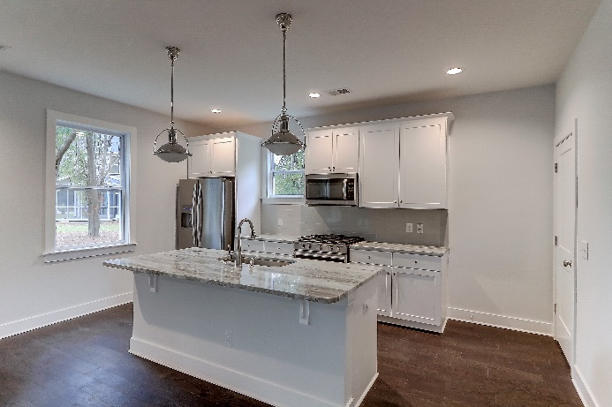

Upgraded Features Include:
- Andersen Silverline Impact Resistant, Low-E Windows
- Hardwoods throughout the downstairs, stairs and upstairs hall
- Beautiful designer tile in bathrooms and laundry room
- Natural gas range, fireplace and water heater
- Gourmet kitchen with shaker cabinets with soft close hinges
- Granite countertops in kitchen and baths
- Frameless shower door
- Tankless hot water heater
- Tiled, walk-in shower in master bathroom
- Screened porch

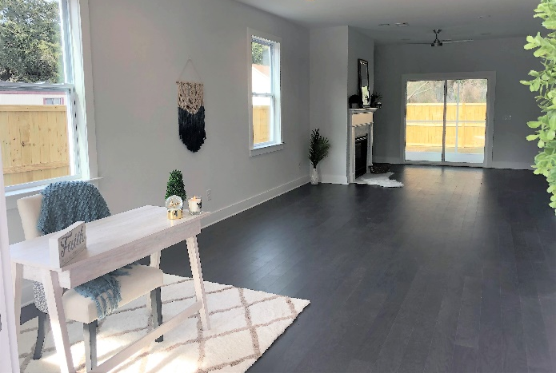

Carrie Newbern
Wilcat Realty
843-557-9001
carrienewbern@gmail.com

Ashley Melton
AgentOwned Realty
843-670-2333
ashley.melton@agentowned.com

