AGENT OPEN HOUSE
THURSDAY, November 17TH, 2016
11:30AM – 2PM

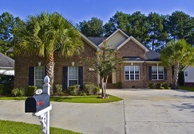  Address: 103 Newcastle Loop  Bedrooms: 4  Bathrooms: 3  Sq.Ft.: 2,100  Price: $300,000  Listing Agent: Stephanie Davis | 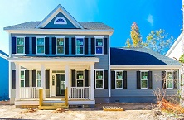  Address: 422 Hamlet Circle  Bedrooms: 5  Bathrooms: 4  Sq.Ft.: 3,109  Price: $459,990  Listing Agent: Chris Eller | 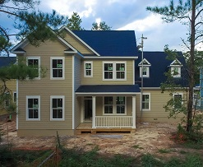  Address: 420 Hamlet Circle  Bedrooms: 4  Bathrooms: 3.5  Sq.Ft.: 3,112  Price: $462,990  Listing Agent: Chris Eller
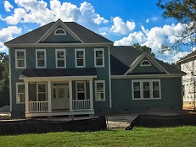  Address: 418 Hamlet Circle  Bedrooms: 5  Bathrooms: 4  Sq.Ft.: 3,219  Price: $474,990  Listing Agent: Chris Eller | 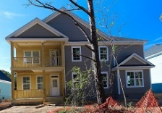  Address: 416 Hamlet Circle  Bedrooms: 5  Bathrooms: 4  Sq.Ft.: 3,324  Price: $479,990  Listing Agent: Chris Eller |       Come and tour these 5 Homes, have some Lunch, Desert, and Enter the Gift Card Giveaway!

