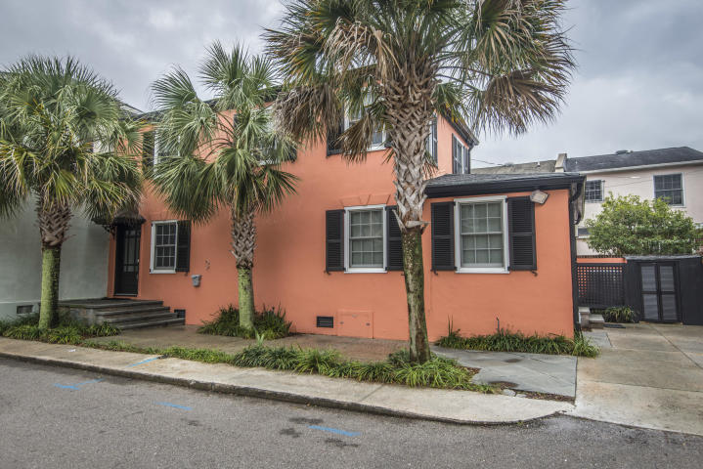
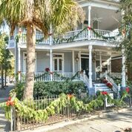
Broker Open House Thurs January 10th
11:00-1:00 Harleston Village
28 Rutledge Avenue
- 4br, 4ba, 3822 sf
- on Colonial Lake
- 3 off-street parking spaces
- 2 electric meters so could be 2 units
- piazzas galore!
- $1,495,000
- Light lunch served
3 Poulnot Lane
- 2br,2ba,1530sf
- 2 parking spaces
- updated
- 1 block to Colonial Lake
- $689,000
- refreshments served

