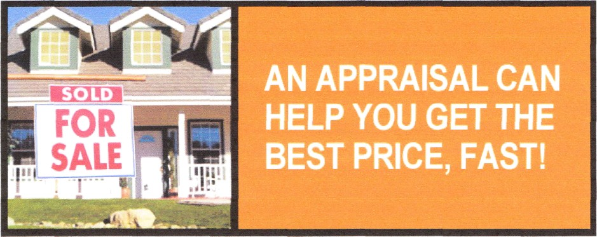

An appraisal from Hillman Appraisal as part of your overall marketing strategy will give the ultimate credibility to your asking price. You’ll have fewer hassles with offers and counter offers, and your sellers will be confident you’re getting top dollar for the home. Plus, you may be selling yourself and your sellers short on unique properties without an accurate, current appraisal. We’re ready to help with excellent client service and fast turn-around times. Please visit my website at http://www.charlestonscappraiser.com or give me a call at (843) 442-3590.

Every Appraisal comes with a professional sketch and accurate square footage.

Mention this add and receive $75 off of the normal price of $350 appraisal, that’s $275 for any non lender appraisal.

Waterfront, riverfront, golf course, marsh front, complex properties, all $275. SFR, Condos, townhouses, divorce appraisals, estate appraisals, bankruptcy appraisals all $275. Single family investment property $275. Rural properties, Duplex, Triplex, Quadroplex $375. Non lender reports only, credit cards accepted.

Certified Residential Appraiser, USPAP compliant reports
Charleston, Berkeley, and Dorchester Counties

We look forward to working with you!

Sincerely

Tim Hillman, CRA
Hillman Appraisal
843-442-3590
hillmanappraisal@live.com

http://www.charlestonscappraiser.com

http://www.thillmanappraisal.com

http://www.sellhousehelpappraisal.com

