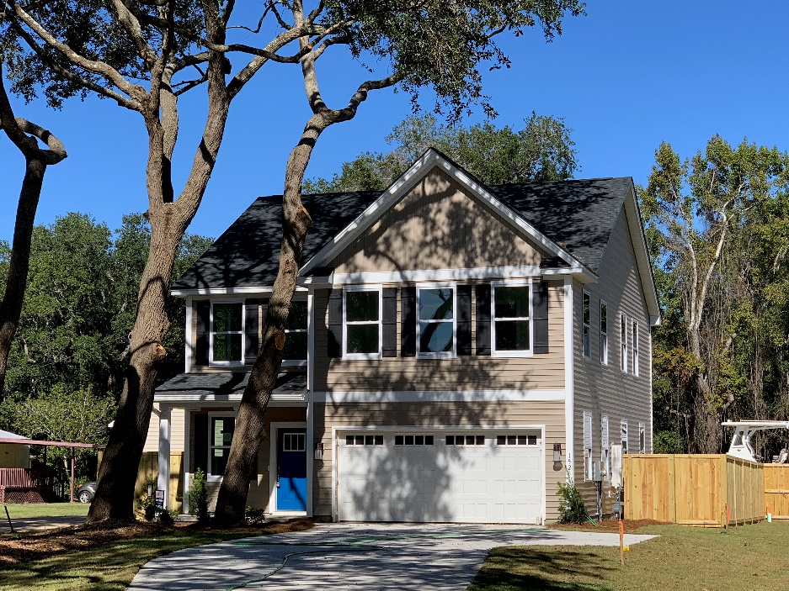
ONLY 2
REMAIN
5 MIN. TO FOLLY
10 MIN. TO DOWNTOWN!
Best Value on James Island!
CLOSE TO WORK AND PLAY
WOODED
ESTATE
LOTS
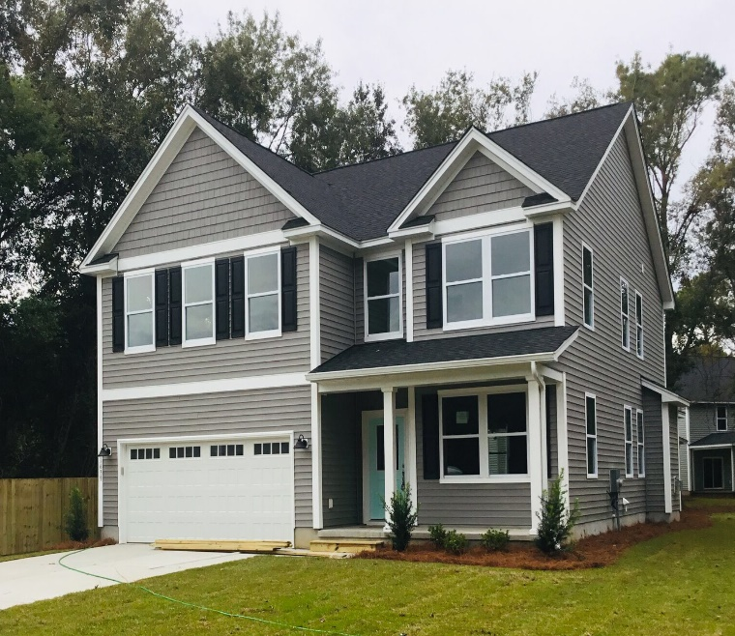
ONLY 4
REMAIN

(Plans and addresses on the back of this flyer)

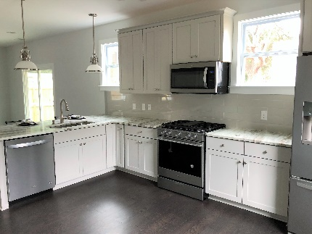
INCLUDED FEATURE LIST
- Andersen Silverline impact resistant windows
- Engineered Wood Floors
- Designer tile in bathrooms and laundry
- Painted cabinets with soft-close features
- Tiled kitchen backsplash
- Stainless steel appliances, including refrigerator
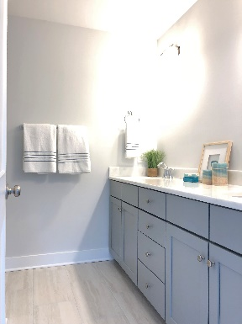
- Granite countertops in kitchen and baths
- Can LED lights and fans in bedrooms
- Dual sinks, full-height vanities and stone countertops in both full baths
- Walk-in, tiled master shower with frameless shower door
- Oversized master bedroom with walk-in closets
- Utility sink in laundry room
- Tankless Rinnai hot water heater
- No Homeowners Association (HOA) – Bring your boat!

Two Great Floor Plans – One Great Location!
The Magnolia Plan
1514 Grimball Rd Extension
4 Bedrooms, 2.5 Bathrooms, 2710 SF
$434,900
1516 Grimball Rd Extension
1518 Grimball Rd Extension
1635 Cooper Judge Lane

The Cypress Plan

1526 Grimball Rd Extension
4 Bedrooms, 2.5 Bathrooms, 2118 SF
$368,500
1622 Donnie Lane

Call to schedule an appointment today!
The Magnolia Plan
Ashley Melton
Agent Owned
843-670-2333
Ashley.Melton@agentowned.com
www.Grimballhomes.com



The Cypress Plan
Carrie Newbern
Wilcat Realty
843-557-9001
carrienewbern@gmail.com
www.donnielanehomes.com

