Keating Tree Service
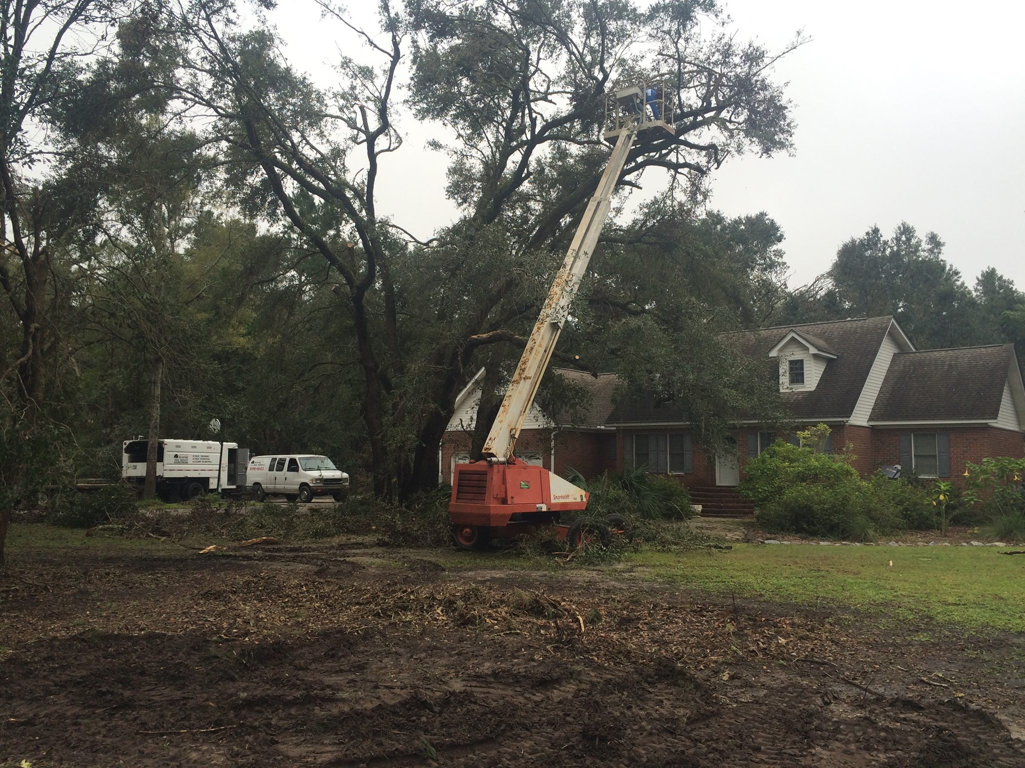
  - 843-696-7377
Tree trimming and tree removal. Specializing in hazardous large tree take down. Services include stump grinding, grading, land clearing and demolition. Over 35 years’ experience. Certified Arborist.
Keating Tree Service
www.keatingtree.com
info@keatingtree.com

