Move-In Ready New Construction
1862 Dogwood Road, Charleston, 29414
4 Bed/3 Bath, 1818 sq ft, MLS #19028537
$317,500
- Centrally located in West Ashley
- Wood-look floors downstairs, stairs and hall
- Impact resistant windows
- Tankless hot water heater
- Bedroom and full bath downstairs
- 1-Car detached garage
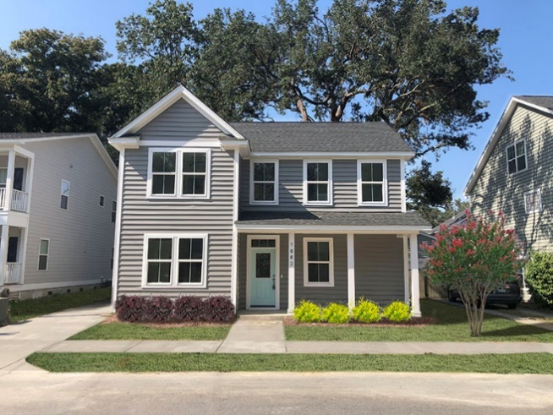

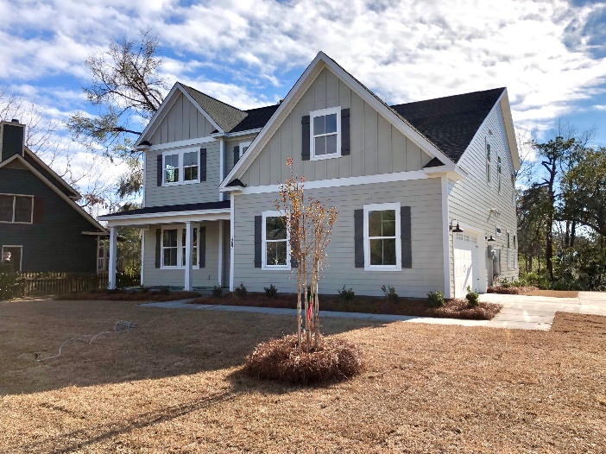
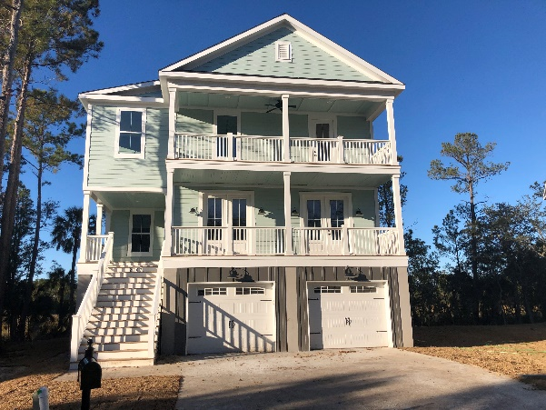
2267 Palmetto Marsh Cir, Mt Pleasant, 29466
5 Bed/4 Bath 3437 sq ft MLS #19018973
$914,500
- Impact resistant windows
- Huge kitchen w/Bosch SS appliances + many extras
- Tankless hot water heater
- Site finished wood floors
- Private shared dock + Rivertowne amenities
- HUGE screened porch
1287 S Barksdale, Mt Pleasant, 29464
5 Bed/4.5 Bath, 3576 sq ft, MLS #19031683
$774,990
- S Mt Pleasant – close to downtown and I-526
- Dual Masters – up and downstairs
- Luxury kitchen with oversized island
- Tankless hot water heater
- Impact resistant windows
- Screened Porch overlooking tidal creek

Carrie Newbern
Wilcat Realty
843-557-9001
carrienewbern@gmail.com

