JANUARY 2017 MEETING
of the
Charleston Area Association of Realtist
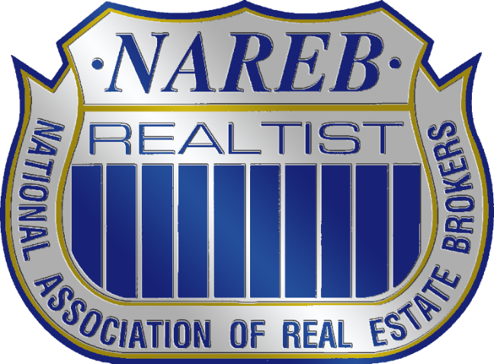
NAREB was founded in 1947 , making it the oldest minority association in America. It was formed out of a need to secure the right to equal housing opportunities regardless of race, creed or color. Since its inception, we have participated in various meaningful challenges and legislative improvements to establish fair housing for all.
Our national goal is to bring together the nation’s minority professionals in the real estate industry to promote the meaningful exchange of ideas about our business and how best to serve our clientele. We strive to create an environment where creativity flourishes in both the workplace and the marketplace.

Monday, January 30th at 5:30pm
Smokey Bones Restaurant
5750 Rivers Ave. (Meeting Room)
North Charleston, SC 29406

COME OUT TO FELLOWSHIP AND LEARN ABOUT
THE ACTION PLANNED YEAR
&
HOW BEING A REALTIST CAN ENHANCE YOUR BUSINESS!

Mattie Nesmith | Charaka Cook
Charleston Chapter President | Region V Vice President
chsnareb@gmail.com | scnareb@gmail.com
843.452.3779 | 803.518.9525

