Join Us for the Reactivation of Charleston Chapter of NAREB
Excellent Networking Opportunities
&
A Plethora of Wealth to Enhance Your Business
~
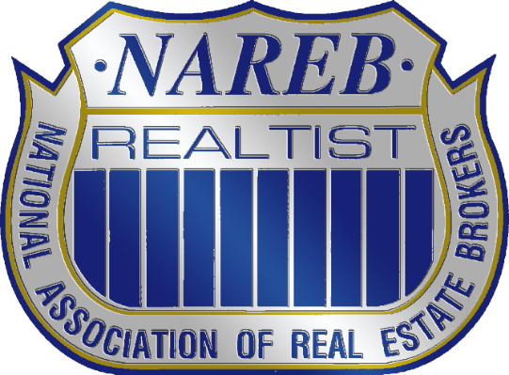
NAREB was founded in 1947, making it the oldest minority association in America. It was formed out of a need to secure the right to equal housing opportunities regardless of race, creed or color. Since its inception, we have participated in various meaningful challenges and legislative improvements to establish fair housing for all.

Otranto Library
2261 Otranto Rd, North Charleston, SC 29406
Friday, May 13th from 1-3

CONTACT INFO
chsnareb@gmail.com
Mattie Nesmith-2016 President
(843) 452.3779

