Dear Valued Agents,
At National Property Inspections, we realize the real estate market is time sensitive. That’s why we make appointment availability a priority. When your clients book with NPI, we guarantee to perform their inspection within 5 days.
NPI Charleston is part of a national network of inspectors and backed by more than 30 years of experience. As your local office, we have the knowledge and expertise to give you the most accurate and thorough evaluation of any home or commercial property, inspecting hundreds of components. From the foundation to the roof and every major system in between, we have the tools and training to help you and your clients make the best deal and invest with success. We’re committed to educating your clients, putting issues in perspective and helping their home-buying or selling process go as smoothly as possible. Here are some highlights:
- Free 6-Month Warranty: NPI Charleston is the only inspection company in the area to offer a free 6-month Limited Warranty that covers most major systems of a home.
- Fully Insured: Our inspectors are fully insured. We carry E & O, General Liability and Indemnification Insurance.
- Guaranteed Availability within 5 Days & Fast Report Turnaround: We realize your time is valuable. That’s why we guarantee your report within 24 hours of your inspection time.

Our team recognizes the need for world-class service in the greater Charleston area. Please feel free to share the offer below with your clients and fellow agents! Thank you for taking the time to learn more about our company. I look forward to working with you.
We invite you to learn more about NPI Charleston at our website: https://www.npiweb.com/Charleston.
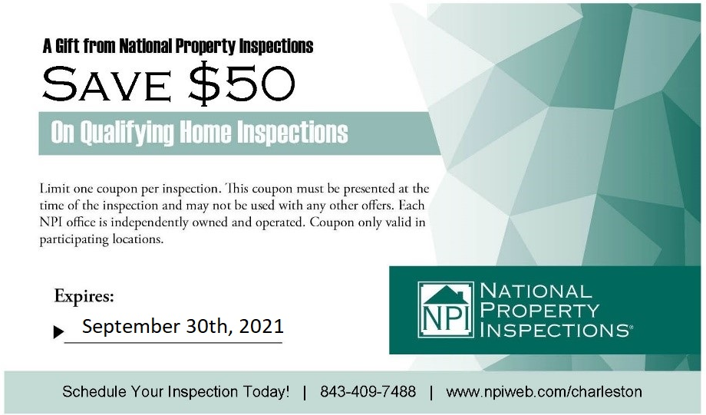
Zac Greenawalt
(843) 409 - 7488
www.npiweb.com/charleston
