
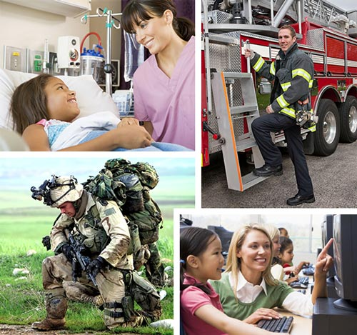
TT v


v 
WHAT DO WE DO?
We give back to those who help make our local communities a better place to live by minimizing the cost and stress of buying, selling or refinancing a home and provide thousands of dollars in benefits to our hometown heroes.
WHO QUALIFIES?
- Medical Professionals
- Non-Profit Employees
- Government Employees
- College Employees and ISD

- Military (Past / Present)
- Police Department
- Fire Department
- Teachers
Serving those who serve our communities every day!

HOME BUYER BENEFITS
MORTGAGE REFINANCE BENEFITS

BE
HOME SELLER BENEFITS
- Free Pre-Approval
- 20% commission rebate from a
HTH certified realtor partner.
- $750 lender credit from Parkmont Lending, credited at closing.
- $200 savings on credit restoration services from Revital Credit.
- Typical savings of approximately $2000 based on a $200,000 home
- Free Pre-approval
- $750 lender credit from Parkmont Lending, credited at closing.
- $200 savings on credit restoration from Revital Credit. Reimbursed at closing.
- 20% commission rebate from a HTH certified realtor partner

- Our Hero typically saves $1200 when selling, or $3200 when selling AND buying a home with
The Hometown Heroes Program
based on a $200,000 home

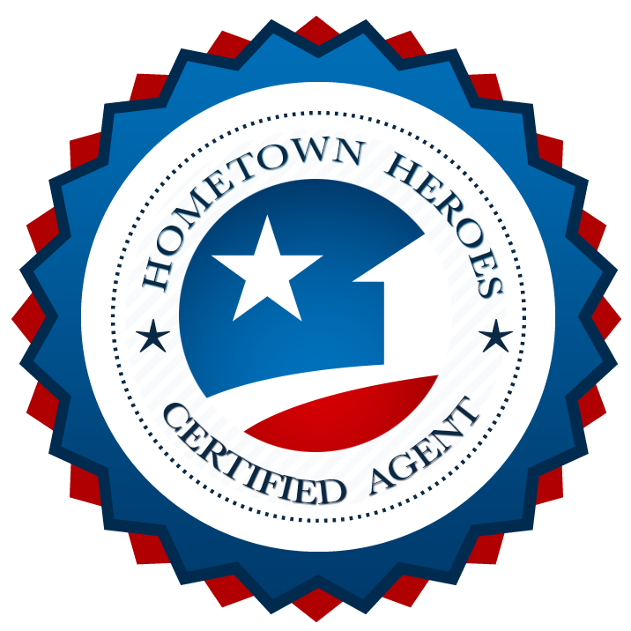


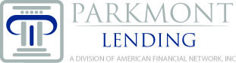

David LeBel, Loan Officer
Parkmont Lending
cell/text:910-695-5703
email: dlebel@parkmont.com
apply online: http://parkmont.com/dlebel

Your Local Preferred Lender
NMLS # 1082471
Contact your Certified Hometown Heroes Agent to get started!

