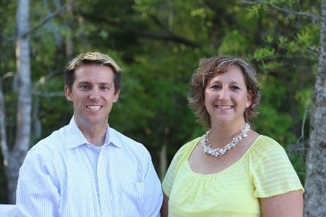
Adam Kernen & Tamara Vandiver of


Cordially invite you to their FREE monthly

REALTOR SUCCESS SERIES!!!

Grow your business | Overcome obstacles and frustrations | Maximize opportunities


Monthly, every 2nd Wednesday and that Friday
October is Wed the 8th or Fri the 10th
From 12:15 to 1:30pm @ Eggs Up Grill
2664 Highway 17 North, Mt Pleasant, SC 29466 (Next to Carrabbas)
**Each month there are NEW topics and GUEST SPEAKERS that are experts in their fields**

for other awesome FREE events!!!

RSVP to Tamara >> tamara.vandiver@guaranteedrate.com
843-412-2577

