I want to help you as a Real Estate Professional sell more homes by eliminating monthly payments for seniors when they purchase a home using a Reverse Mortgage. Taxes and insurance will still have to be paid but the cash flow benefit to the buyer is huge!
I have many tools and programs available to you and your clients. Over the coming weeks, I will be sending more information. Keep an eye out for these emails. If you have any questions or if you are ready to learn more now, call, text, or email me.
Please Text the word REVERSE to 474747 for free information! I want to help!

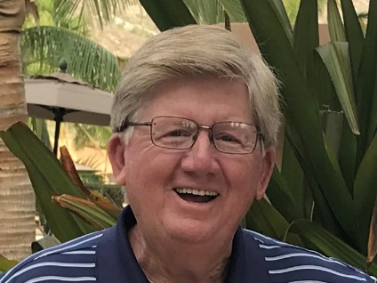
Keith Gannett
NMLS#1713315
Keith@SMPReverse.com | www.SMPReverse.com
Cell: 843-566-3296 | Fax: 843-872-0512
