

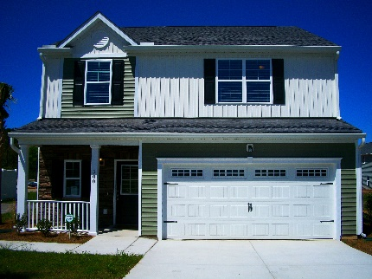
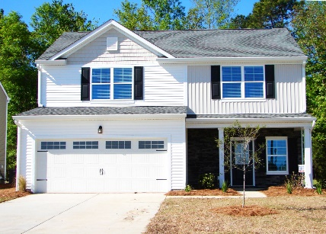

125 Grande Tree Drive
Moncks Corner, SC 29461

***$234,900***

EXTRA LARGE CORNER LOT
3BR with Loft – 2-1/2 Ba
Upgrades Galore!
MLS#17011805

Cypress Grove

HOMES
453 Brookgreen Drive
Moncks Corner, SC 29461

***$229,896***

Master Down ~ 2289 SqFt.
4 BR with Loft – 2-1/2 Ba
MLS#16030682

