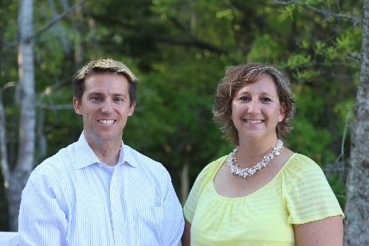
Adam Kernen & Tamara Vandiver of


Cordially invite you to their FREE monthly

“Street-Wise” Situational Awareness & Self-Defense Class
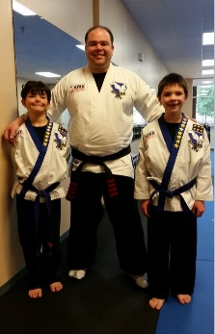
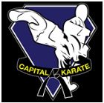
Taught from a Realtors perspective!!

OCTOBER is….
Thursday the 16th from 2-5pm
or
Tuesday the 21st from 1230-330pm
Choose the one that works best for you!

Superbly Taught by Aaron Hawk of Capital Karate
3365 S Morgan’s Point Rd #103, Mt Pleasant, SC 29466 (Charleston National Shopping Center)

Peering around a corner Looking for an entrance Squatter hiding behind couch Squatter hiding under bed
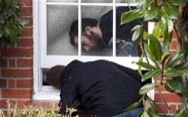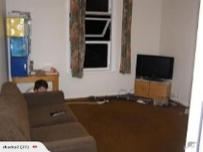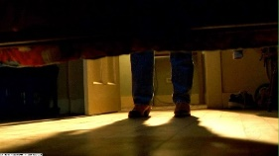
These things are occurring EVERY day, even in “Mount Perfect”. We have been hearing of squatters and other instances that are making Realtors uncomfortable. PLEASE come to see how to protect yourself and avoid confrontations all while making your buyers feel safe.
RSVP to Tamara >> tamara.vandiver@guaranteedrate.com // 843-412-2577

