Tremex Termite & Pest Eradicators
2414-A Clements Ferry Rd
Wando, SC 29492
843-849-8994 (O) 843-849-8995 (F)
Tremex2@aol.com

*** Mold & Fungi stain removal without encapsulation
*** Impervious to Moisture Penetration
*** Surface is clean & restored
*** Innovative process gives clear to close
*** 50% percent less than full encapsulation
*** We Will MEET OR BEAT any deal in writing
*** Eco-Friendly

CL-100s: $75 (PAYABLE AT THE TIME OF INSPECTION) & $150 IF HELD OUT OF CLOSING

COMPLETE ALL ASPECTS OF TERMITE & PEST CONTROL SERVICES.
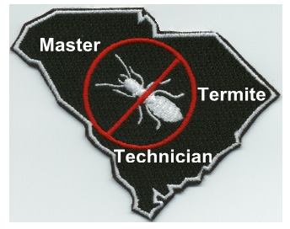

*LETTERS ARE E-MAILED OUT BEFORE THE CLOSE OF BUSINESS DAY*

Now Presenting….PRESSURE WASHING
- A Cleaner house will stand out!
- One of the 1st things that’s notice on a home is the roof
- IS YOURS CLEAN?
- We can power clean the entire home, driveway, decks, etc.

Call us for more information!

