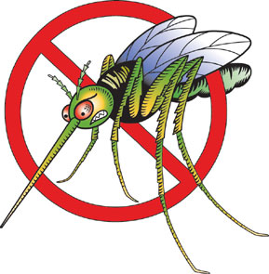
“You can kill both of them with a newspaper”
Smile!

Tremex Termite & Pest Control, Inc.
NOW INTRODUCING MOSQUITO CONTROL!

Contact us for all your outdoor event needs
• Residential yards
• Commercial Landscapes
• Private and Public Events (Wedding, parties, etc)

TIRED OF THOSE NICE OUTDOORS EVENTS BEING RUINED BY THE BITES, SWATS & SMACKS??

Enjoy the outdoors without those tiresome gnats & mosquitoes ruining your events & family time!

Call us today for free professional inspections, quotes and discounts!

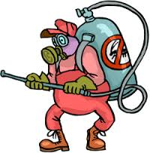
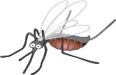
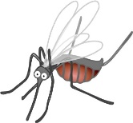
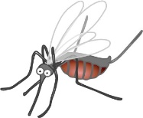
15% off

