Why do the best agents stay with a brokerage?
Top producers aren’t focused on splits or flashy perks—they’re focused on real connection, real support, and real leadership.

🧠 Culture That Feels Personal
Agents don’t want to feel like a number. They want a brokerage where people know their name, know their goals, and truly care about their success. At True Carolina Realty, we build real relationships—not just headcounts.

🤝 Collaboration Over Competition
Top agents thrive where support is genuine and collaboration is daily—not just a slogan. We foster a community where agents share ideas, help each other win, and grow together.

🛠 Support That Actually Helps
Agents want help that works—not cluttered tech or hollow promises. They want someone who will sit down with them, solve problems fast, and help them use tools effectively. That’s the kind of deep support we live every day.

📈 Leadership with Real Accountability
Great leadership isn’t about supervising—it’s about setting clear expectations and helping agents hit them. Our leadership style combines direction, coaching, and accountability to help you turn goals into results.

📣 A Brokerage That Balances Warmth and Professionalism
Agents want a place that feels welcoming and serious about business. Not cold. Not chaotic. Just the right environment to build a lasting, successful career.

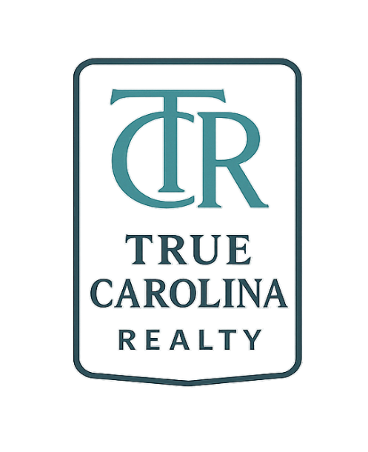
Join True Carolina Realty
Where culture isn’t an idea — it’s lived.
Where leadership guides, supports, and pushes you forward.
Where support isn’t just available — it’s personal.
Your career deserves more than a logo.
It deserves a team, a leader, and a culture that helps you thrive.
➡️ Connect with us today! 843.834.1241

info@truecarolinarealty.com or BrookeMadsen.Realtor@Gmail.com

