UNIQUE STAGING

843-300-2810
Uniquestaging123@gmail.com

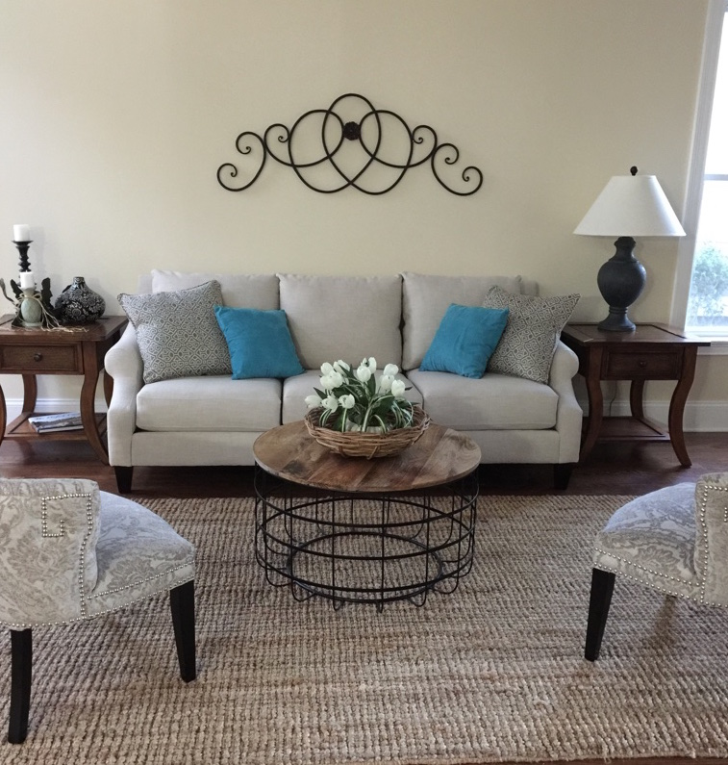

OFFERS A FLAT AFFORDABLE RATE WITH NO MONTHLY FEES. (ALL FEES CAN BE PAID AT CLOSING!)

WE SPECIALIZE IN HOME STAGING FOR THE RETAIL MARKET INCLUDING OCCUPIED STAGING, VACANT STAGING AND INTERIOR DESIGN. (FULL OR PARTIAL STAGING IS AVAILABLE).

LET US HELP YOU SELL YOUR HOME QUICKLY
To view some of our work visit: Facebook.com/Uniquestagingllc

