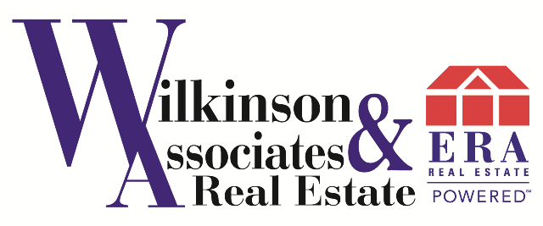


Join For Only $49/month and a 90/10 Split!

Call Rick Knight 843-839-9060 or visit JoinWilkinson.com

Download an Interactive Business Plan, Weekly Career Tips,

and a Confidential Business Assessment!

*Additional 5% franchise fee & 195 per transaction

Virtual Change Management Coaching

This broker-only course is designed to increase success at managing people, inventory, and leads – and ultimately profitability. The six-month course consists of bi-weekly teleconferences and includes a roundtable format. Topics range from prospecting to social media and technology.
Your listings sell in a finite period of time, or ERA buys them! This innovative program gives sellers the assurance that their property will sell, with clear parameters, set deadlines, and no surprises. Backed by ERA Franchise, this is a selling assurance tool you can rely on! *Conditions & limitations apply
Enhance your skills and expand your knowledge base through the education courses offered through the ERA Learning Exchange. Nationally accredited certification programs are available on demand at discounted rates. Designations and special training helps our agents set themselves apart form their competition!

The Learning Exchange

ERA Sellers Security Plan

Three Tools We Love…

Join Us and Get

Over 25 BUSINESS TOOLS

(at no extra charge!)

