



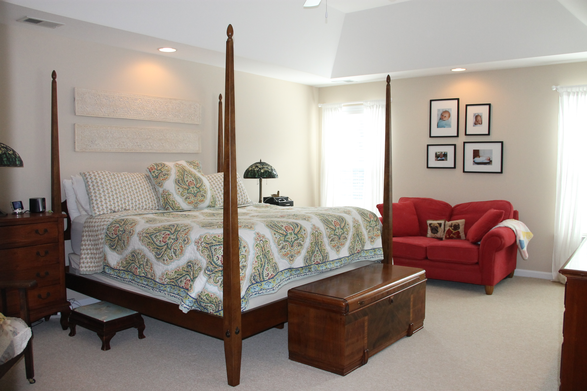
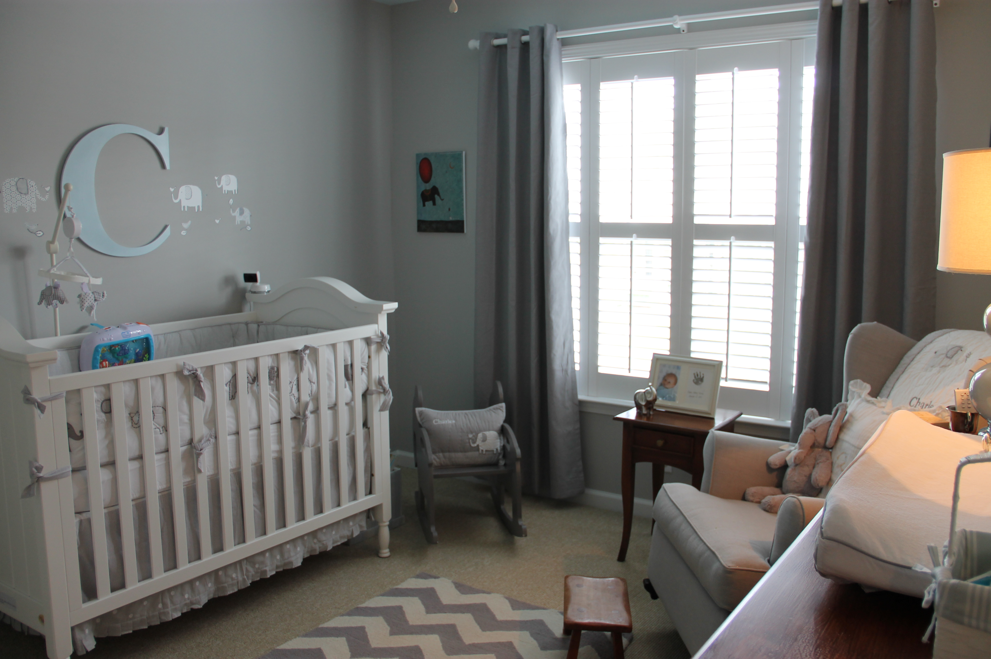
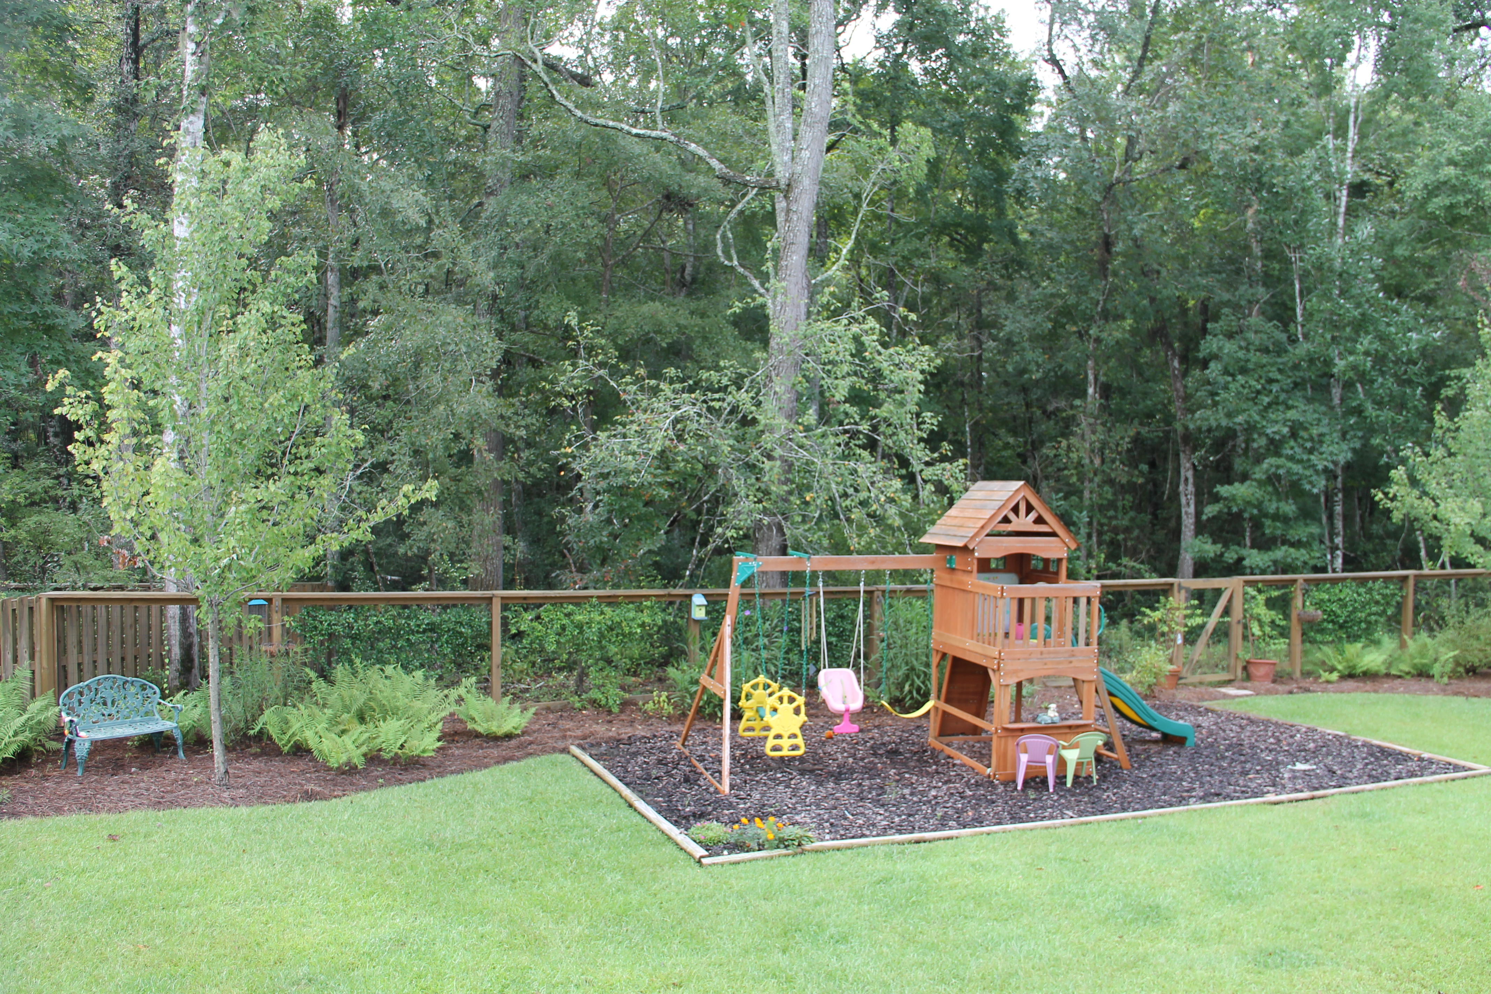
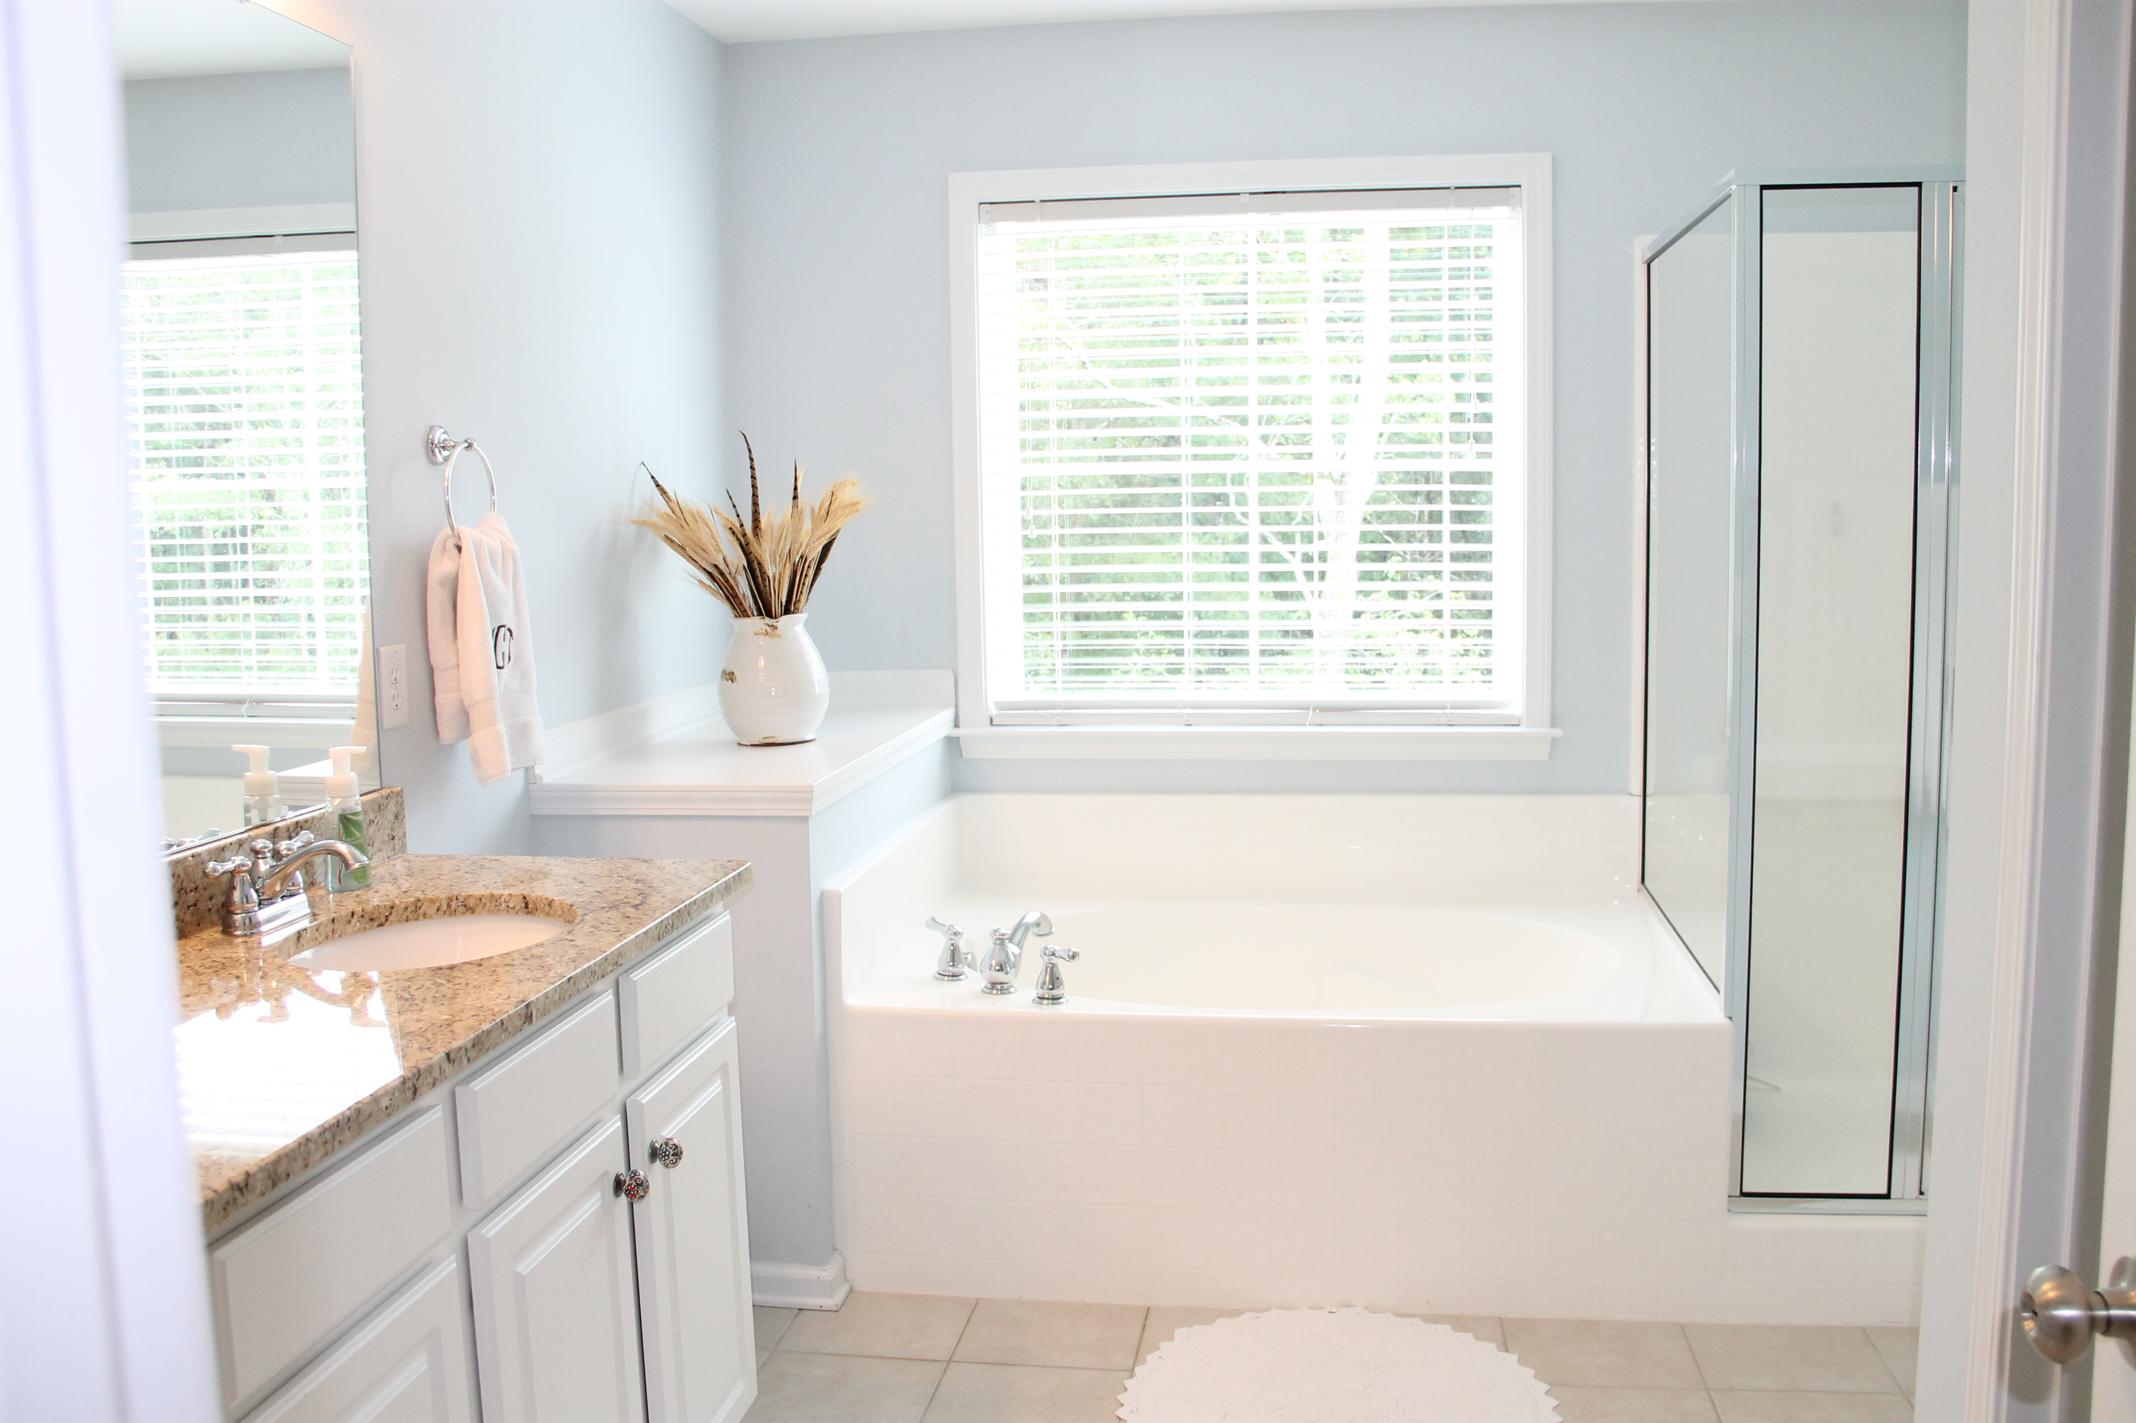
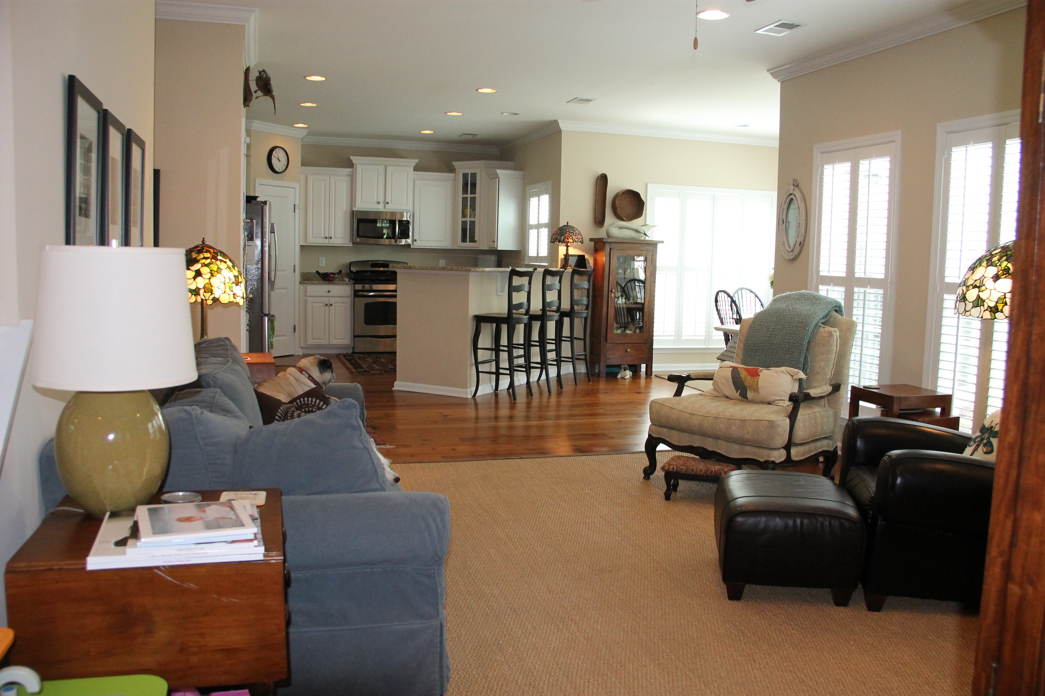
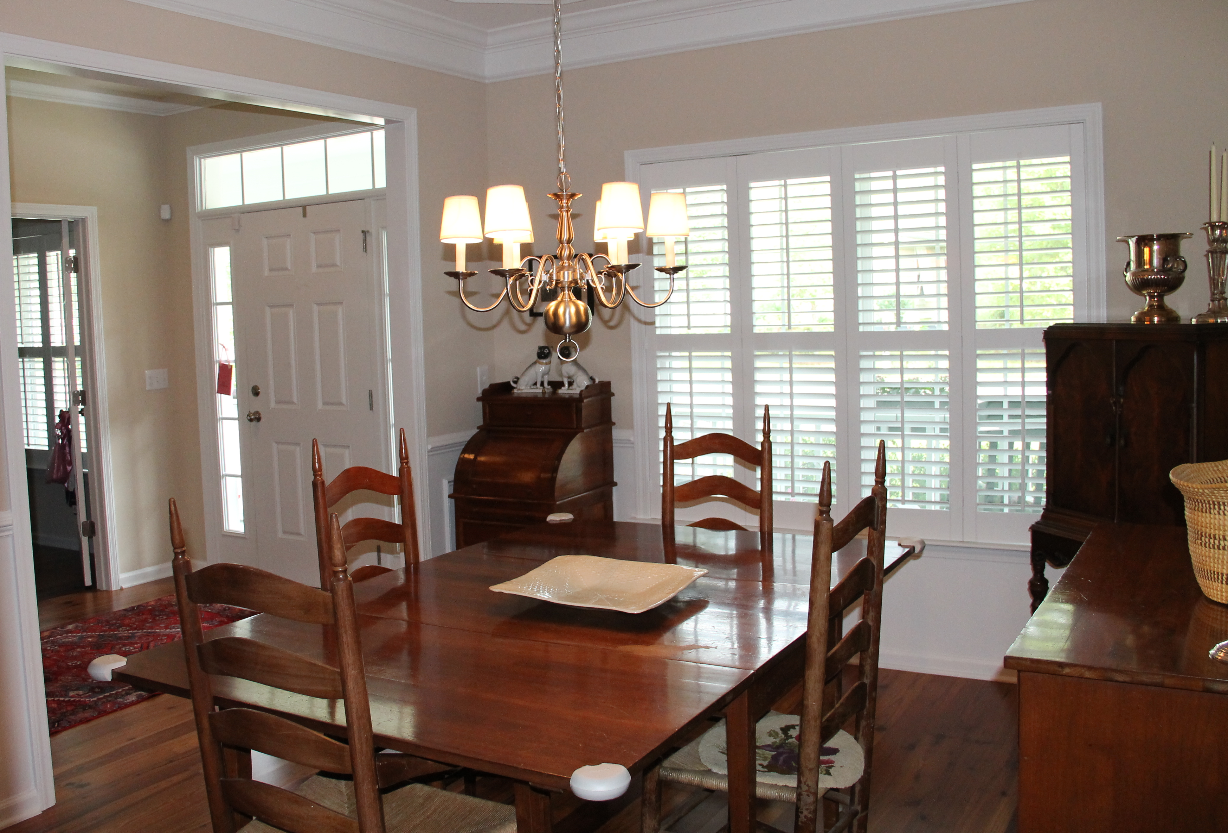
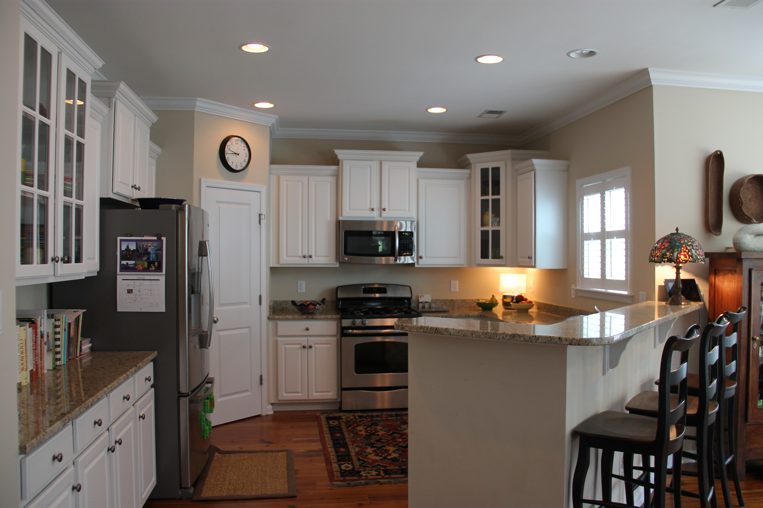
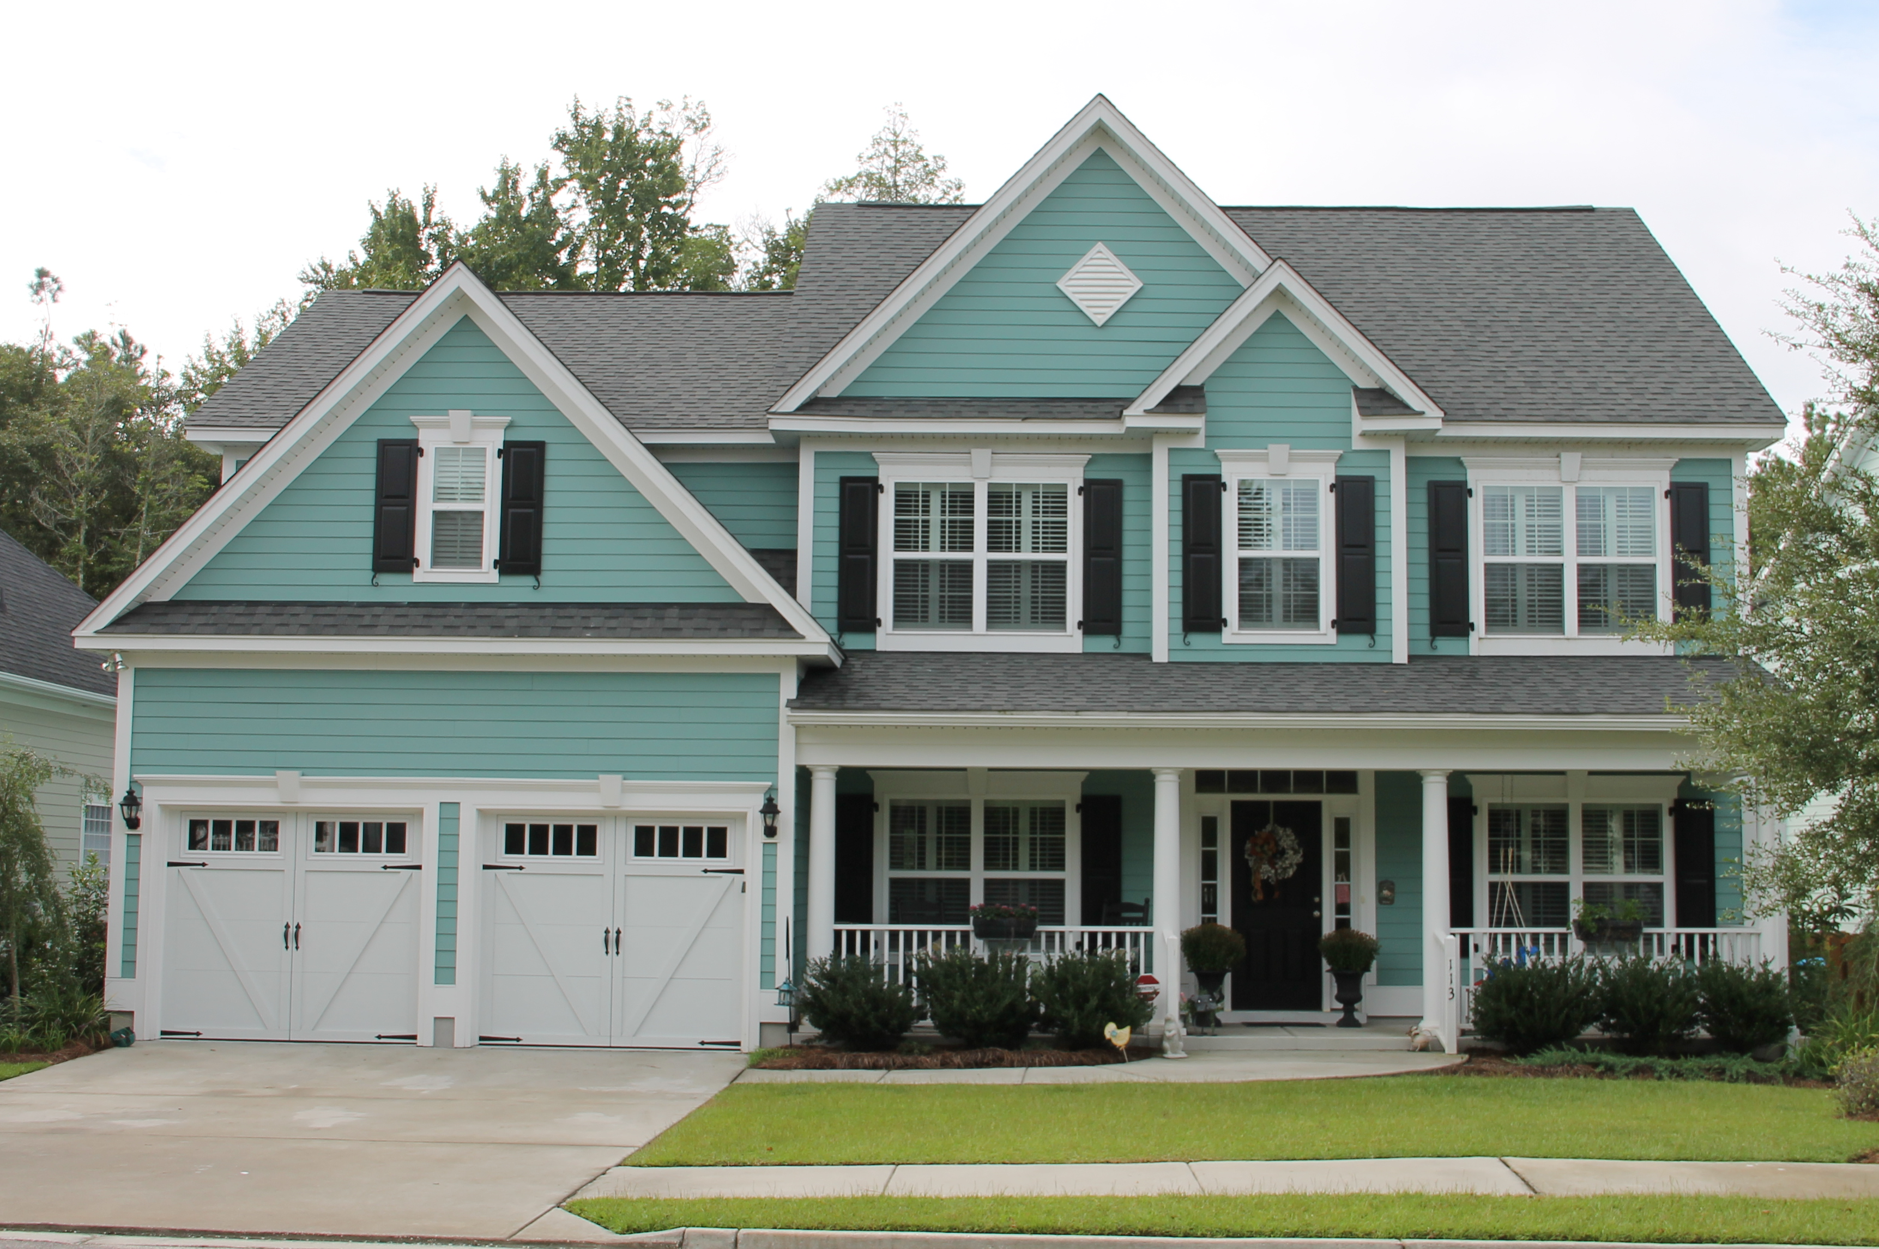

View Property:
Text E41456 to 85377

Katherine Mappus
Exit Realty The Tracey Group
843-478-5731
Kat@TheTraceyGroup.com
www.KatMappusRealEstate.com
A gorgeous home on a quiet street with a spacious fenced yard backing up to woods and wetlands and an amazing neighborhood! What more could you ask for? How about fabulous upgrades, including stainless appliances, tankless hot water heater, gas range, upgraded wood floors throughout the first floor, granite countertops in the kitchen and in the master bath, ceiling fans in all five bedrooms, plantation shutters on all first floor windows and second story front windows, security system, and wainscoting in the dining room. These owners spared no expense in building this home, opting for the morning room and oversized bedroom/bonus room additions, which added more than 200 square feet to the original floor plan. They also have a 12'x14' deck for outdoor fun overlooking the lovely backyard. This home is truly a find, and as an added bonus, The Ponds boasts miles of walking trails, gorgeous oak trees, an onsite YMCA, a beautifully restored 1840s farmhouse, a party pavilion, a zero entry pool, an amphitheater, multi-sport recreational fields, organized events and so much more! Schedule a showing as soon as possible, and you will not be disappointed.
MLS#16018991

The Ponds of Summerville
113 Red Bay Lane, Summerville, SC 29483
5 Bedroom/3 Bath ~ 2,878 Square Feet ~ $379,500

PRICE REDUCED!

