Memorial Day Open House Sale!!
3 townhomes on golf course for 20% below current appraised value! No regime fee for five years! must buy this weekend to take advantage of this offer!
Open House Sat 11-6, Sun 1-5, Mon 11-5
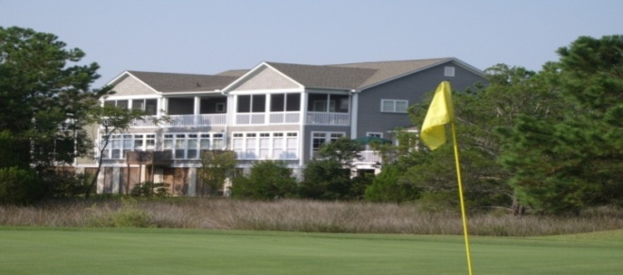
*5 years HOA dues at $172 a month have a value of $10,320 to be prepaid by seller at time of closing.

Call Beth or Meg Bernthal
for an appointment
843.377.3266

