Turn Key Townhome on the Golf Course with Elevator
No regime fees for five Years!!!!
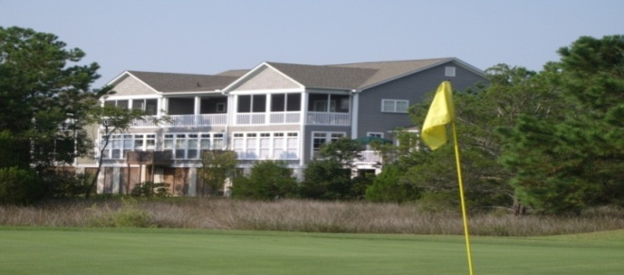

1904 Hopeman Lane Now $329,950 Reduced Over $95,000

Contact Beth or Meg
Bernthal at 843.377. 3266 or
theteam@bernthalandbernthal.com
for an Appointment.

